DETECTION AND GENOTYPE DETERMINATION OF LYMPHOCYSTIS DISEASE VIRUS FROM ORANGE CLOWNFISH Amphiprion percula IN BATAM

Murwantoko ¹⁾*, Endang Wijayanti²⁾, Sri Agustatik²⁾, Harshelly Valianti²⁾, Lalla Kumala Yulanda¹⁾, Nur Lailatul Fitrotun Nikmah¹⁾

- Department of Fisheries, Faculty of Agriculture Universitas Gadjah Mada
Jl. Flora Bulaksmumur Yogyakarta 55281 INDONESIA
- Batam Mariculture Development Center, Directorate General of Aquaculture, Ministry of Marine Affairs and Fisheries
Jalan Raya Trans Barelang Jembatan III. Pulau Setoko, Kec. Bulang, Kota Batam PO Box 550 Batam INDONESIA

Coresponding author murwantoko@ugm.ac.id

ABSTRACT

Orange clown fish Amphiprion percula is the one of popular fish in the global marine ornamental trade. In March 2021, several orange clown fishes at Batam Mariculture Development Center showed the lethargic with the presence of wart-like nodules on fins. This study aims to detect the viral disease agent and determine its genotype. The fish tissues with wart-like nodules were collected and fixed in ethanol. The DNA was extracted from the tissues and used as template for the amplification of the major capsid protein (MCP), myristylated membrane protein (MMP) and DNA Polymerase (DNAPol) genes using PCR. The nucleotide sequences of the PCR products were analyzed on the homology using Basic Local Alignment Search Tool (BLAST). Multiple alignment of the amino acid sequence of MCP was performed using MEGA to determine the genotype. The PCR amplification producted the expected bands on the detection of MCP, MMP and DNAPol genes. Those results indicated the presence of Lymphocystis disease virus (LCDV) and designated as LCDV-Oc-Btm. The seqensing of MCP and MMP genes produced the 1221 and 407 nucleotides respectively. The BLAST analysis showed the highest identity was obtained with the species of LCDV-1 (LCDV-Sa strain) at 91.04 % and 88.19 % for MCP and MMP respectively. The UPGMA phylogenic tree showed LCDV-Oc-Btm is differ from the existing genotype and can be assigned as a new genotype. In conclusion, LCDV-Oc-Btm is supposed to be a novel species of lymphocystis disease virus.

KEYWORD: DNA polymerase, Genotype, LCDV, MCP, MMP.

INTRODUCTION
Lymphocystis disease virus (LCDV) is the causative agent of lymphocystis disease, affecting more than 140 species of marine and freshwater fish worldwide in both wild and farmed fish. The pathognomonic signs of lymphocystis-infected fish are mostly external multinodular tumor-like or wart-like masses growths on the fins, skin, or gills (Hick et al., 2016; Lam et al., 2020). Nodular lesions may also be observed on the surfaces of viscera. However, in some species, such as yellowtail, nodules do not form and the affected fibroblasts are disguised by overlying melanocytes, resulting in pigmented lesions (Hick et al., 2016).
The tropism of LCDV-1 for fibroblasts, combined with characteristic cytopathology of cell hypertrophy in pathognomonic lesions as a nodule. Each nodule diameter up to 1 mm, consists of a single enlarged dermal fibroblast, which is visible macroscopically. This cell hypertrophy can be confirmed by direct microscopy using a wet mount or by histopathology. The cytoplasm of lymphocystis-affected cells contains multiple, highly reticulate or basophilic inclusion bodies in the nucleus and nucleolus are also hypertrophic (Hick et al., 2016). The LCDV has a tropism that is limited to the dermis, rather than causing a systemic infection, the mortality associated with lymphocystis was once considered to be rare. However, LCDV has been associated with significant mortality events in farmed fish (Hick et al., 2016).
Lymphocystis disease causes serious economic losses in the aquaculture and ornamental fish industries. Affected fish has low market value due to disease-associated anemia, appearance of external lesions, reduction in the growth rate, high susceptibility to secondary bacterial infections, and high rates of cannibalism (Hick et al., 2016; Maganha, 2020)
LCDV is a large iridovirus with virions of heterologous size characterized by an icosahedral capsid approximately 200-230 nm in diameter, a double-layered capsid with an outer envelope and a fringe of fibril-like external protrusions (Chinchar et al., 2017). LCDV is distinguished from other iridoviruses of fish by a genomic GC content of 29% compared with 48–55% (Hick et al., 2016). The ICTV recognizes three species of LCDV as Lymphocystis disease virus 1 (LCDV-1), Lymphocystis disease virus 2 (LCDV-C) and Lymphocystis disease virus 1 (LCDV-Sa) with their genome are 102 kbp, 186 kbp and 208 kbp respectively (Chinchar et al., 2017). A novel lymphocystis disease virus from whitemouth croaker (Micropogonias furnieri) (LCDV-WM) is the largest vertebrate iridovirus with a 211 kpb genome and 148 genes compared with 108 kbp for LCDV-1 (Doszpoly et al., 2020). This LCDV-WM has been established as a novel species, the Lymphocystis disease virus 4 (Walker et al., 2021).
Phylogenetic and evolutionary analyses of the family Iridoviridae is mainly based on the highly conserved major capsid protein (MCP) gene (Hossain et al., 2008; Maganha, 2020). Several genotypes were present in the genus Lymphocystivirus, based on MCP gene sequence and the pathogenicity of lymphocystiviruses: genotype I (consisting of LCDV-1); genotype II (consisting of Japanese flounder isolates and sea bass isolate); genotype III (consisting of rockfish isolates) (Kitamura et al., 2006); genotype IV (for the sea bass isolate), genotype V (for painted glass fish isolates) and genotype VI (for gourami isolates) (Hossain et al., 2008). The nine genotypes of Lymphocystivirus have been describe with from yellow perch, Perca flavescens (Palmer et al., 2012).
The clown anemone fish ‘Nemo’ Amphiprion ocellaris is the most popular fish species in the global marine ornamental trade. This condition leads to the exploitation of this species in the natural environment. The densities A. ocellaris are significantly lower at coral reefs with high exploitation than at reefs with low exploitation (Madduppa et al., 2014). Study by Lam et al. (2020) have confirmed the lymphocystis disease virus from the captive-bred clownfish Amphiprion percula from South Sulawesi by sequencing a portion of the DNA polymerase (DNAPol) gene. Breeding efforts of the orange clownfish A. percula, has been conducted at Batam Mariculture Development Center. In March 2021, several orange clown fishes at the grow out stage showed lethargic, anorexia and tumor-like nodules on the body surface. In this study we confirmed by PCR the presence of lymphocystis disease virus from that orange clownfish based on the MCP, DNAPol and myristylated membrane protein (MMP) genes. We also first determined on LCDV genotype based on the sequence of MCP in Indonesia.

MATERIAL AND METHODS:

Fish sampling
The Ornamental Fish Unit of Batam Mariculture Development Center was established to produce several ornamental marine fishes including orange clown fish Amphiprion percula. The production of clown fish involvs the breeding, larva rearing, nursery and grow out stages. In March 2021, several clown fish showed the lethargic, anorexia in the tank, with the presence of tumor-like nodules. The fish were collected for the observation in laboratory. The tissues with nodules were removed and preserved in ethanol 96%.

DNA genomic isolation
The tissue samples were washed using PBS. Approximately 25 mg of tissue were grinded in a 200 µL buffer and treated for Proteinase K (1 mg/mL) at 60 ºC for 1.5 hour. The next steps for DNA isolation were using FavorPrepTM Tissue Genomic DNA extraction Mini Kit with protocols as recommended by the manufacturer. At the final steps, the DNA was eluted in a 50 µL elution buffer and stored at -20 ⁰C until used.
DNA amplification of the major capsid protein (MCP), myristylated membrane protein (MMP) and DNA polymerase (DNAPol) LCDV genes were conducted by polymerase chain reaction (PCR) using a thermal cycler TM 100 (Biorad, US) with the specific primer pairs as listed in Table 1. The PCR mixtures were composed of 2 µL of each oligonucleotide primer, 2 µL DNA template, 20 µL nuclease-free water, and 24 µL PCR mix 2x (My Taq Hs Red Mix, Bioline, US). The amplification was conducted with the reaction of the initial denaturation at 95 ºC for 120 sec, 37 cycles of denaturation at 95º C for 45 sec, annealing at 50 ºC for 45 sec and extension at 72 ºC for 120 sec, following one cycle of final extension at 72 ºC for 7 min.

Table 1. Major capsid protein, myristylated membrane protein and DNA polymerase primers for detection and sequencing of lymphocystis disease in orange clown fish Amphiprion percula from Batam

Gene | Primer | Sequences | Reference
Major capsid protein | MCP-PF | ATGACTTCTGTAGCGGGTTCAAGTG | Huang et al., 2015
Major capsid protein | MCP-PR | AATTCAAARTTTTGWGCATCTTTATAACC | Huang et al., 2015
Myristylated membrane protein | MMP-PF | CACAAGTAGCAGATATTAACAACA | Huang et al., 2015
Myristylated membrane protein | MMP-PR | TCTTGAGCACAATCTTGAAATA | Huang et al., 2015
DNA Polynerase | DNA Pol-PF | ATGATAGTTTTTATTTTTCAATGG | Huang et al., 2015
DNA Polynerase | DNA Pol-PR | AGC TGATATTTTACATGCTAATTG | Huang et al., 2015

PCR products were evaluated by gel electrophoresis on a 1 % agarose gel containing 0.03 % DNA stain (1st Base, Singapore), in the presence of 100 bp DNA ladder (Geneaid, Taiwan). The direct sequencing of PCR products was performed by a commercial company (Genetika Science).

Data Analysis
Obtained sequences were aligned to determine the consensus among those forward and reverse primer sequences. The consensus DNA sequences were analyzed using Basic Local Alignment Search Tool (BLAST) to look for the homology with the data on Genbank (https://blast.ncbi.nlm.nih.gov/Blast.cgi). Multiple alignments for phylogenic analysis of this study sequences with data in Genbank was conducted using the MEGAX software (Kumar et al., 2016). Construction of phylogenetic trees was based on the unweighted pair group method using arithmetic average (UPGMA) and bootstrap analysis is performed with resampling 1000 times.

RESULTS AND DISCUSSION

Clinical Signs
Several orange clown fishes at the grow out stage which were reared in a conical fiberglass tank showed the clinical symptoms of lymphocystis. The 4 cm of clown fish showed white spots or small warts on the dorsal and caudal fins. The fully developed warts on the body surface were present in the caudal peduncle and abdomen (Fig. 1). This clinical sign was similar with the presence of white wart on the dorsal fins of LCDV-infected clownfish A. percula in Makassar (Lam et al., 2020). In this study, the lesions in the mouth was found in a fish (data not shown).

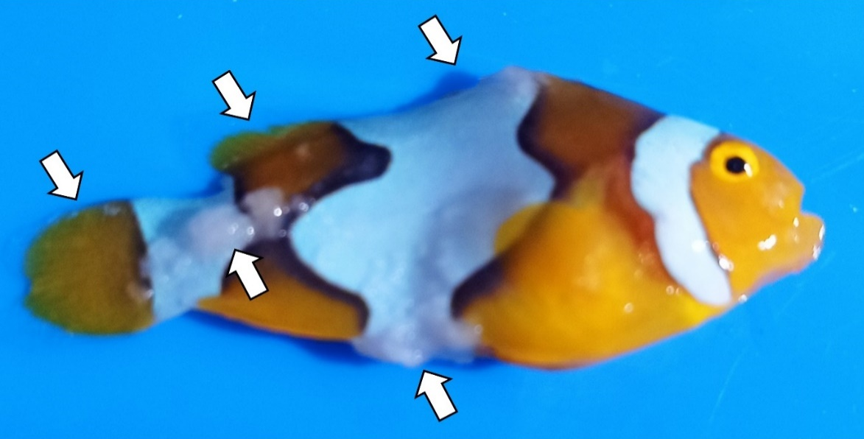
Figure 1. Orange clown fish Amphiprion percula from Batam showing the presence of the whitish wart on dorsal fin, dorsal fin severe warts on skin.

The genomic DNA from the wart-like tissue was used as a template for amplification of MCP, DNA Pol, and MMP genes. The specific PCR product band was observed on the detection of MCP and MMP genes with the size at approximately 1200 bp and 400 bp respectively. The amplification using DNA Pol primer produced a thin band at approximately 1600 bp as expected, but in the presence of several non specific fine bands (Fig.2). Those results using three genes strongly confirmed that the orange clownfish from Batam was infected by LCDV and we designated this virus as LCDV-Oc-Btm. In several studies, the confirmation of LCDV only using one gene such as Sihananto et al. (2019) on giant snakehead, Lam et al. (2020) on orange clown fish.
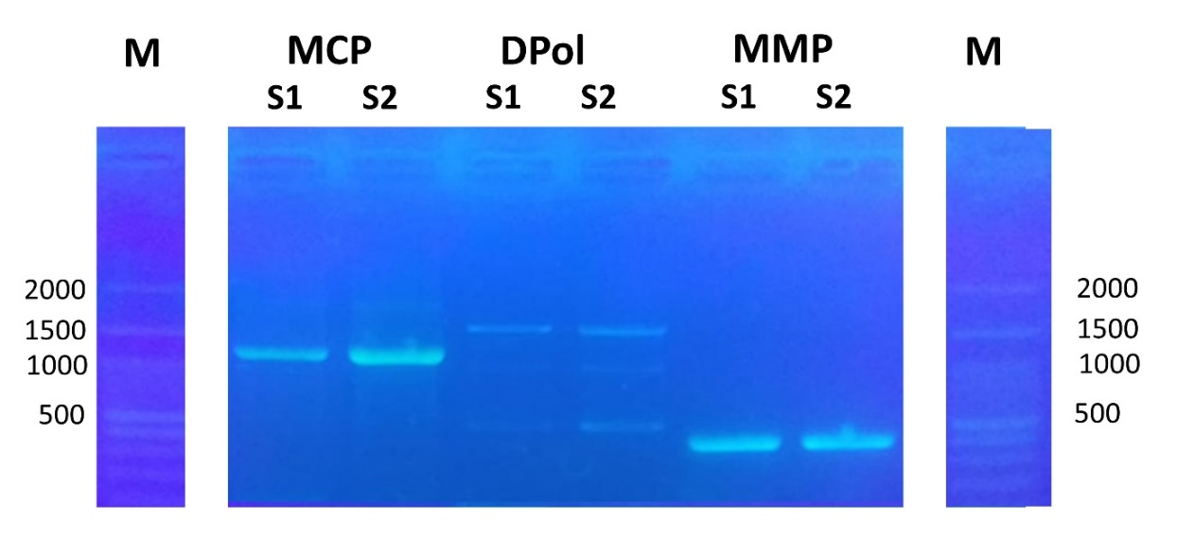
Figure 2. Agarose gel electrophoresis amplification product of major capsid protein (MCP), myristylated membrane protein (MMP) and DNA polymerase (MMP) of LCDV from orange clownfish Amphiprion percula in Batam with DNA marker as indicated size.

The PCR product of MCP, MMP and DNA polymerase from LCDV-Oc-Btm were applied for sequencing. From the sequencing, we can read the MCP and MPP genes at 1221 and 407 nucleotides respectively. The nucleotide sequences of the MCP and MPP genes in Table 2. Since multi bands were present in PCR, the sequences of DNA polymerase gene of this LCDV could not be read.
Table 2. The nucleotide sequences of the major capsid protein and myristylated membrane protein genes of LCDV-Oc-Btm from orange clown fish Amphiprion percula in Batam

Gene | Nucleotide sequence | Size (nt)
Major capsid proteian (MCP) | CCAGCGCTTTTATAGATTTAGCCACTTACGATACTATTGAAAAACATCTTTACGGCG  GCGATTCAGCCGTGGCTTATTTTGTACGAGAAACTAAAAAATGTACTTGGTTCAGCA  AATTACCGGTGCTTTTAACGCGATGCTCGGGATCGCCCAATTTTGACCAAGAATTTT  CCGTTAACGTTTCTCGGGGCGGAGATTACGTCATCAACGCCTGGATGACGGTGCGTA  TACCCGCCGTTAAATTGAAAAATAACAATAGAATGAACGCCAACGGCACCATTCGAT  GGTGTAAAAATTTGTTTCACAATCTGGTCAAACAAACGTCCGTTCAATTCAACGATT  TGGTGGCTCAAAAATTCGAGAGTTACTTCCTCGATTTCTGGTCCGCCTTTGGCATGT  GCGGATCTAAACGAACGGGCTACGACAACATGATCGGAAATACCGCCGATATGACGC  AACCCGTCGATTCCAACGGTCAACTACCCGAAAAAGTGTTGGTATTACCTTTACCTT  ATTTCTTTTCCCGGGACAGCGGCGTAGCTTTACCCAGCGCCGCTCTGCCTTATAACG  AAATAAGATTAACCTTTCATCTCAGAGATTGGACCGAATTGCTTATTTTTCAAAACA  AAAACGACTCTACCATCATGCCTCTAACGGCCGGCGATTTAGAATGGGGTAAACCCG  ATTTAGAGGACGTACAAGTATGGATCACCAACGTCGTGGTAACCAACGAAGAACGTC  GATTGATGGGTACGGTACCCAGAGATATTTTGGTGGAACAAGTACAAACGGCGCCGA  AACACGTGTTTCAACCGTTGACCATCCCCAGTCCCAATTATGACATCAGATTTTCTC  ACGCCATCAAAACTCTTTTTTTCGGCGTGCGCAACGTGACTCATCAAGCCGTACAAT  CCAATTATACCAGTTCTTCTCCGGTTATTTTTGACGGCGGAATAGCCAGCGATTTGC  CGGGTATCGCCGCCGATCCTATTTCGGACGTGACCTTGGTGTACGAAAACAGCGCGC  GTCTCAACGAAATGGGCAGCGAATATTATTCTTTGATTCAACCTTATTATTTCGGGG  GTTCTATTCCTATAGAAACGGGTTATCACATGTATTGTTATTCTCTCAACATGATGG  ACGTCGTTCCTATGGGATCCACCAATTACGGTCGATTGTCCAACGTCAGCATTAAAT  TGAAAACGTCTCCTAAAGCGGTAA | 1221
Myristylated membrane protein (MMP) | CACAAGTAGCAGATATTAACAACAGTCAAATCGTTACCGTTTCGGACGTAGACGGCG  ACGTGGATGTTTCGGACGTGTATTTTGTTCAACAAATCGACGTCAACGTAAAAAGTT  TGATGAACGTATTGTCTCAGCAAAAAGCTCAACAAGATTTATTCGAAGCCGTAGCTC  AAAACGCTAAATCCGTCACTTCAGGTTTAAACGCCGCGCAATACGCTTACGCCGTTA  ATCAAATCAGCGCTATAGCAACGGCGTGCGTTCAAGCTGCCGTACGCATCGACGATT  CGTGTTCGTTGGTCGACGCTATGACGCAAGAAATCGTTTTACAAAACGTAGGCGGTT  CCGTTAAAATAAAAGATTTAAATCTGTCTCAAATACAACGCGTATTTCAAGATTGTG  CTCAAGAA | 407

The alignment analysis on the MMP using BLAST showed only six entries have high similarity. The highest identity of the MMP LCDV-Oc was at 90.53 % with the LCDV-PF (accession number KJ408273) which is isolated from paradise fish Macropodus opercularis in China (Xu et al., 2014). The second highest identity is at 88.19 % with LCDV-Pa (accession number KX643370) which isolated from gilthead seabream (Sparus aurata) in Spain (López-Bueno et al., 2016). The MMP of LCDV-Oc-Btm has identity at 84% with the MMP of LCDV-C, LCDV-JP-Oita, LCDV-WC (Table 3).
Major capsid protein (MCP) gene is highly conserved in the family Iridoviridae and has been used for phylogenetic and evolutionary analyses (Hossain et al., 2008; Maganha, 2020). The alignment analysis on the MCP using BLAST showed the high identity with 51 entries of Lymphocystis disease virus MCP genes. This MCP LCDV-Oc-Btm has highest identity at 92.15 % with LCDV-PF (accession number KJ408271) which is isolated from paradise fish M. opercularis in China (Xu et al., 2014). The second highest identity at 91.24 % is with LCDV isolated from painted glass fish collected from an aquarist shop in Yeosu City Korea (Hossain et al., 2008). This MCP sequence showed 91.04 % identity with LCDV-Sa which isolated from gilthead seabream Sparus aurata in Spain (López-Bueno et al., 2016). The MCP of LCDV-Oc-Btm has identity at approximately 84% with the MCP of LCDV-C, LCDV-JP-Oita, LCDV-WC. The MMP LCDV-1 had the lowest identity at 76.80 % with this MCP LCDV-Oc-Btm (Table 3).
Table 3. Blast analysis of major capsid protein and myristylated membrane protein genes of LCDV-Oc-Btm from orange clown fish A. percula in Batam with established LCDV species

Virus strain  Acession number |  | Species | Identity
Virus strain  Acession number |  | Species | MCP | MMP
LCDV-PF  KJ408271.1, KJ408273.1 |  | n.a | 91.15 | 90.53
LCDV-Sa  KX643370.1 |  | LCDV-3 | 91.03 | 88.19
LCDV-C  AY380826.1 |  | LCDV-2 | 83.73 | 84,75
LCDV-JP_Oita LC534415.1 |  | LCDV-2 | 83.73 | 84.75
LCDV-WC  NC_055603.1 |  | LCDV-4 | 84.76 | 84.92
LCDV-1  L63545.1 |  | LCDV-1 | 76.80 | 69.40

Based on the full genome data, the ICTV recognizes four species of LCDV as Lymphocystis disease virus 1 (LCDV-1), Lymphocystis disease virus 2 (LCDV-C), Lymphocystis disease virus 3 (LCDV-Sa) and Lymphocystis disease virus 4 (LCDV-WM) (Walker et al., 2021). The identity of this LCDV-Oc-Btm with those established LCDV species were presented in Table 3. The LCDV-Oc-Btm has the highest identity with the LCDV-Sa at 91.04 % and 88.19 % for MCP and MMP sequences respectively. Those results indicated that this Indonesian LCDV is close to the species of Lymphocystis disease virus 3.
The identity of MCP intra species of LCDV is very high at least at 98.77 % among LCDV-3 species, and at 99.70 % among LCDV-2 species (data not shown). In this study, the highest identity is only at approximately 90 %, so it gives the possibility that Indonesian LCDV is a novel species of LCDV. Using the DNA polymerase sequence analysis, Lam et al. (2020) also suggests a new strain LCDV from A. percula in Makassar South Sulawesi. Those DNAPol sequences showed the highest identity of nucleotides at 91.2 % with LCDV-PF from Paradise Fish in China. This LCDV-Oc-Btm also showed the highest identity with LCDV-PF. Those result indicated the possibility that the LCDV from Batam and from Makassar are the same species.
The phylogenetic and evolutionary analysis of the family Iridoviridae is mainly based on the highly conserved major capsid protein gene. The determination of the genotype based on MCP has been widely used and showed the nine genotypes were existing in the genus Lymphocystivirus (Palmer et al., 2012). The MCP amino acid sequences was used to construct phylogenic tree of this LCDV-Oc-Btm with others lymphocystis viruses MCP (Fig 3). The LCDV-Oc-Btm is located at distinct branch indicating that the genotype of LCDV-Oc-Btm is differ from the existing genotype and can be assigned as a new genotype (10-th genotype). The other branch also appeared as the LCDV in croaker from Uruguay where the genotype was not determined yet.
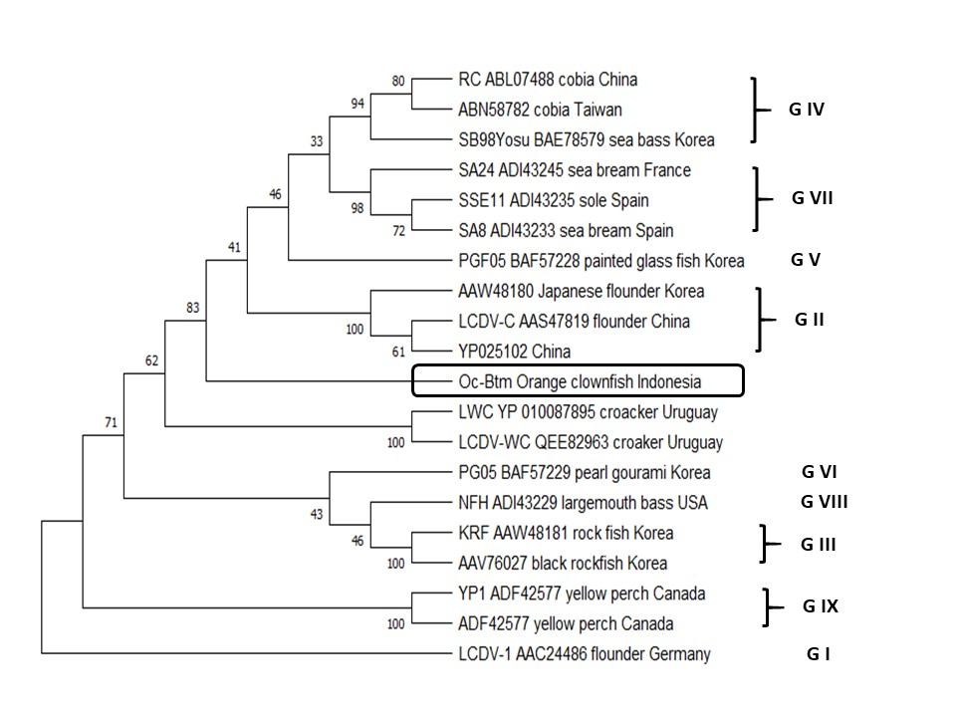
Figure 3. UPGMA Phylogenic on the amino acid sequence of major capsid protein of LCDV with the virus strain, Genbank accession number, host and country are indicated. The position of LCDV-Oc-Btm is highlighted by the box. G I – G IX are existing genotypes I to IX.

A limited study Lymphocystis disease in Indonesia has been reported. Lam et al. (2020) has used DNA polymerase gene to identify a lymphocystis disease virus (LCDV) using PCR, to construct phylogenetic, and to develop detection assays. The LCDV is found at 19.4% among the PCR-tested clownfish, but is not found in seahorse Hippocampus spp., mandarin fish Synchiropus spp., and pajama cardinal fish Sphaeremia nepatoptera from hatchery in Makassar. Study by Sihananto et al. (2019) have proved the presence of Lymphocystis virus in farmed giant snakehead Channa striata in Mandiangin South Kalimantan through histopathological and PCR investigation. Many species of fishes have been cultured in marine and freshwater, however limited species as in above have been studied for the LCDV. Those conditions lead to sugesstion on the study on the host range of LCDV in Indonesia is need. Lam et al. (2020) and this study suggested that Indonesian LCDV is differ from other LCDV species. To prove that hypothesis, a more comprehensive genetic study on LCDV is needed.

CONCLUSION
The orange clownfish Amphiprion percula from Batam with wart-like nodules was infected by lymphocystis disease virus. Based on the major capsid protein, myristylated membrane protein genes, this LCDV-Oc-Btm is supposed as a new species of lymphocystis disease virus. The genotype of LCDV-Oc-Btm is differ from the existing genotypes and can be assigned as a new genotype (10-th genotype).

ACKNOWLEDGEMENT
This study was funded by Research Grant Pendidikan Magister Menuju Doktor Untuk Sarjana Unggul (PMDSU) Batch V the Ministry of Research and Technology, Republic of Indonesia

REFFERENCES
Cano, I., Valverde, E.J., Lopez, J.B., Alonso, M.C., Garcia, R.E., Sarasquete, C., Borrego, J.J., & Castro, D. (2010). A New Genotype of Lymphocystivirus Isolated from Cultured Gilthead Seabream, Sparus aurata L., and Senegalese sole, Silea senegalensis (Kaup). Journal of Fish Disease. 33 (8), 695-700.; https://doi.org/10.1111/j.1365-2761.2010.01164.x

Chinchar, V.G., Waltzek, T.B., & Subramaniam, K. (2017). Ranaviruses and Other Members of The Family Iridoviridae: Their Place in The Virosphere. Virology, 17, 30184-30188. https://doi.org/10.1016/j.virol.2017.06.007

Doszpoly, A., Kajan, G., Puentes, R., & Perretta, A. (2020). Complete Genome Sequence and Analysis of a Novel Lymphocystivirus Detected in Whitemouth Croaker (Micropogonias furnieri): Lymphocystis Disease Virus 4. Archives of Virology, 165 (5), 1215 – 1218. https://doi.org/10.1007/s00705-020-04570-1

Fu, X.Z., Shi, C.B., Li, N.Q., Chang, O.Q., & Wu, S.Q. (2007). Inverse PCR Amplification of The Complete Major Capsid Protein Gene of Lymphocystis Disease Virus Isolated from Rachycentron canadum and Phylogenetic Analysis of The Virus. Bing Du Xue Bao, 23 (5), 412-416.

Hick, P.M., Becker, J.A., & Whittington, R.J. (2016). Iridovirus of Fish (Chapter 8). In Kibenge, F.S.B., & Godoy, M., USA (Ed.) Aquaculture Virology (pp.127-152). Ist Ed. Amsterdam: Elsevier Inc.

Hossain, M., Song, J.Y., Kitamura, S.I., Jung, S.J., & Oh, M.J. (2008). Phylogenetic Analysis of Lymphocystis Disease Virus from Tropical Ornamental Fish Species Based On A Major Capsid Protein Gene. Journal Of Fish Disease, 31 (6), 473-479. https://doi.org/10.1111/j.1365-2761.2008.00917.x

Huang, X., Huang, Y., Xu, L., Wei, S., Ouyang, Z., Feng, J., & Qin, Q. (2015). Identification and Characterization of a Novel Lymphocyctis Disease Virus Isolate from Cultured Grouper in China. Journal of Fish Disease, 38 (4), 379-387. https://doi.org/10.1111/jfd.12244

Kim, T.J., & Lee, J.I. (2007). Sequence Variation in The Genes Encoding The Major Capsid Protein, The ATPase, and The RNA Polymerase 2 (Domain 6) of Lymphocystis Disease Virus Isolated From Schlegel’s Black Rockfish, Sebastes schlegelii Hilgendorf. Journal of Fish Disease, 30 (8), 501-504. https://doi.org/10.1111/j.1365-2761.2007.00827.x

Kitamura, S.I., Jung, S.J., & Oh, M.J. (2006b). Differentiation of Lymphocystic Disease Virus Genotype by Multiplex PCR. The Journal of Microbiology, 44 (2), 248-253.

Kitamura, S.I., Jung, S.J., Kim, W.S., Nishizawa, T., Yoshimizu, M., & Oh, M.J. (2006). A New Genotype Of Lymphocystivirus, LCDV-RF, From Lymphocystis Diseased Rockfish. Archives of Virology, 151 (3), 607-615. https://doi.org/10.1007/s00705-005-0661-3

Kumar, S., Stecher, G., & Tamura, K. (2016). Mega7: Molecular Evolutionary Genetics Analysis Version 7.0 for Bigger Datasets. Molecular Biology and Evolution, 33 (7), 1870-1874. https://doi.org/10.1093/molbev/msw054

Lam, C., Khairunissa., Damayanti, L., Kurobe, T., Teh, S.J., Pfahl, H., Rapi, S., Janetski, N., & Baxa, D.V. (2020). Detection of New Strain of Lymphocystis Disease Virus (LCDV) in Captive-Bred Clownfish Amphiprion percula in South Sulawesi, Indonesia. Aquaculture International, 28, 2121-2137. . https://doi.org/10.1007/s10499-020-00581-6

López-Bueno, A., Mavian, C., Labella, A.M., Castro, D., Borrego, J.J., Alcami, A., & Alejo, A. (2016). Concurrence of Iridovirus, Polyomavirus, and a Unique Member of a New Group of Fish Papillomaviruses in Lymphocystis Disease-Affected Gilthead Sea Bream. Journal of Virology, 90 (19), 8768-8779. https://doi.org/10.1128/JVI.01369-16

Madduppa, H.H., Juterzenka, K.V., Syakir, M., & Kochzius, M. (2014). Socio-Economy of Marine Ornamental Fishery and Its Impact on The Population Structure of the Clown Anemone Fish Amphirion ocellaris and Its Anemones in Spermonde Archipelago, Indonesia. Ocean & Coastal Management, 100, 41-50. https://doi.org/10.1016/j.ocecoaman.2014.07.013

Maganha, S.R.D.L., Cardoso, P.H.M., Balian, S.D.C., Queiroz, S.R.D.A., Fernandes, A.M., & Sousa, R.L.M.D. (2020). Detection and Molecular Characterization of Lymphocystivirus in Brazilian Ornamental Fish. Brazillian Journal of Microbiology, 51 (2), 531-535. https://doi.org/10.1007/s42770-019-00196-x

Palmer, L.J., Hogan, N.S., & Van den Heuvel, M.R. (2012). Phylogenetic Analysis and Molecular Methods for The Detection of Lymphocystis Disease Virus From Yellow Perch, Perca flavescens (Mitchell). Journal of Fish Diseases, 35 (9), 661-70. https://doi.org/10.1111/j.1365-2761.2012.01391.x

Sihananto, B.S., Novita, H., Wianty, C., & Lusiastuti, A.M. (2019). A Case Study of Lymphocystis Virus Disease in Farmed Giant Snakehead (Chana Striata) in Mandiangin, South Kalimantan. Indonesian Aquaculture Journal, 14 (2), 75-81. https://doi.org/10.15578/iaj.14.2.2019.75-81

Tidona, C.A., & Darai, G. (1997). The Complete DNA Sequence of Lymphocystis Disease Virus. Virology, 230 (2), 207-216.https://doi.org/10.1006/viro.1997.8456

Walker, P.J., Siddell, S.G., Lefkowitz, E.J., Mushegian, A.R., Adriaenssens, E.M., Alfenas-Zerbini, P., Davison, A.J., Dempsey, D.M., Dutilh, B.E., García, M.L., Harrach, B., Harrison, R.L., Hendrickson, R.C., Junglen, S., Knowles, N.J., Krupovic, M., Kuhn, J.H., Lambert, A.J., Łobocka, M., Nibert, M.L., Oksanen, H.M., Orton, R.J., Robertson, D.L., Rubino, L., Sabanadzovic, S., Simmonds, P., Smith, D.B., Suzuki, N., Van Dooerslaer, K., Vandamme, A.M., Varsani, A., & Zerbini, F.M. (2021). Changes to Virus Taxonomy and to The International Code of Virus Classification and Nomenclature Ratified by The International Committee on Taxonomy of Viruses. Archives of Virology, 166 (9), 2633-3648. https://doi.org/10.1007/s00705-019-04306-w

Xu, L., Feng, J., & Huang, Y. (2014). Identification of lymphocystis disease virus from paradise fish Macropodus opercularis (LCDV-PF). Archives of Virology,, 159 (9), 2445-9. https://doi.org/10.1007/s00705-014-2060-0

Zhang, Q.Y., Xiao, F., Xie, J., Li, Z.Q., & Gui, J.F. (2004). Complete Genome Sequence of Lymphocystis Disease Virus Isolated from China. Journal of Virology, 78 (13), 6982 – 6994. https://doi.org/10.1128/JVI.78.13.6982-6994.2004

