PARTIAL SEQUENCE OF GROWTH HORMONE (GH) mRNA OF TIGER SHOVELNOSE CATFISH Pseudoplatystoma fasciatum (LINNAEUS, 1766)

ABSTRACT
The pituitary secretes growth hormone, and the amount is limited in an individual. Tiger shovelnose catfish is introduced as ornamental fish with fast growth to isolate growth hormone genes used in fish farming. This study aims to isolate and identify the growth hormone (GH) mRNA gene in Tiger shovelnose catfish (Pseudoplatystoma fasciatum Linnaeus, 1766). The sample was isolated from the pituitary, the fish measuring 602 g and 43 cm long; RNA was extracted using the Tri Reagent Kit, followed with cDNA synthesis. The success of the extraction was confirmed by quantification and PCR using the β-actin gene as an internal control. GH mRNA gene was isolated by RT-PCR method, with degenerated primers from seven catfish species sequence data in the NCBI gene bank. The single band from GH gene was cloned and sequenced. Total RNA quantification with a concentration of 227 ng.µL and purity of 1.821. The successful isolation of mRNA from the pituitary gland was confirmed by amplifying the β-actin gene generated at 300 bp. This isolation of the growth hormone mRNA gene had a sequence length of 234 bp. PsGH gene consists of 17 amino acids, with an amino acid composition of seven types of R non-polar (48.0 %), five types of R polar (29.3 %), three types of R Base (16.0 %), and two types of R Acid (6.7 %). The GH gene of Tiger shovelnose catfish was closed to striped catfish (Pangasianodon hypophthalmus) and African catfish (Clarias batracus) with the same homology value of 90.6 %.
KEYWORDS: RT-PCR; expression gene; pituitary; degenerate primer; psGH

INTRODUCTION
Growth in fish culture is one of the keys to increase the productivity of cultured fish. Genetic engineering in increasing growth has been through various methods such as transgenesis and the administration of recombinant growth hormone (rGH). Growth hormone (GH) is a hormone secreted by the pituitary gland of an individual. GH in an individual has a limited amount and is only used for himself. Growth hormone functions to improve and stimulate individual fish growth through fat conversion and increase protein biosynthesis, metabolic system, osmoregulation, reproduction, immune function, and improve feed conversion (Buwono et al., 2012; Buwono & Suparta, 2009; Moriyama et al., 2000; Pinheiro et al., 2008). To get growth hormone, it is necessary to isolate the GH gene. GH gene can be isolated from the fish pituitary to obtain genomic DNA or mRNA (Alimuddin et al., 2007; Buwono et al., 2012).
The utilization of growth hormone in fish culture has been widely applied through the transgenesis method. Transgenics in carp have been carried out by inserting the TiGH gene (GH tilapia), which can increase the growth of carp higher than control (Faridah, 2012; Kurdianto et al., 2016). In Siamese catfish, the insertion of the PhGH gene through sperm has also been successfully conducted through the electroporation method (Dewi et al., 2012). The PhGH gene from catfish has also been successfully applied to betta fish (Betta imbellis) through the transfection method. It can increase the growth with an average gene transmission in F1 betta fish of 62.5 % (Kusrini et al., 2018).The utilization of growth hormone is not only through the transgenesis method but can also be applied by recombinant growth hormone (rGH). The rGH method is safer in producing aquaculture products because it is not passed on to the next generation (Apriliana et al., 2017). One of the growth hormones that has been successfully commercialized is "Mina Grow”. “Mina Grow” is rGH from the giant grouper (rEIGH). rEIGH began to be assembled after discovering three types of rGH vectors from grouper, gourami, and carp (Alimuddin et al., 2010; Lesmana, 2010). “Mina Grow” has been widely applied to accelerate fish growth, both consumption fish such as sangkuriang catfish (Triwinarso et al., 2014), eel (Alimuddin et al., 2014), larasati tilapia (Setyawan et al., 2014), nile tilapia (Safir et al., 2017), as well as ornamental fish such as botia fish (Permana et al., 2018), betta fish (Hayuningtyas & Kusrini, 2016), and black ghost fish (Sembiring et al., 2018).
Tiger shovelnose catfish (Pseudoplatystoma fasciatum Linnaeus, 1766). is one of the introduced fish that has been widely cultivated in Indonesia and is an ornamental fish export commodity (Kusrini et al., 2015). Tiger shovelnose catfish have an aggressive and cannibalistic nature and fast growth, especially in the early stages. The growth of Tiger shovelnose catfish can reach a size of 2 m (Britz & Pienaar, 1992; Hseu et al., 2007; Nuñez et al., 2008). This fast-growing potential can be utilized in obtaining growth hormone genes. There is not much information regarding the isolation of the GH gene from ornamental fish, and there is no data on GH sequences from Tiger shovelnose catfish in the NCBI Gene Bank. Therefore, it is necessary to isolate the growth hormone gene in Tiger shovelnose catfish through mRNA isolation. The purpose of this study is to isolate and identify growth hormone (GH) gene mRNA in Tiger shovelnose catfish (Pseudoplatystoma fasciatum Linnaeus, 1766).

MATERIALS AND METHODS

Preparation sampling of fish

The fish used is the Tiger shovelnose catfish, measuring 602 g and a total length of 43 cm. This fish was obtained from the private collection of tiger shovelnose catfish hobbyists traded online. This research was conducted at the Testing Laboratory – Genetics, Research Institute for Ornamental Fish Culture, Depok, West Java, Indonesia. Fish samples were anesthetized with phenoxyethanol and waited until unconscious. Fish were weighed and measured in length, and the fish was dissected on the head to take the pituitary gland. This is located at the bottom of the brain. The pituitary was then weighed and put in an RNA Latter solution to stabilize the condition of the RNA so that it is not easily damaged. The following steps include RNA extraction, cDNA synthesis, RT-PCR amplification performed with the β-actin gene as an internal control (housekeeping gene) and the GH gene. The single band of GH gene amplification was cloned at the Genetics Lab, PT. Genetics Science and continued sequencing at the 1st Base Laboratory.
RNA Extraction
RNA extraction was carried out using the Tri Reagent (MRC) RNA isolation kit. Pituitary tissue was put in 100 μL of Tri Reagent solution, and ground until smooth using a pestle. After being crushed, 900 μL of Tri Reagent solution was added and mixed by vortex. Samples were incubated for 5 minutes at room temperature. Chloroform was added 200 μL, then vortexed and incubated for 2-15 min at room temperature. Samples were centrifuged at 12000 rcf for 15 min. The supernatant was transferred to a new microtube and added with 500 μL of isopropanol. Inverted the microtube and incubated for 5-10 minutes at room temperature. The sample was centrifuged again at a speed of 12000 rcf for 4 min, after which a white pellet will appear. The supernatant solution was discarded, and 1 mL of 75 % ethanol was added, slowly inverted. The sample was centrifuged at a speed of 7500 rcf for 5 min. The supernatant was discarded, and the microtubes were air-dried for 3-5 min. Nuclease Free Water was added 50 μL and vortexed. Total RNA concentration to be calculated using a UV-Vis spectrophotometer (Gene-Quant, GE). After measuring, the sample can be stored at -80 °C.
cDNA synthesis
cDNA was synthesized using the NZY First-Strand cDNA Synthesis Kit (Nzytech). The premix composition for cDNA synthesis includes NZYRT 2x Master mix 10 μL, NZYRT Enzyme Mix 2 μL, Total RNA concentration of 1 ng.µL, and DEPC – treated H2O up to a total volume of 20 µL. The mixed premix solution was then incubated at 25 °C for 10 min. The samples were incubated again at 50 °C for 30 min. Subsequently, the reaction was inactivated by heating at 85 °C for 5 min. 1 μL of NZY RNase E. coli was added and was incubated at 37 °C for 20 min. After the cDNA was obtained, it can be directly used for the PCR step or stored in the refrigerator at -20 °C.
Detection of β-actin gene
Detection of the β-actin gene as a housekeeping gene was done through the PCR method. This uses the DreamTaq Master Green PCR Master Mix (2x) Kit (Thermo Scientific). Reaction composition consists of 12.5 μL master mix, 1 μL universal β-actin primer F (5'- GGT CGA GCT GGA CGG CGA CG –'3), 1 μL universal β- primer R (5'- ACG AAC TCC AGC AGG ACC AT –'3) each primer with a concentration of 10 ρmol, 1 μL cDNA, and nuclease-free water up to a volume of 25 μL. The conditions of PCR amplification include consisting of initial denaturation temperature of 94 °C for 3 min, denaturation temperature of 94 °C for 30 sec, the annealing temperature of 58 °C for 30 sec, and extension temperature of 72 °C for 30 sec. This cycle was repeated 35 times, was terminated with a final extension at 72 °C for 3 min and final conditioning at 4 °C. PCR samples can be stored in a refrigerator or directly electrophoresed on the agarose gel. The target gene resulting from the amplification was 300 bp DNA fragment.
Primer Design, TM Optimization, Primer Selection and Detection of GH Genes
The degenerate primer was designed based on seven sequence data in the Gene Bank (NCBI). The primer was designed from 5 GH catfish gene species, namely, Heteropneustes fossilis (AF147792.1), Pangasianodon gigas (L27835.1), Pelteobagrus fulvidraco (DQ112163.1), Ictalurus punctatus (NM_001200245.1), and three sequence data for Clarias gariepinus species (FJ823972.1, MN249238.1, EF411172.1) (Figure 1). Sequence data were aligned using BioEdit software, then forward and reverse primers were designed. The resulting forward and reverse primer designs are shown in Table 2. The resulting primer has 21 bases on the forward primer and 24 bases on the reverse primer. There are three types of primers designed, consisting of 1 forward primer and two reference primers. The forward primer (F1) was paired with both reverse primers (R1 and R2), resulting in 2 pairs of primers with different target gene sizes (Table 1). Optimization of Melting PCR Temperature was at 61°C and 62 °C.
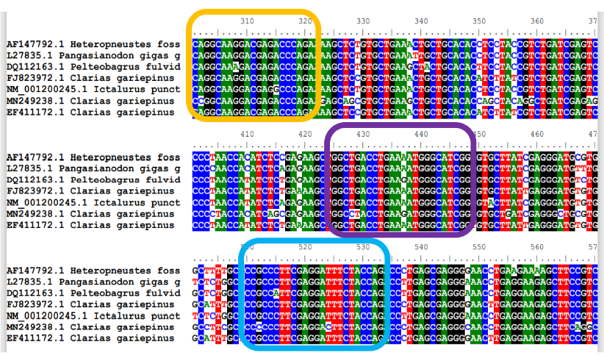
Figure 1. Alignment of GH gene of 7 catfish species (Ordo Siluriformes) from the NCBI gene bank data. Note: Yellow box = sequence area for primer forward (F1); Blue box = sequence area for primer reverse 1 (R1); Purple square = sequence area for primer reverse 2 (R2)

Table 1. Primer sequence, length, GC content, TM, and size target of GH Catfish (GHC) for Tiger shovelnose catfish
No. | GH Primer | Sequence (5’-3’) | Length | GC (%) | TM (°C) | Size (bp)
1 | F1 | CAG GCA AGG ACG AGA CCC AGA | 21 | 61,9 | 61,2 | 234
1 | R1 | CTG GTA GAA ATC CTC GAA GGG CGG | 24 | 58,33 | 61,1 | 234
2 | F1 | CAG GCA AGG ACG AGA CCC AGA | 21 | 61,9 | 61,2 | 148
2 | R2 | CCG ATG CCC ATT TTC AGG TCA GCC | 24 | 58,33 | 62, 5 | 148
Note: TM = Temperature Melting
The GH gene was detected using the DreamTaq Master Green PCR Master Mix (2x) Kit (Thermo Scientific). Reaction composition consists of 12.5 μL master mix, 1 μL primer GH F, 1 μL primer GH Reach with a concentration of 10 ρmol, 1 μL cDNA, and nuclease-free water up to a volume of 25 μL. The conditions of PCR amplification include consisting of initial denaturation temperature of 94 °C for 3 min, denaturation temperature of 94 °C for 20 sec, the annealing temperature of 61 °C for 30 sec, and extension temperature of 72 °C for 30 sec. This cycle was repeated 40 times and was terminated with a final extension of 72 °C for 7 min and the final conditioning at 4 °C. PCR samples can be stored in a refrigerator or directly electrophoresed on the agarose gel.
Electrophoresis and Visualization
The PCR results were then electrophoresed using horizontal electrophoresis (Biorad). Electrophoresis was carried out on 1.5 % agarose gel with 1× TBE then immersed in 0.5× TBE solution. PCR product was inserted 2 μL of into the electrophoresis well, parallel to the DNA leader 100 bp plus (Vivantis) as a marker. Electrophoresis was run at 100 volts for 30 min. Electrophoresis results were visualized and documented on a Gel Doc UV transilluminator (Simple Protein). The amplification results of the β-actin gene were used as an internal control to confirm the success of mRNA isolation.
Cloning and Sequencing
The results of GH gene amplification showing a single fragment were then cloned in the PT. Genetika Science, Indonesia, and sequencing at the 1st Base Laboratory, Malaysia. The PCR product was cloned with stages including purification, ligation, transformation, and colony PCR using pTA2 vector (Toyobo) a pair of primers, namely T3 Primer: 5'- ATTAACCCTCACTAAAG – 3' and T7 Promoter Primer: 5'-TAATACGACTCACTATAGGG – 3'. The results of GH gene amplification showing a single fragment were then cloned at the PT. PCR colony program: initial denaturation of 95 °C for 5 min, denaturation temperature of 94 °C for 15 sec, the annealing temperature of 45 °C for 30 sec, and extension temperature of 72 °C for 45 sec. This cycle was repeated 35 times, and final conditioning was at 4 °C. The DNA sequencing process was conducted using the Sanger sequencing method.
Data analysis
The analyzed data are descriptive. The chromatogram image was generated using the Finch TV software. Sequencing results were analyzed using BioEdit software, MEGA X, to produce a phylogenetic tree and amino acid reduction. The amino acid composition was tabulated. BLASTN software was applied to check the similarity of the GH gene with the closer species.

RESULTS AND DISCUSSION

The Tiger shovelnose catfish was 602 g of body weight, 43 cm of Total Body Length, and 4.6 mg of pituitary gland weight. The concentration of the total RNA from the pituitary gland was 227 ng/µL with a purity of A260/A280 was 1.821. The visualization of the total RNA electrophoresis results is shown in Fig 2a. The amplification results using β-actin primer as an internal control are shown in Figure 2b. The amplification results show a fragment in the pituitary sample parallel to the positive control of the β-actin gene, which was at a size of 300 bp. The amplification of cDNA from tiger shovelnose catfish samples using β-actin primers indicates that the gene was successfully isolated from the pituitary gland and producing a single band. This is in line with Dewi et al. (2009), using the β-actin gene as an internal control to confirm GH gene isolation in catfish (P. hypophthalmus).
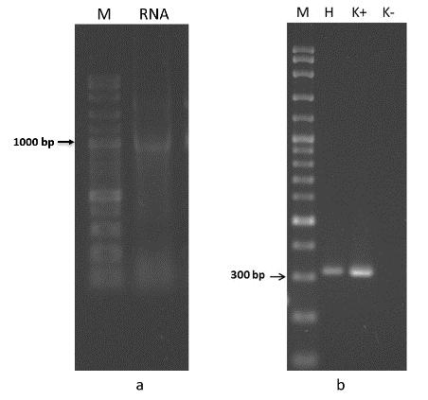
Figure 2. Result of (a)Total RNA electrophoresis, and (b) amplification β-actin gene from pituitary by Tiger shovelnose catfish. Note: M= Marker (100 bp plus DNA Ladder), RNA = Total RNA, H = Pituitary by Tiger shovelnose catfish, K (+) = Positive control, K (-) = negative control.
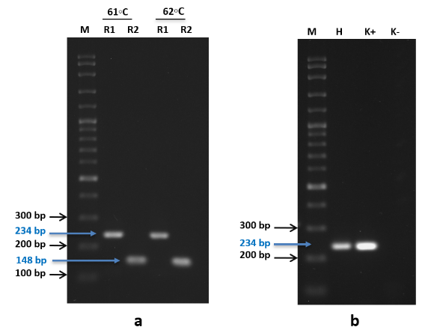
Figure 3. a) The results of optimization GH degenerate primers, b) amplification growth hormone (GH) from Tiger shovelnose catfish using degenerate primers. Note: M = Marker (100 bp plus DNA Ladder); (a) R1= Primer design with pair forward 1 and reverse 1; R2= Primer design with forward 1 and reverse two pairs. Samples used are from the pituitary organ. (b) H = Pituitary by Tiger shovelnose catfish, K (+) = Positive control, K (-) = negative control.
The success of GH gene isolation was strengthened by the amplification results using two types of GH degenerate primers, namely with a size of 234 bp at annealing temperature of 61°C and at 148 bp with an annealing temperature of 62°C. Both pairs of GH degenerate primers could produce a clear single band. The amplification results in the optimization of GH primers are shown in Figure. 3a. The F1 and R1 primer pairs produced the appropriate target gene at 234 bp. The bands that appeared were seen at 61 °C and 62 °C, but the thickest bands that occurred were at 61 °C. The F1 and R2 primer pairs produced the appropriate target gene at 148 bp. The resulting band was at both temperatures of 61 °C and 62 °C, but the thickest appearance was at 62 °C. The results of the annealing temperature were determined from the thickness and consistency of the band. The primer with a target of 234 bp had an annealing temperature of 61 °C, while the target of 148 bp had an annealing temperature of 62 °C. Primer pairs F1 and R1 are primers with clearer results and have better consistency than pairs F1 and R2. Therefore, we determined the primer pair used for sequencing is F1 and R1, whose final product of the primer pair for sequencing is 234 bp. Primers with a target of 148 bp are suggested as GH detection primers for gene expression using the Real-Time PCR technique because they have targets with lower molecular weights.
The GH gene in Siberian Sturgeon (Acipenser bareii) was analyzed for gene expression using real-time PCR using primers with a target gene of 159 bp (Abdolahnejad et al., 2015). Target genes used for semi-quantitative detection of GH genes can use higher molecular weights. Detection of GH genes in gurami (Og-mGH), carp (Cc-mGH), and giant grouper (El-mGH) resulted in PCR products of target genes was 576 bp, 579 bp, and 576 bp, respectively (Alimuddin et al., 2010). In the results of the PCR product with a lower size of 148 bp, it is more appropriate to use as a marker using the real-time PCR method. The PCR product with a size of 234 bp is a GH gene partially isolated from tiger shovelnose catfish. It also shows GH gene expression in tiger shovelnose catfish.
Figure 3b. shows the growth hormone (GH) gene of Tiger shovelnose catfish pituitary. The GH gene band was at 234 bp, which was in line with the positive control. This shows that the GH gene was isolated using degenerate primers, which have been designed from several fish belonging to the same order as Tiger shovelnose catfish. The PCR product shows a single and clear band. According to Slater et al. (1986), the fragments carried the important information not only for coding certain structural domains in hormones but also for controlling gene expression.
Figure 4. shows the chromatograms generated from the sequencing performed on the GH gene of the Tiger shovelnose catfish. The total length of the resulting sequence is 393 bp. The result GH target gene sequence of 234 bp was a blocked image. The resulting chromatogram shows a good quality because it has a high and single curve shape. However, one overlap occurs in area 244, namely between bases T and G, which was read as T. The Open Reading Frame of the GH gene sequence is shown in Figure 5. The initial sequence in the ORF shows the target GH gene starting with the R1 primer sequence consisting of 24 bases. The sequences were also translated into amino acids to produce 78 amino acid codes. Three of which are TGA sequences, stop codons (end) that are not translated into amino acids. The characteristics of the GH gene from various species have different amino acid compositions produced. The growth hormone species Pangasius hypophthalamus has about 200 amino acids with 20 types contained therein (Dewi et al., 2009).
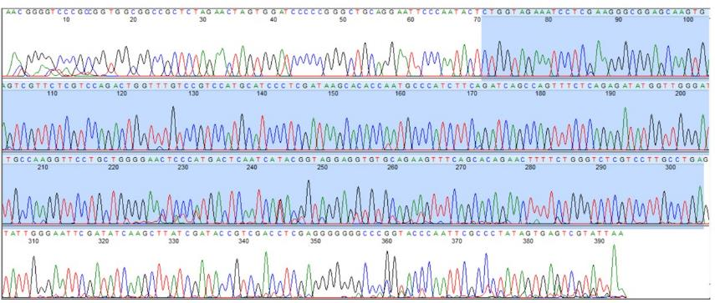
Figure 4. Chromatogram of GH gene sequencing of Tiger shovelnose catfish (Pseudoplatystoma fasciatum Linnaeus, 1766).
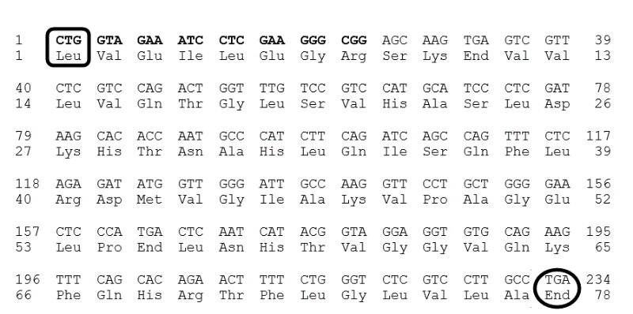
Figure 5. Open Reading Frame (ORF) sequence and amino acid of a GH gene encoding isolated from Tiger shovelnose catfish. (Note: Bold: R1 primer sequence, box = start codon, circle = stop codon, A= adenine, G= guanine, T= thymine, C= cytosine).
However, the GH gene that was partially isolated in Tiger Shovelnose Catfish produced only 75 amino acids (Figure 5.), consisting of 17 types of amino acids in it (Figure 6). Although 234 nucleotides were initially supposed to be translated into 78 amino acids, three of them could not be translated into amino acids because they were TAG sequences. The TAG sequence was a stop codon (end), so it was not translated into amino acids but served as a signal sequence for the last translational activity (Dewi et al., 2009). GH genes between fish species have different lengths. The length of the GH gene in Pangasionodon gigas was 1.176 bp (Lemaire et al., 1994); while in Pangasionodon hypophthalmus, it was 1.151 bp (Dewi et al., 2009). The GH gene in yellow catfish (Pelteobagrus fulvidraco) has 615 bp ORF translated into a polypeptide amino acid code to 204 (Tang et al., 2021). Tiger shovelnose catfish GH gene has 17 types of amino acids in it. GH grouper duck (Cromileptes altivelis) has 618 bp of GH gene sequence translated into amino acids into 205 amino acid codes consisting of 20 types of amino acids (Syarifudin et al., 2007). The composition of amino acids in Tiger shovelnose catfish was than giant grouper and striped catfish with 20 types of amino acids (Dewi et al., 2009; Syarifudin et al., 2007).
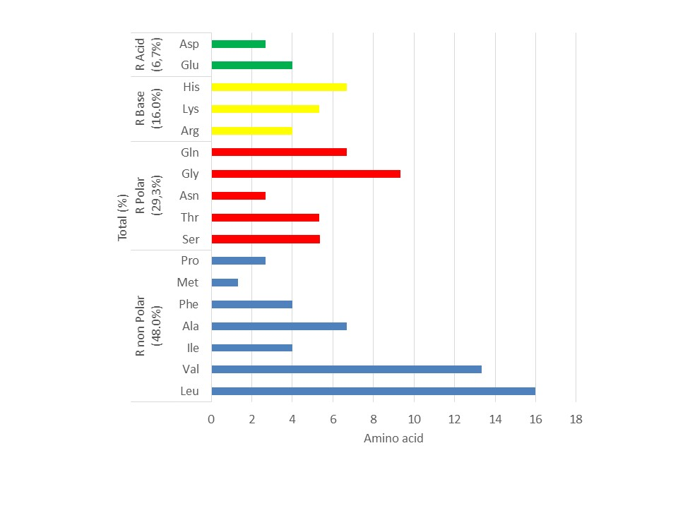
Figure 6. Amino acid composition of GH gene from Tiger shovelnose catfish and its division by amino acid group (R Non-Polar, R Polar, R Base, and R Acid).
Note: Leu= Leucine, Val = Valine, Ile= Isoleucine, Ala= Alanine, Phe= Phenylalanine, Met= Methionine, Pro= Proline, Ser=Serine, Thr= Threonine, Asn=Asparagine, Gly= Glycine, Gln= Glutamine, Arg= Arginine, Lys=Lysine, His= Histidine, Glu=Glutamate, Asp=Aspartate
Figure 6 shows the percentage composition of the amino acids without the TAG sequence. The amino acid composition of GH Tiger shovelnose catfish was divided into four category amino acids based on the R group. The first group, i.e., non-polar R, consists of Leucine (16.0 %), Valine (13.3 %), Isoleucine (4.0 %), Alanine (6.6 %), Phenylalanine (4.0 %), Methionine (1.3 %), Proline (2.6 %), so that a total of 48.0 % of amino acids are in this group. The second group is R polar, which consists of Serine (5.3 %), Threonine (5.3 %), Asparagine (2.6 %), Glycine (9.3 %), and Glutamine (6.6 %); with a total of 29.3 %. The third group, R Base, consists of Arginine (4.0 %), Lysine (5.3 %), and Histidine (6.6 %), making a total of 16.0 %. The fourth group is R Acid with a total of 6,6 %, consisting of glutamic acid (4.0 %) and aspartic acid (2.6 %). The amino acid composition of catfish was more complete than Tiger shovelnose catfish because it has 20 types of amino acids. The difference lies in Tryptophan, Cysteine, and Tyrosine types, although the percentage of occurrence is small, ranging from 0.5 - 4.0 % (Dewi et al., 2009). Sequences that do not code for amino acids are called untranslated regions (Nugroho et al., 2016). Each amino acid has a different R group or side chain; depending on the size, shape, charge, hydrogen-binding capacity, and chemical reactivity (Hanum, 2017).
The composition of amino acids in the GH gene of each species was different. In grouper, there were 20 types of amino acids of GH gene. The non-polar R group had 40.5 % (Syarifudin et al., 2007). The highest group was the GH of Tiger shovelnose catfish. Percentage of amino acid composition in grouper, based on other R groups, was polar R group consisting of seven types of amino acids (36.1 %), basic R composed of three types of amino acids (12.2 %), and acidic R of two types of amino acids (10.7 %) (Syarifudin et al., 2007). The pattern of amino acid composition based on the R group has similarities between grouper and Tiger shovelnose catfish, but the types and percentages are different.
The amino acid with the highest percentage is leucine, both in catfish (14.0 %) (Dewi et al., 2009), giant grouper (14.6 %) (Syarifudin et al., 2007), and Tiger shovelnose catfish (16.0 %). The lowest composition of striped catfish and giant grouper has the same amino acid, namely in tryptophan 0.5 % and 0.49 %, respectively, while the lowest GH in Tiger shovelnose catfish was methionine (1.3 %). The amino acid composition of tiger shovelnose catfish is not as complete as that of striped catfish and giant grouper because it does not contain cysteine and tyrosine in R non-polar groups. Cysteine ​​is an amino acid residue conserved in grouper GH (Dewi et al., 2009; Syarifudin et al., 2007). It is necessary to know the composition of amino acids in the GH gene because this can be used as a reference in the preparation of feed formulations in tiger shovelnose catfish aquaculture. According to Dewi et al. (2009), fish cannot synthesize essential amino acids, so their needs must be supported by protein in feed containing essential amino acids. Under normal physiological conditions, GH is secreted by the pituitary, thereby triggering the production of IGF-1 in the liver and other tissues. It can promote growth and especially metabolism by stimulating IGF-1 receptors (Chan et al., 2021; Wood et al., 2005).
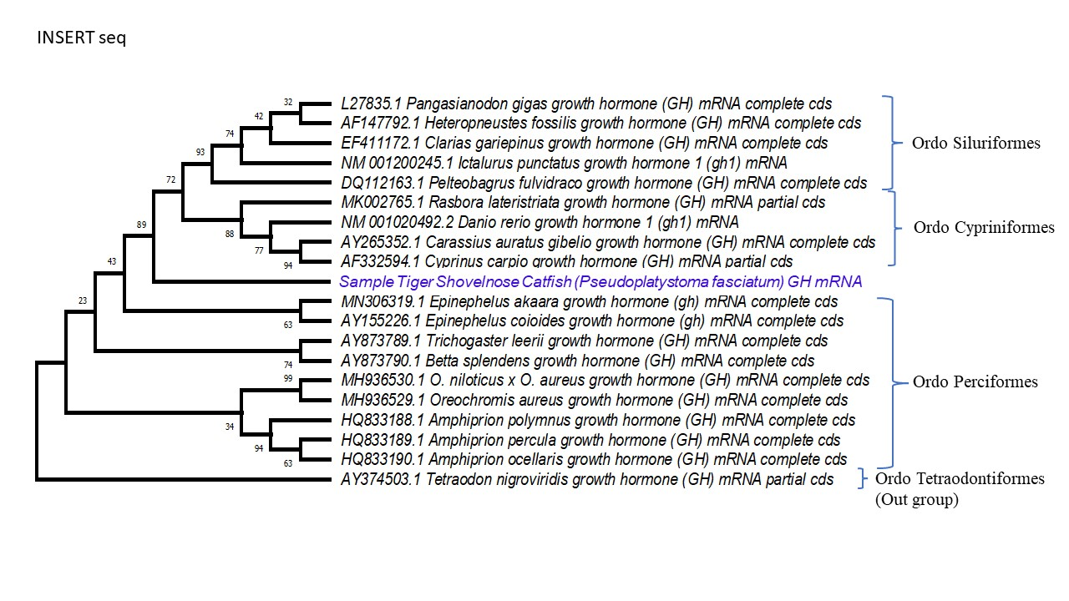
Figure 7. Phylogenetic relationship between Tiger shovelnose catfish GH and all species in one order or outgroup using the Neighbor-Joining method, the number shows the bootstrap value.
The phylogenetic relationship between the evolutionary history of the GH gene was analyzed using the Neighbor-Joining method. This analysis involved 20 nucleotide sequences representing the GH gene in 20 species consisting of 4 orders, namely Siluriformes, Cypriniformes, Perciformes, and Tetraodontiformes as outgroups. The percentage of replicate trees in which related taxa clustered together in the bootstrap test (500 replicates) is shown next to the branch. The evolutionary distance was calculated using Kimura’s 2-parameter method and in base substitutions per location units.
Phylogenetic analysis is to compare the GH gene of Tiger shovelnose catfish with several fish species from several order groups, with the furthest order being GH from the Order Tetraodontiformes as the outgroup. The analysis results show that the GH gene in Tiger shovelnose catfish was between two clades of orders, namely Siluriformes and Cypriniformes. The closest relationship between the two clades of the order was with Siluriformes, a type of catfish. The Tiger shovelnose catfish is still a catfish of the order Siluriformes. The link between the GH gene of the Tiger shovelnose catfish and the GH gene of other Siluriformes was not seen in the same clade but separated by the presence of a clade from the order Cypriniformes. The relationship between the Tiger shovelnose catfish GH gene and the order Perciformes was further seen because it does not belong to the same clade. This can be observed more deeply by looking at the nucleotide sequence alignment of several species of GH genes in the order Siluriformes with the GH of Tiger shovelnose catfish (named psGH) (Figure 8).

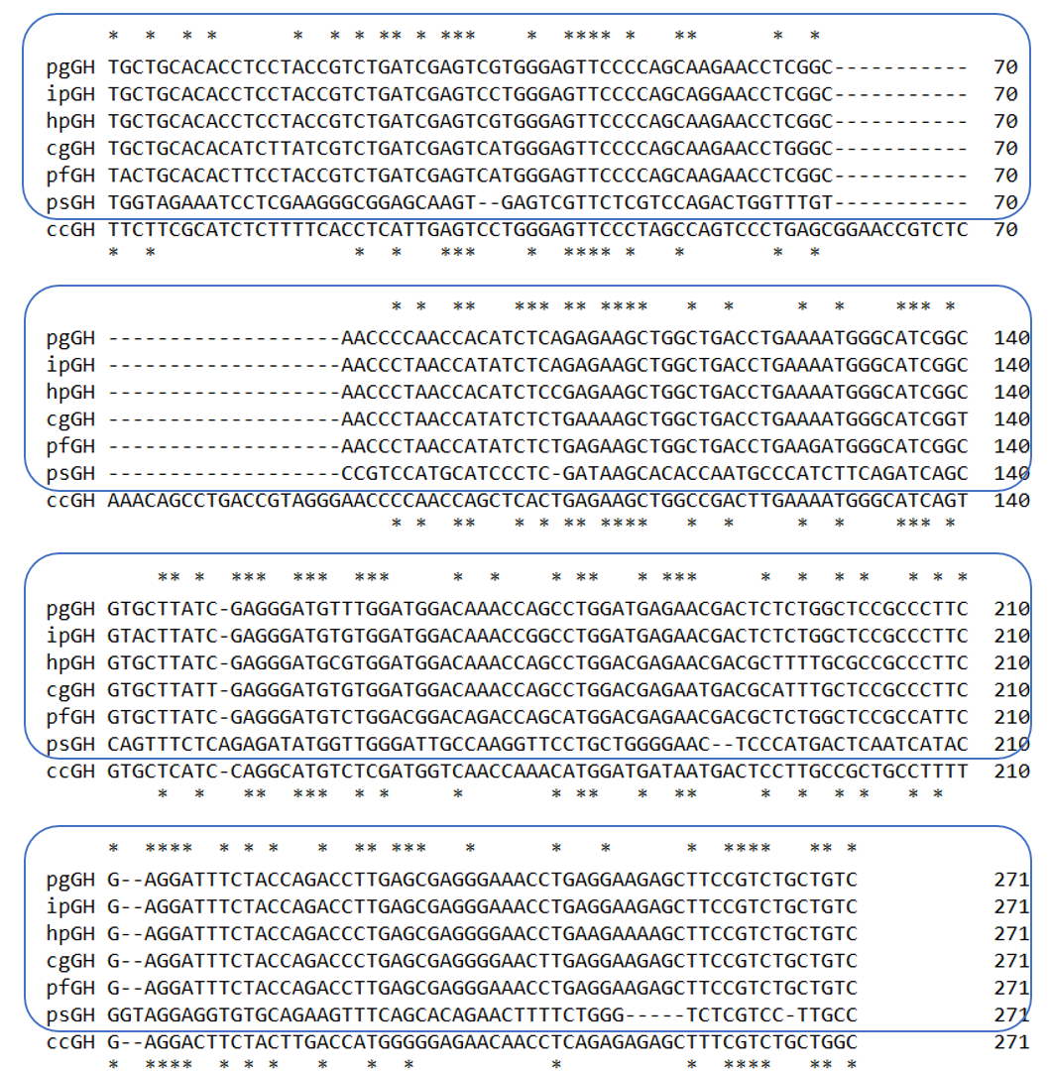
Figure 8. Alignment of the GH gene sequences of 5 catfish species with the GH of the Tiger shovelnose catfish (psGH) in the Order Siluriformes, and the GH gene (ccGH) of the Cyprinus carpio species (out group representing the order Cypriniformes).
Note: The sign (*) above is the similarity of five species of catfish to the psGH gene; The sign (*) below represents the similarity of 5 species of catfish plus ccGH to the psGH gene. (pgGH = Pangasianodon gigas GH, ipGH = Ictalurus punctatus GH, hpGH = Heteropneustes fossilis GH, cgGH = Clarias gariepinus GH, pfGH = Pelteobagrus fulvidraco GH, psGH = (Pseudoplatystoma fasciatum Linnaeus, 1766) GH, and ccGH = Cyprinus carpinus).
Sequence alignment results from 6 species of the order Siluriformes, including Tiger shovelnose catfish, 241 bp and 98 bp have similar sequences. The alignment was also compared with the GH gene from the carp (Cyprinus carpio) with the code ccGH, compared to the order Cypriniformes. After adding the ccGH gene (the GH Cyprinus carpio gene), there were 271 bp alignments with 78 nucleotide sequences similar. This indicates that between GH genes in both orders, the psGH gene is more closely related to the clade in the Siluriformes group with a nucleotide similarity of 40.6 %. On the contrary, with the order Cypriniformes, the nucleotide similarity was 28.7 %. The psGH gene does have a low resemblance to other GH genes, especially goldfish, which have different orders so that the phylogeny tree does not belong to the clade Siluriformes. This is due to divergent growth hormone genes, which is explained by the high conservation and, accordingly, weak phylogenetic signal and low resolution between closely related species (Kamenskaya & Brykov, 2020).
BLAST analysis was performed to determine the similarity of the sequences obtained with the GH gene data in the Gene Bank. Based on the results of the BLAST analysis on NCBI, homology was between the GH gene of Tiger shovelnose catfish and the GH gene in several fish species that were still in the same order (Table 2.). The homology level was ranged from 89.3 % to 90.6 %. The highest similarity of the GH gene of the Tiger shovelnose catfish was with the catfish species Pangasianodon hypophthalmus and catfish (Clarias batracus).
Table 2. Percentage of homology of Tiger shovelnose catfish against several species that are still in the same order.
Name of species | Gen GH | Accession number | Query cover (%) | Homology (%)
Pangasianodon gigas | mRNA | L27835.1 | 55 | 90.17
Ictalurus puntatus | mRNA | NM_001200245.1 | 55 | 89.74
Clarias gariepinus | mRNA | FJ823972.1 | 55 | 89.32
Pangasianodon hypophthalmus | mRNA | XM_026942413.2 | 55 | 90.60
Clarias batracus | mRNA | AF416485.1 | 55 | 90.60

Homology analysis in rainbow trout of the gh1 and gh2 genes had 78.6 % and 89.2 % homology at 3′ and 5′ UTR, respectively, compared to 96.8 % homology in the coding region (Chen et al., 1989). The two genes’ non-coding regions were significantly different, which can be explained by the lack of gene conversion between the two genes. In many cases, identical proteins were also coded by GH gene (Kamenskaya & Brykov, 2020).

CONCLUSION
The growth hormone gene in Tiger shovelnose catfish (Pseudoplatystoma fasciatum Linnaeus, 1766). was isolated from the pituitary gland mRNA with a molecular weight of 234 bp. The GH gene of Tiger shovelnose catfish has 234 nucleotides and contains 17 types of amino acids. The GH gene of Tiger shovelnose catfish was closely related to the striped catfish (Pangasianodon hypophthalmus) and African catfish (Clarias batracus) with a homology value of 90.6 %. The GH gene has been submitted in the gene bank with accession number OL439543.

ACKNOLEDGEMENTS
The authors are grateful to the Test Laboratory of the Research Institute for Ornamental Fish Culture of the Ministry of Marine Affairs and Fisheries, and Fajriyani as a laboratory assistant who was involved in this research.

REFERENCES

Abdolahnejad, Z., Pourkazemi, M., Khoshkholgh, M. R., & Yarmohammadi, M. (2015). Expression of growth hormone gene during early development of Siberian sturgeon (Acipenser baerii). Molecular Biology Research Communications, 4(4), 181–188. https://doi.org/10.22099/mbrc.2015.3166
Alimuddin, Handoyo, B., & Utomo, N. B. P. (2014). Effectiveness of recombinant giant grouper (Epinephelus lanceolatus, Bloch 1790) growth hormone through immersion and oral delivery on growth of eel (Anguilla bicolor bicolor). Jurnal Iktiologi Indonesia, 14(3), 179–189. https://doi.org/https://doi.org/10.32491/jii.v14i3.79
Alimuddin, Lesmana, I., Sudrajat, A. O., Carman, O., & Faizal, I. (2010). Production and Bioactivity Potential of Three Recombinant Growth Hormones of Farmed Fish. Indonesian Aquaculture Journal, 5(1), 11. https://doi.org/10.15578/iaj.5.1.2010.11-17
Alimuddin, Nugrahani, W., Aliah, R. S., & Sumantadinata, K. (2007). Isolation and characterization of B-actin promoter from humpback grouper (Cromileptes altivelis). Jurnal Riset Akuakultur, 2(2), 199–210. https://doi.org/http://dx.doi.org/10.15578/jra.2.2.2007.199-210
Apriliana, R., Basuki, F., & Agung, R. (2017). The effects of Recombinant Growth Hormone (rGH) with different doses for growth and survival of Java Barb Fish (Puntius sp.). Jurnal Sains Akuakultur Tropis, 2(July), 49–58. https://doi.org/https://doi.org/10.14710/sat.v2i1.2561
Britz, P., & Pienaar, A. (1992). Laboratory experiments on the efect of light and cover on the behaviour and growth of African catfish, Clarias gariepinus (Pisces: Clariidae). Journal of Zoology, 227, 43–62. https://doi.org/https://doi.org/10.1111/j.1469-7998.1992.tb04343.x
Buwono, I. D., Carsono, N., & Mulyani, Y. (2012). Isolation and analysis of growth hormone gene African catfish (Clarias gariepinus Burch). Jurnal Riset Akuakultur, 7(3), 371–379. https://doi.org/10.15578/jra.7.3.2012.371-379
Buwono, I. D., & Suparta, M. H. (2009). Isolation of partial fragments of growth hormone of Majalaya carp fish and GIFT nile using CTAB–PCR methods. Jurnal Riset Akuakultur, 4(2), 213–219. https://doi.org/http://dx.doi.org/10.15578/jra.4.2.2009.213-219
Chan, M. T. T., Muttray, A., Sakhrani, D., Woodward, K., Kim, J.-H., Christensen, K. A., Koop, B. F., & Devlin, R. H. (2021). Sexually Dimorphic Growth Stimulation in a Strain of Growth Hormone Transgenic Coho Salmon (Oncorhynchus kisutch). Marine Biotechnology, 23, 140–148. https://doi.org/https://doi.org/10.1007/s10126-020-10012-5
Chen, T. T., Agellon, L. B., Lin, C. M., Tsai, H. J., Zhang, P., González-Villasénor, L. I., & Powers, D. A. (1989). Evolutionary implications of two rainbow trout growth hormone genes. Fish Physiology and Biochemistry, 7(1–6), 381–385. https://doi.org/10.1007/BF00004732
Dewi, R. R. S. P. S., Alimuddin, Sudrajat, A. O., & Sumantadinata, K. (2012). PhGH gene transfer effectivity and expression on stripped catfish (Pangasianodon hypophthalmus). Jurnal Riset Akuakultur, 7(2), 171–180. https://doi.org/10.15578/jra.7.2.2012.171-180
Dewi, R. R. S. P. S., Sudrajat, A. O., Alimuddin, & Sumantadinata, K. (2009). Identification of growth hormone gene of Pangasionodon hypophthalmus. Indonesian Aquaculture Journal, 4(1), 9–17. https://doi.org/10.15578/iaj.4.1.2009.9-17
Faridah, N. (2012). Introduction and expression of growth hormone gene on transgenic common carp. IPB University. Bogor. 58 pp.
Hanum, G. R. (2017). Biokimia Dasar (S. B. Sartika (ed.); 1st ed.). UMSIDA Press. Sidoarjo. 154 pp.
Hayuningtyas, E. P., & Kusrini, E. (2016). Performance of wild betta fish (Betta imbellis) growth treated with recombinant growth hormone (rEIGH) through immersion and natural feed food. Media Akuakultur, 11(13), 87–95. https://doi.org/http://dx.doi.org/10.15578/ma.11.2.2016.87-95
Hseu, J., Huang, W., & Chu, Y. (2007). What causes cannibalization‐associated suffocation in cultured brown‐marbled grouper, Epinephelus fuscoguttatus (Forsskål, 1775)? Aquaculture Research, 38(10), 1056–1060. https://doi.org/10.1111/j.1365-2109.2007.01762.x
Kamenskaya, D. N., & Brykov, V. A. (2020). Fish Growth Hormone Genes: Structure and Divergence. Russian Journal of Marine Biology, 46(4), 233–242. https://doi.org/10.1134/S1063074020040033
Kurdianto, Alimuddin, Faridah, N., Yoshizaki, G., Nuryati, S., & Setiawati, M. (2016). Growth, Survival, and Body Composition of Transgenic Common Carp Cyprinus carpio 3rd Generation Expressing Tilapia Growth Hormone cDNA. HAYATI Journal of Biosciences, 23(3), 150–154. https://doi.org/10.1016/j.hjb.2016.12.002
Kusrini, E., Alimuddin, Junior, M. Z., & Soelistyowati, D. T. (2018). Foreign growth hormone gene transmission and expression in F1 Transgenik Betta fish (Betta imbellis). Pakistan Journal of Biotechnology, 15(1), 1–9. http://www.elsevier.com/locate/scp
Kusrini, E., Priyadi, A., & Prasetio, A. B. (2015). Business challenge tiger Catfish (Pseudoplatystoma fasciatum) through controlled spawning technology. Media Akuakultur Vol., 29(2), 79–83. https://doi.org/http://dx.doi.org/10.15578/ma.10.2.2015.79-83
Lemaire, C., Warit, S., & Panyim, S. (1994). Giant catfish Pangasianodon gigas growth hormone-encoding cDNA: cloning and sequencing by one-sided polymerase chain reaction. Gene, 149(2), 271–276. https://doi.org/10.1016/0378-1119(94)90160-0
Lesmana, I. (2010). Production and bioactivity of growth hormone recombinant protein from three types of cultured fish. IPB University. Bogor. 62 pp. http://repository.ipb.ac.id/handle/123456789/57531
Moriyama, S., Ayson, F. G., & Kawauchi, H. (2000). Growth regulation by insulin-like growth factor-i in fish. Bioscience, Biotechnology and Biochemistry, 64(8), 1553–1562. https://doi.org/10.1271/bbb.64.1553
Nugroho, E., Alimuddin, Kristanto, A. H., & Carman, O. (2016). Cloning of β-actin promoter from giant gouramy (Osphronemus gouramy). Jurnal Riset Akuakultur, 4(1), 23–31. https://doi.org/10.15578/jra.4.1.2009.23-31
Nuñez, J., Dugué, R., Arana, N. C., Duponchelle, F., Renno, J. F., Raynaud, T., Hubert, N., & Legendre, M. (2008). Induced breeding and larval rearing of Surubí, Pseudoplatystoma fasciatum (Linnaeus, 1766), from the Bolivian Amazon. Aquaculture Research, 39(7), 764–776. https://doi.org/10.1111/j.1365-2109.2008.01928.x
Permana, A., Alimuddin, Hadie, W., Priyadi, A., & Ginanjar, R. (2018). The effects of using recombinant growth hormone on the growth of Clown Loach (Chromobotia macracanthus) juveniles with different methods of administration. Jurnal Riset Akuakultur, 13(2), 123–130. https://doi.org/10.15578/jra.13.2.2018.123-130
Pinheiro, J. S., Wolff, J. L. C., Araújo, R. de C., & Hilsdorf, A. W. S. (2008). Molecular cloning and sequence analysis of growth hormone cDNA of Neotropical freshwater fish Pacu (Piaractus mesopotamicus). Genetics and Molecular Biology, 31(1 SUPPL. 1), 381–384. https://doi.org/10.1590/s1415-47572008000200037
Safir, M., Alimuddin, Setiawati, M., Junior, M. Z., & Suprayudi, M. A. (2017). Growth Performance of Nile tilapia Immersed in 17α-methyltestosterone and rElGH, and Fed a Diet Enriched with rElGH. Omni-Akuatika, 13(2), 57–64. https://doi.org/10.20884/1.oa.2017.13.2.288
Sembiring, A. A., Tarsim, & Utomo, D. S. C. (2018). The use of recombinant growth hormone (rGH) in stimulating the growth of Black Ghost fish larvae (Apteronotus albifrons). Jurnal Sains Teknologi Akuakultur, 2(1), 51–56. http://digilib.unila.ac.id/30072/
Setyawan, P. K. F., Rejeki, S., & Nugroho, R. A. (2014). The effect of giving recombinant growth hormone (rGH) through immersion methods with different doses on survival and growth of Larasati tilapia larvae (Oreochromis niloticus). Journal of Aquaculture Management and Technology, 3(2), 69–76. https://ejournal3.undip.ac.id/index.php/jamt/article/view/5061
Slater, E. P., Baxter, J. D., & Eberhardt, N. L. (1986). Evolution of the growth hormone gene family. Integrative and Comparative Biology, 26(4), 939–949. https://doi.org/10.1093/icb/26.4.939
Syarifudin, M., Alimuddin, Widyastuti, U., & Aliah, R. S. (2007). cDNA encoding growth hormone from humpbac grouper (Cromileptes altivelis). Biotropia, 14(2), 1–8. https://doi.org/https://doi.org/10.11598/btb.2007.14.2.14
Tang, X., Ye, X., Wu, Q., Tang, Y., & Zhang, D. (2021). Molecular characterization and expression analysis of a novel C-type lectin ( CTL ) gene in yellow catfish Pelteobagrus fulvidraco. Aquaculture Reports, 20(February), 100640. https://doi.org/10.1016/j.aqrep.2021.100640
Triwinarso, W. H., Basuki, F., & Yuniarti, T. (2014). Effect of Recombinant of Growth Hormone (rGH) through Immersion Method with Different Time on Growth and Survival Catfish Varieties Sangkuriang. Journal of Aquaculture Management and Technology, 3(4), 265–272. http://ejournal-s1.undip.ac.id/index.php/jfpik
Wood, A. W., Duan, C., & Bern, H. A. (2005). Insulin-like growth factor signaling in fish. International Review of Cytology, 243, 215–285. https://doi.org/10.1016/S0074-7696(05)43004-1

