AUTHORSHIP STATEMENT

We hereby submitted a manuscript of a research/study to be published in the Indonesian Aquaculture Journal managed by the Center for Fisheries Research, titled: SPECIES IDENTIFICATION AND GENETIC DIVERSITY OF PORTUGESE OYSTER (Magallana angulata): IMPLICATIONS FOR BREEDING IN VIETNAM. The data we use is the result of our research activities “Study on genetic characterization of oyster populations (Crassostrea angulata) for selection” in the year of 2021-2024.
We declare that the manuscript has not been or is not under assessment to be published in other journals or elsewhere and contains no data fabrication/falsification. We confirm that this manuscript is my/our own work, is not copied from any other person’s work (published or unpublished) and has been thoroughly checked to avoid plagiarism. The co-authors included in the manuscript have been consulted prior to the submission of this manuscript and their approvals have been retained indicated by their signatures below.
We understood and confirm that any violation of the aforementioned codes of conduct including plagiarism can cause severe penalties including the withdrawal of the published article and an automatic two years prohibition to publish in this journal.
This statement is made to be used accordingly.
Date: 21 February 2025
The first author,

Luan Thanh Nguyen

Approved: | Confirmed:
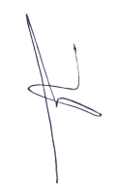  Author 2: Thong Hoang Nguyen | Head of Research Institute for Aquaculture No.2  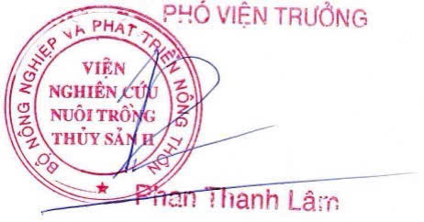
Author 3: Loc Hong Nguyen   | Author 4: Nguyen Hoang Khoi Le  
Author 5: Suong Thao Nguyen   | Author 6: Thanh Minh Nguyen  
Author 7: Tri Nhu Nguyen   | Author 8: Sang Van Nguyen  

