Dear
Editor in Chief
Indonesian Aquaculture Journal

I wish to submit my article for intended publication in Indonesian Aquaculture Journal.
I declare that the work submitted for publication is original, previously unpublished, and not under consideration for publication elsewhere. I also certify that all the authors have approved the paper for release and are in agreement with its content.
Below are the particulars of my paper being submitted to you for publication:
Author’s name : 1. Luan Thanh Nguyen
2. Thong Hoang Nguyen
3. Loc Hong Nguyen
4. Nguyen Hoang Khoi Le
5. Suong Thao Nguyen
6. Thanh Minh Nguyen
7. Tri Nhu Nguyen
8. Sang Van Nguyen
Institution : 1. Research Institute for Aquaculture No. 2, Ho Chi Minh City, Vietnam
2. Nong Lam University, Ho Chi Minh City, Vietnam
3. International University – VNU HCMC, Ho Chi Minh City, Vietnam
Email : 1. nguyenluan0309@gmail.com
2. thongnguyenbio@gmail.com
3. hongloc@gmail.com
4. lhknguyen98@gmail.com
5. suongthaonguyenvn@gmail.com
6. nmthanh@hcmiu.edu.vn
7. nntri@hcmuaf.edu.vn
8. sangnv.ria2@mard.gov.vn
Title : SPECIES IDENTIFICATION AND GENETIC DIVERSITY OF PORTUGESE OYSTER (Crassostrea angulata): IMPLICATIONS FOR BREEDING IN VIETNAM
We have no conflict of interest to disclose and I am willing to be responsible if in the future there are certain parties who feel personally harmed or legal claims for the publication of this article.
Thank you very much for your consideration

Date 18-02-2025
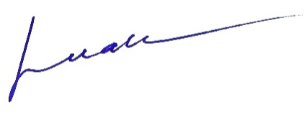
Luan Thanh Nguyen

