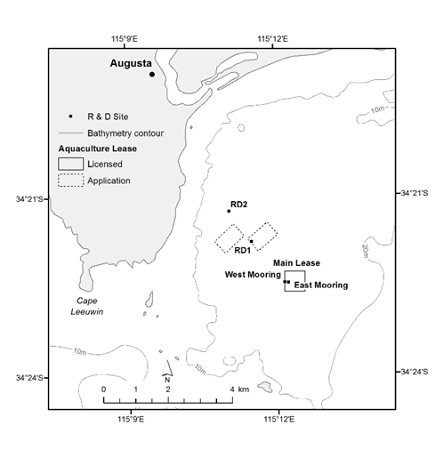

Map showing greenlip abalone (Haliotis laevigata) sampling sites at the Ocean Grown Abalone Pty Ltd sea ranch in Flinders Bay, Augusta

The different amount of circulating haemocyte (5x10⁴) in the haemolymph of greenlip abalone (H. laevigata) after transportation in each sampling site in different sample groups.

The performances of osmoregulatory capacity (osmol/kg) of greenlip abalone (H. laevigata) after transportation in each sampling site in two different sample groups.

