SUPPLEMENTS
RED COVERAGE VARIATIONS ANALYSIS OF CULTURED NEON TETRA (Paracheirodon innesi) IN BOJONGSARI, DEPOK, WEST JAVA FOR BREEDING STRATEGIES
Ruby Vidia Kusumah^{*)#}, Dinar Tri Soelistyowati^{**)#}, Alimuddin Alimuddin^{**)}, and Melta Rini Fahmi^{*)}
^{*)} Research Institute for Ornamental Fish Culture, Ministry of Marine Affairs and Fisheries,
Jl. Perikanan No. 13 Pancoran Mas, Depok City, 16436, West Java, Indonesia,
E-mail: rubyvkusumah@kkp.go.id
^{**)} Department of Aquaculture, Faculty of Fisheries and Marine Sciences, IPB University,
Jl. Agatis IPB Dramaga Campus, Bogor, 16680, West Java, Indonesia,
E-mail: sdinarts@yahoo.com

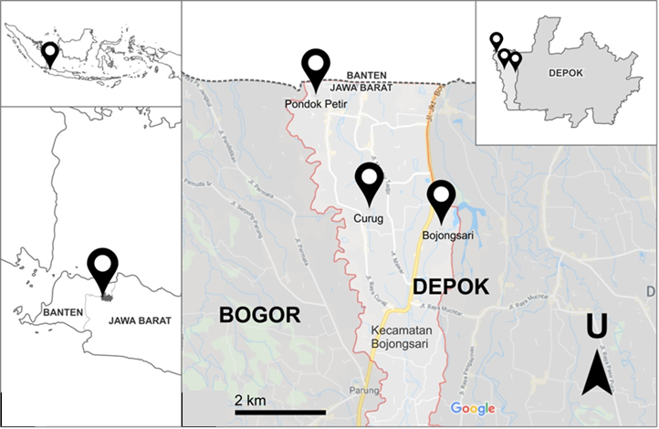
Supplement 1 Sampling location on Center of Neon Tetra Cultured, Bojongsari Subdistrict, Depok City, West Java.
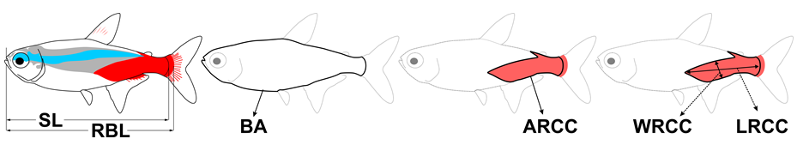
Supplement 2. Size measurement and red color coverage (RCC) quantification. RBL: red border length, SL: standard length, BA: body area, LRCC: RCC length, WRCC: RCC width, ARCC: RCC area
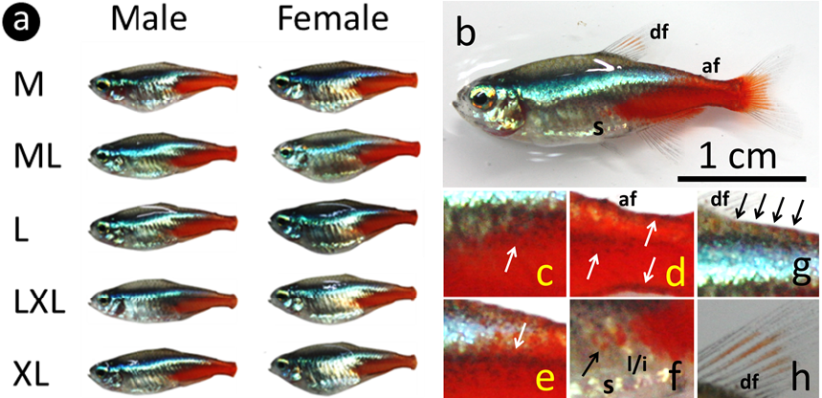
Supplement 3. RCC variation in sex and sizes (a) and RCC position in the body of neon tetra (b-h). (b) RCC position in the whole body, (c-e) erythrophore and melanophore overlapping, (f) erythrophore and leucophore/iridophore overlapping, (g) erythrophore distribution on the edge of dorsal, (h) erythrophore distribution on dorsal fin rays, af: adipose fin, s: stomach, l/i: leucophore/ iridophore, df: dorsal fin, M: 1.9-2.1 cm RBL, ML: 2.2-2.3 cm RBL, L: 2.4-2.5 cm RBL, LXL: 2.6-2.7 cm RBL, XL: >2.7 cm RBL, RBL: red border length
Red color coverage (RCC) of cultured neon tetra is formed by red pigment cells (erythrophore) associated with other color cells. RCC distributed from caudal fin to adipose fin in dorsal, go down to stomach area, anal fin in the abdomen area, and then back to caudal fin (Supplement 3b). Erythrophore overlapping to melanophore in the back of the lateral area (Supplement 3c), in the top, middle, and bottom of caudal peduncle area (Supplement 3d), in the dorsal and the end of the neon strip (Supplement 3e), and then enter the back of the stomach area and partially covered silver-gold of the structural color cell (leucophore/iridophore) (Supplement 3f). Red pigment area is also found in the front edge of an adipose fin in the dorsal area (Supplement 3g) and dorsal fin rays (Supplement 3h). In our research, the RCC character was only the red pigment on the body, not including on the fins (Supplement 3a).

