Dear Prof. Dr. I Nyoman Adiasmara Giri,
Thank you for the opportunity to re-submit our manuscript entitled “RED COVERAGE VARIATIONS ANALYSIS OF CULTURED NEON TETRA (Paracheirodon innesi) IN BOJONGSARI, DEPOK, WEST JAVA FOR BREEDING STRATEGIES”, for your consideration. We appreciate the time and efforts by the editor and reviewers in reviewing this manuscript.
In revising the paper, we have carefully considered your comments, suggestions, and we have tried to do our best to respond to all the points raised. Please contact me if you need any further information.
Yours sincerely,
Ruby Vidia Kusumah
Balai Riset Budidaya Ikan Hias

- Information:
Dinar Tri Soelistyowati email sdinarts@yahoo.com has changed to dinarsoegono@gmail.com
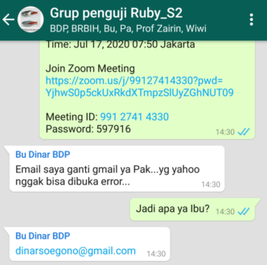
- Q1: Characidae ---Charasid
R1: We thank the reviewer for the suggestion. In many papers, “Characidae” family usually is called “Characid”, such as Mirande et al (2004; 2010); Fagundes et al (2020); Azevedo (2010). “Characid” is common name for “Characidae” family.
- Q2: Figure 1: in order to easy understand the similarity of RCC total among locations, can you change the fig. Similarity you put below the fig and RCC total in left fig. and no need to put four square
R2: We thank the reviewer for the suggestion. We have change the figure.
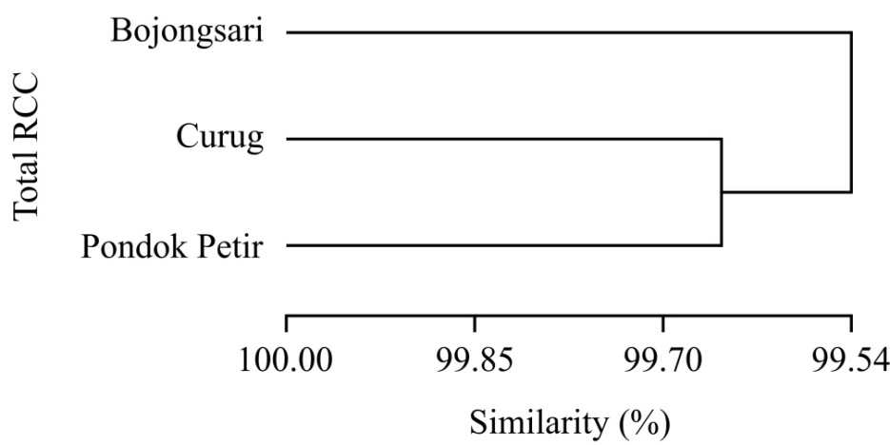
- Q3: Figure 2: please change same as figure 1 and the similarity you put below the fig
R3: We thank the reviewer for the suggestion. We have change the figure.
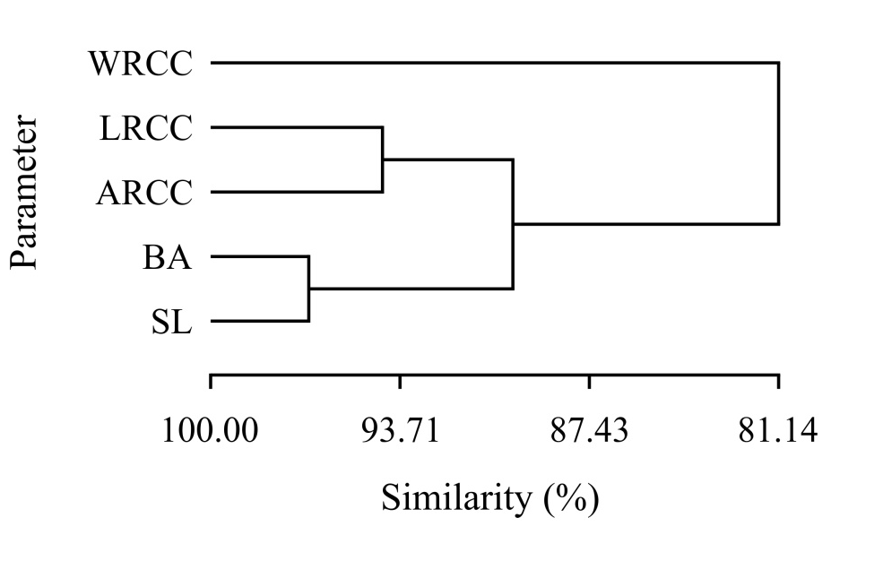
- Q4: Acknowledgments: too long, make it shorter
R4: We thank the reviewer for the suggestion. We have make it shorter.
The authors would like to thank The Research Institute for Ornamental Fish Culture, Depok, for partially funded the research, the National Outstanding Farmers and Fishermen Association (KTNA) chapter Bojongsari Subdistrict, Community Empowerment Organization (LPM) chapter Curug Village, Rodi Fish Farm, Ape Fish Farm, Joy Fish Farm, Riyon Iki, Robi Darwis, Safendi, Irwan Setiawan, Abdan Julian Kusumah, Isa Budi, Tarsiwan, Mrs. Indriyani Kusumah, and all of the genetic group members for their support, permits, material, facilities in conducting the research, data analysis, and improving the English style of the manuscript.

