MAPPING THE POTENTIAL MARINE LIVING RESOURCES IN OUTER ISLAND OF SOUTHWEST MOLUCCAS

Ralph Thomas Mahulette*¹⁾, Duto Nugroho¹⁾, and Andarias Steward Samusamu¹⁾
¹Fisheries Research Center, Jakarta

ABSTRACT
Formation of Southwest Moluccas Regency on the island of Moa, there is great hope for advancing the leading regions in the border similar to other regions in Indonesia. And aim find data and information about Southwest Maluku as potential area with marine resources Several islands in Southwest Moluccas Regency bordering neighboring countries including East Timor Island Luang sub-Distric Mdona Hyera (Sermata island) and Damer island is perfect for capture fisheries, the development of salt commodity, seaweed farming and mariculture. Moluccas fish catches in the southwest is increasing from year to year, but opresional catch fish in the sea is still very traditional. Fleet catches mostly use a rowboat or screen as much as 585, without the use of motor 310 and 184 outboard engines. A larger number of fleets <10 GT as many as 1,079 units. Determination of the number of floating net cages units and the location of aquaculture with the carrying capacity of the existing land area. While the manufacture of salt is done traditionally and not a business that is traded

Keywords: Fisheries; Aquaculture; Southwest Moluccas

INTRODUCTION
Southwest Moluccas Regency is new administrative region expanded from the Southeast Moluccas Regency with capital city located in Tual (Kei Islands). Moa Island is one of sub-Regency of the Southwest Moluccas. The total area of the sub-Regency Moa is about 960 km² with capital city of Tiakur. Southwest Moluccas Regency is geographically located at coordinates between 07⁰06’55”–08⁰28’15”South Latitude and 125⁰ 71’85” – 130⁰ 08’87” East Longitude. The administrative boundaries were: Banda Sea in the Northern part, Tanimbar Island in the Eastern part Alor islands in the Western part and the Timor Sea in the Southern Geographically, the Southwest Moluccas Regency is surrounded by marine and coastal areas with a territorial waters of around 64 thousands km². Several islands in Southwest Moluccas Regency are bordering neighboring countries of East Timor, Luang sub-Distric Mdona Hyera and Damer islands. The major source of livelihood is capture fisheries, in addition table salt, seaweed farming and mariculture are also potential natural resources existing in the area. Salt is a traditional product carried out by fishermen particularly during dry season. These salt products are not for sale, but are used for the family's daily needs. The transitional seasons East to West with the arrival of cold winds from the Australian continent to make District Mdona Hiera very hot, the high temperature occurred almost a full year. From May to October an east monsoon occurs due to the Asian continent, which is experiencing summer, while Australia experiences winter so hot and dry air in Australia is sucked into Asia. At the time the water vapor passes through Indonesia, the water vapor does not fall as rain so that there is a dry season in Indonesia from April to October (Anonim 2014). This type of climate is the benefit to produce traditional salt mainly for domestic consumption. Especially in Luang Island, people use salt traditionally to make salted fish Besides being a center for seaweed production, Luang island known as an area of anchovy production and its already exist since decades. Because it consists of islands that are separated from each other, the natural potential that exists with their temporary workforce. The diversity of marine products owned is then stated in this paper. Some other interesting sea potentials will be presented in addition to showing diversity as a floating net cage business and seaweed cultivation there is also salt activity as a complement to the household that is done traditionally. Compared to limited land resources, marine resources play an important role in the lives of people Southwest Moluccas .

Objective
To find data and information about the life of the people of Southwest Moluccas as a potential area with various marine resources for the welfare of the outer islands.

MATERIALS AND METHODS
The location is Moa Island, Southwest Moluccas Regency, Moluccas Province. Short observation was made by using rapid appraisal during period of 8 - 22 April 2016. Data were collected through interviews or Partisipatory Rural Appraisal (PRA). Participatory . The data needed is based on primary and secondary data in the field. Primary data is the result of interviews with local fishermen. While secondary data is a small part of the Marine and Fisheries Service and the Regency.
This activity begin with conducting a survey to several places, through meetings with local government officials, village Moain. Tiakur as the capital of Southwest Moluccas, Leti islands, village Kaiwatu are the center for Fish Landing Base (FLB) that supervised by Marine and Fisheries office at Regency level. Of all the areas visited by activities that can make money are floating floating nets. For this reason, so that there is a contribution between expenditure and income, the floating net is made as a calculation to be used as a model for other business growth that will stand out.
The following is determination of the number of floating net cage units that can be supported by aquaculture with the carrying capacity of the land obtained, derived from the formula:
$J_{ub}= \frac{D_{dl}}{A_{ub}}$ ………………………………….. (1/Figure 8)
Where:
J_{ub} : the number of fish farming units (unit)
D_{dl} : the carrying capacity of the land (ha)
A_{ub} : broad of fish farming unit (unit/ha).
An area which can be used for fish farming in floating net cages is based on the existing reference (Radiarta et al., 2004). The suggested extents that can also describe the carrying capacity of the land to be considered based on the broad suitable for fish farming in floating net cages. An area which can be used for fish farming in floating net cages based on the existing reference
RESULTS AND DISCUSSION
Results
Geographical characteristics
Southwest Moluccas geographically located in south eastern part of Indonesia with coordinates of 07⁰06’55”–08⁰28’15”South latitude and 125⁰ 71’85” – 130⁰ 08’87” East longitude. There are 8 Regency with 17 villages under manage by Southwest Moluccas Regency with total population of around 72 thousands people (BPS-Southwest Moluccas, 2016). Three major clusters islands were established on its Regency development plan i.e. I : southernmost islands, II : Leti, Moa, Lakor and III : Babar islands the estimate numbers of fishery household in Southwest Moluccas Regency in 2014 was 2.172 household, which numbers of fisherman was 10.004 (BPS-Southwest Moluccas, 2016) (Figure 1). The Mdona Hyera islands is the area has a largest coral reefs.
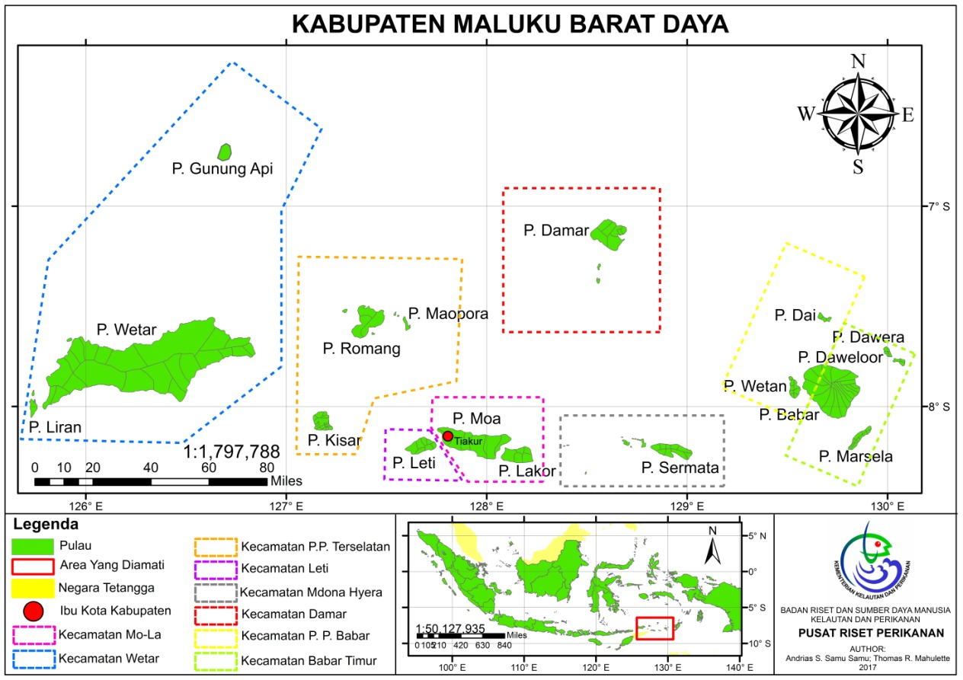
Figure 1. Map of Southwest Moluccas
Source: Kab. Moluccasbaratdaya.blogspot.com

Number of Fishers
Among 17 villages of Southwest Moluccca Regency, the highest fishers population were found in Mdona Hyera at about 2394 fishers, followed by Wetang island (1494) and Babar islands (1488) (Figure 2). The percentage of fishers to population almost 80% were found in Wetang Island then Dawelor-Dawera Island (65%) and Mdona Hyera (45%) (Figure 3). These indicates thet 3 villages has a strong connectivity with fish resources, while other source of livelihood occurs particularly in transport, agriculture and animal husbandry.
Figure 2. Number of fishers by villages in 2014
Figure 3. Percentage of fishers to population by villages in 2014. Source: BPS-Southwest Moluccas (2016)

Table 1. Number of vessel groups Southweast Moluccas
No | Size vessel groups | Number
1.  2.  3.  4.  5. | Without a boat  < 10 Gross Tonagge (GT)  10 – 30 Gross Tonagge (GT)  > 30 Gross Tonagge (GT)  Without Motor | 585  184  3  1  310

Almost throughout the Regency Southweast Moluccas using a fleet of ships, among others: 1.5 GT, GT 3, 5 GT and 10 GT. In Table 1, shows the number of larger fleets yet when compared to < 10 GT which amounted to 1079 units. Ship used a length of 8 m and a width of 1.20 m. These boats equipped with outboard engine Yamaha 15 HP and 40 HP, while the engine yanmar 30 HP and 70-80 HP. Most ships used for 3 GT type "V" (3.V) and "VL". Types of aid ships to the 2016 total of 36 and each group of fishermen got 2 pieces through the Cooperative Joint Venture.
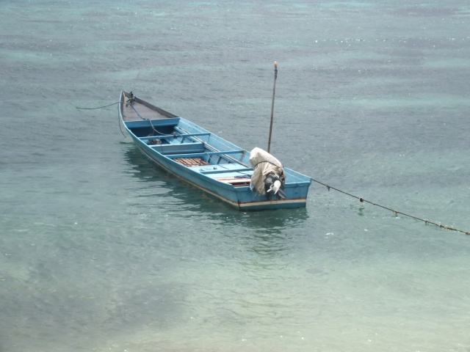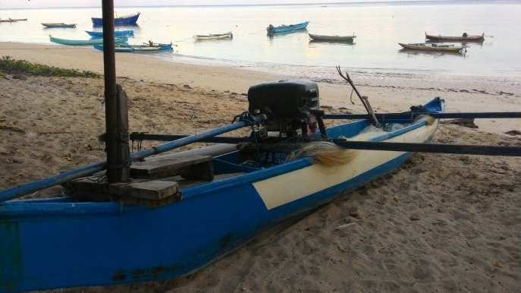
Figure 4. Ship aid for fishermen fishing fishery
Distribution of the number of vessels fishing fisher are in Southwest Moluccas Regency diverse and tailored to their needs. The fact that views other than motor boats government assistance, but most boats without motors. The tendency has a boat without a motor has been used since. To speed up the movement of these boats, sometimes equipped with screens. Almost all of the island there is a boat, and most common in the island of Leti and Mdona Hyera (Figure 5).
Figure 5. Distribution of number of fishing boat by villages
Fishery Resources Southwest Moluccca
Capture fisheries
Capture fisheries in Southwest Moluccas consists of large pelagic fish, small pelagic and demersal. Pelagic fish caught by boat length of 8 m with a width of 1,5 m, using engine 15 HP and equipped with purse seine or bobo nets.
Biological Resource Potential fishery is comprised of the Pelagic, Demersal and other marine life that needs to be exploited optimally. Since five years have done as much as 74.369 tons of fish production. Catching small pelagic and demersal increased in the year 2012 - 2015, while the large pelagic of stagnant. In carrying out the exploration potential is to be supported by various supporting factors such as catches unit (Anonim 2016). Total production of the catches of pelagic fish, small and demersal for 5 years can be seen in Figure 6.

Figure 6. Production Pelagic and Demersal Year 2011 - 2015
Maricultur
Aquaculture applied in Indonesia include mariculture, brackish water aquaculture (fishpond), freshwater aquaculture (pool), public waters, and mina padi. Among the five types of aquaculture, mariculture has the greatest potential of land that is an area of 12,545,072 hectares or 70.70 % of the total potential of aquaculture in Indonesia, but the utilization rate is relatively small, namely 2.60 %. Therefore, chances of mariculture development in Indonesia is still very large. Prospects for the development of mariculture can be developed starting shoreline area less than 4 miles, an area the beach 4-12 mil to the offshore area or off shore over 12 miles. Moreover, extensive national indicative potential mariculture area reached 4.58 million ha and only used less than 2 %. Commodities mariculture has high economic value, where mariculture commodity demand tends to increase from year to year. Going forward, this commodity market opportunity continues to have the greater. Where predictable markets for commodities mariculture is still wide open. To that end, the development of mariculture area is certainly an opportunity that should be utilized optimally (Mustafa et al, 2015).
The depth of the waters and sheltered to an factor criteria
which limits the suitability of land for mariculture in West Southeast Moluccas District. Mariculture for land suitability assessment, the limiting factor is an important variable that should be considered. Important variables that can be categorized as a barrier marine aquaculture, including seaweed farming including field ecosystems seagrass, ship ports, industrial areas and tourism areas (Pérez et al., 2005).
The total area of Southwest Moluccas for cultivation area of 7.044 Ha, while the area used 341 Ha. Than the area used for only about 48 %, still relatively small for the size of the farms are expected. Sometimes plagued with difficult transportation between islands, as a result of fishermen becomes passive with mariculture activities. The dependence of the central and provincial governments, makes worse off (Anonim 2016). The suggested extents that can also describe the carrying capacity of the land to be considered based on the broad suitable for fish farming in floating net cages. The number of farming units, then it can be determined for the location of Southwest Moluccas at the moment is 9.96 Ha. Calculation shows that there are still many other islands that have the potential of promoting the cultivation.

Reef Fish
Reef fish species that could potentially be developed for aquaculture and numerous around Southwest Moluccas is grouper, napoleon, trevallies / cake and baronang. In Figure 7, seen demersal fish most caught by fishermen, namely, grouper, and baronang. Most fishermen cultivate fish baronang, so the results could be spread to areas around to Ambon.

Figure 7. Production of reef fish catches in 2015-2016

The fishing communities have traditionally fishing skill. In addition to the boat 15 GT some are using a paddle boat with bait shrimp. This picture shows perform traditional fishing equipment.
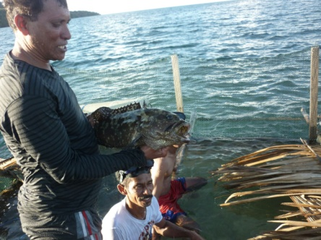
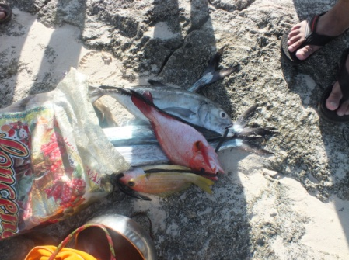

Figure 8. Reef fish fishery product traditional

Until now, mariculture activities have not been able to do the seeding for reef fishes, but fishermen have been trying to create a floating net for enlargement of reef fish such as grouper, snapper and baronang. Feeding with trash fish caught from the sea. The result can be sold to local markets and restaurants.
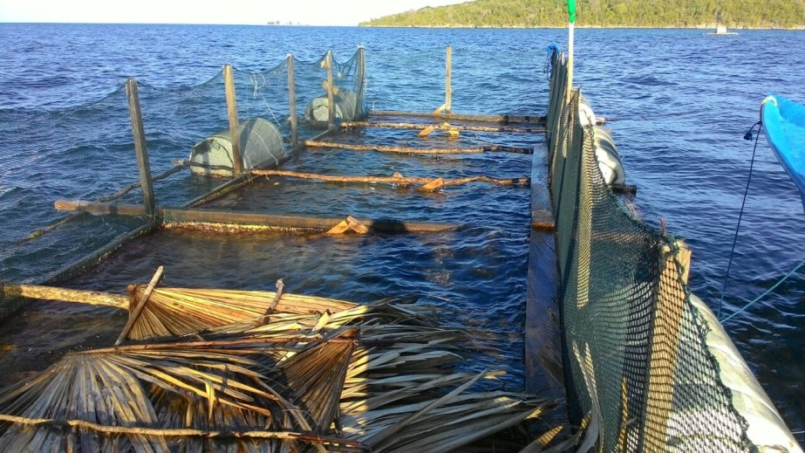
Figure 9. Floating net Cages for Fish Rearing Grouper
Seaweed
Seaweeds are marine algae: saltwater-dwelling, simple organisms that fall into the somewhat outmoded, but still useful, category of "plants". Most of them are the green (more than 1500 species), brown (about 2000 species) or red (over 7000 species) kinds, samples of which are each illustrated on this page, and most are attached by holdfasts, which generally just have an anchorage function, although a particularly efficient one.
Moluccas Sea in general is very good for the cultivation of seaweed species Eucheuma Cotonii and Gracilaria spp. But in Southwest Moluccas were encountered types Euchema Cotonii. Several islands in Southwest Moluccas like Mdona Hyera, Wetar and Masela there bay is a good location and is ideal for the cultivation of seaweed. In oceanography meets the requirements of mariculture for seaweed. This is shown in Table 2, terms or conditions of oceanography.

Table 2. Oceanographic conditions seaweed farming

No. | Factors Oceanography | The Mean Size
1 | Wave heights | < 0.5 M
2 | Current velocity | 40 – 100 m/dt
3 | Temperature | 26 – 30 °C
4 | Depth | > 10 M
5 | Brightness | > 5 M
6 | Salinity | 32 – 34 ppt
7 | pH | 7,3 – 8,3
8 | Nitrat | 0,9 – 3,5
9 | Fosfat | 0,2 – 1
10 | Bottom waters | Muddy and free of debris

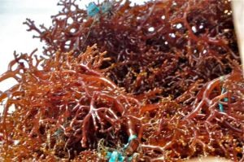
Figure 10. Eucheuma cottonii the largest in Southwest Moluccas

Obstacles faced by fishing communities in Southwest Moluccas as lack of new seaweed seedlings. Result has been an awful lot of seaweed ice-ice disease that makes stem seaweed quickly broken or loose, so the harvest is always not match expectations. Over the last five years (2011 - 2015) data from the islands of the Southwest Moluccas fluctuations. It can be seen from Figure 11.

Figure 11. Seaweed production in 2011 – 2015
Salted Fish
The salted fish marine products are made to avoid fish from decay (rigor mortis) after being caught from the sea. Catches of large pelagic fish, especially small often discarded if excessive. With traditionally processed fish are not discarded again however, be used as anchovies although not as good as the processed factory. This is one way of many ways to preserve marine products quickly decay. If fishermen catch lots of fish are often discarded, it often happens to the fishermen in Southwest Moluccas. There is a tendency that, the fish can not be sold to the capital, because of transportation problems and the weather is changing, as a result of ocean waves. In the traditional way of making salt, with clam peels to accommodate salt water from the sea and allowed to evaporate so that all that remains is the salt.
Hole clams (Tridacna crocea) is types of clam smallest and most abundant populations. This clam is generally live in holes in the reef (hard coral) are still alive or dead. Hole clams into the reef is chemically and mechanically, ie rock drill slowly with the opening and closing movement of the shell. Hole clams color cuff striking and beautiful. The maximum length of clams, reaching only 15 cm. Clams (Tridacnidae) is types of bivalves sized distribution is widely available in the Indo-Pacific coral ecosystems. In eastern Indonesia (Moluccas and Papua), the use of meat and clam adductor muscle quite intensively in the last five years (Arifin dan Setyono 1992).
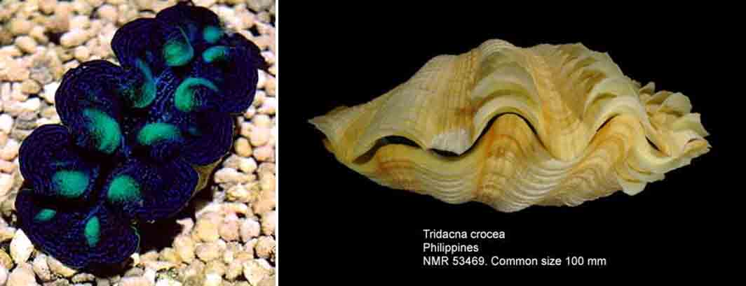
Figure 12. Hole clam Tridacna crocea.
Source: Wikipedia dan http://www.nmrpics.nl/Tridacnidae/

Shells of clams hole shaped flat and thick with 6-10 folds. Shell shape is irregular because should follow the shape of the hole in the reef. Activities memboring, causing a clam derived from nature, generally do not have scales shell intact. Luang island and Damer sub-Distric Mdona Hyera very suitable for the development of commodity salt. Community on the islands since the last decades has been used to make the traditional salt for their own consumption. Communities in the two islands had been taking sea water with a bucket, and then hold them on the skin are large clams and dried under the sun for six to eight months into a salt crystal, and is used for daily consumption. Lodging Luang island, people use salt traditionally made it to make salted fish.
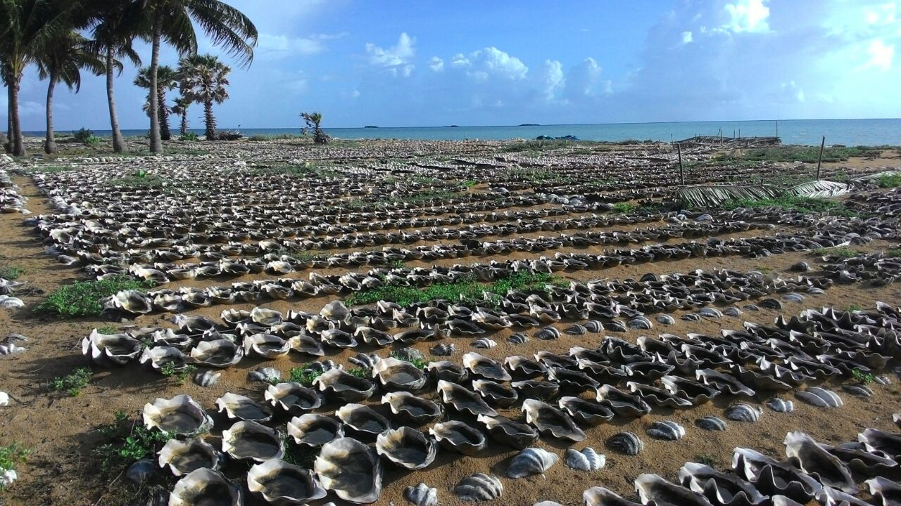
Figure 13. Hole clams (Tridacna crocea) located on the Luang island.

Discussion
Potential fishery resources Southwest Moluccas Regency, very promising so much about the fishery itself. Since the island Moa established by Law No. 31 Year 2008 on the Establishment of Southwest Moluccas Regency on the island of Moa, the capital of Tiakur, then the program direction and marine fisheries become clearer.
Fish Resource Potential
In the Figure 9, it can be seen that the sea is so vast when compared to mainland. This proves that the role of fishing communities in small islands are very influential to the future development of Southwest Moluccas.
According to data of five annual fishing production experienced a significant increase of small pelagic and demersal, while pelagic still largely under production. Since the aid ship from the Maritime and Fisheries Ministry channeled through the Department of Marine and Fisheries there are changes that occur when fishing. The tools used are gill net surface and mid, purse seine and hand line to fish demersal and tool traditional of spears. The fact that small pelagic fish dominate in all areas catching. As a result of overfishing, the fish sometimes discarded because there is no infrastructure for processing. For people in Southwest Moluccas, targeting large pelagic fish catches, while to catch the necessary of special expertise. Southwest Moluccas islands identical to the rocky area and there are many fish demersal or reef fish such as grouper, snapper, baronang and other. The desire to get demersal fish, make all the people to go to sea, and most of the activities to earn a living or as a distraction daily. Compared to catch pelagic fish big and small, for demersal fish did not require special skills, but only boat, bait and fishing rods. Fish obtained also large, there can be up to 15 kg. The range of the catch for small pelagic, demersal large and still be under the threshold. In the future, in order to remain sustainable in the search for alternatives to make floating net. Demersal fish spesies that have been cultivated are fish baronang. Baronang farmed fish for the fishermen became an important icon, so that fishermen can generate income through the aquaculture.
Life of Fisherman
Activity as a fisherman at sea to fill everyday life, either as a main or side business is a routine activity. Some of the circumstances that make Southwest Moluccas barely audible, because it is constrained by several things:
Financial Aid
Finance became the main supporter for the smooth running of a form of fishing, especially in Southwest Moluccas. On the one hand, the original income is very low, given this area the most income from the ocean compared to mainland. On the other hand the distance of fishing using boats, fuel ration / food quite at sea, thus requiring a considerable cost. The cultivation process is carried out is not easy, is associated with very limited funding. Ministry of Maritime Affairs and Fisheries and local government Southwest Moluccas, started holding several meetings and site surveys for manufacturing fishing port Fish decent and hygienic equipped by cooling the surrounding areas and to promote the cultivation of Southwest Moluccas. Preparation substantial funds have been made to assist the fisheries and marine program but there is always the policy process. This is so seafood is not discarded in vain, can be handled and processed again into useful products that generate money for regional development.
Human Resources
Construction of a new area identical to human resources ready with the right mindset and applied technology ready. Fishermen in Southwest Moluccas is not a good sailor to produce fish. Mastery of science and technology or expertise on fisheries is very less. In fact, deep-sea fishing and aquaculture necessary knowledge and skills, so that does not disappoint. Although the funds that many if it can not be processed because of limited human resources in the end, all the help abandoned. Strengthening human resources need to be increased by raising workers / teachers to impart knowledge and training how to capture and cultivate fish is good and right.
Infrastructure and Transport
Moa Island as Southwest Moluccas Regency, of course, still a lot of development should be the priority, in order to complement deficiency. As the center of government, infrastructure and transport needs to be improved both land mainly sea. For fishery there must be ship, the access road to the port, the cooling of buildings, offices and fish processing. Completeness as support such as, electricity, fuel oil and docks. Infrastructure planning program in Southwest Moluccas Regency adapted to the Spatial Plan 2010-2030. Southwest Moluccas Regency, Document Regional Long Term Development Plan 2010-2030, Medium Term Development Plan 2011-2016. Some things are related to infrastructure development program road network, upgrading and infrastructure systems and irrigation water resources and the realization of infrastructure systems, energy and electricity along telecommunications. All of this activity is done for the entire Southwest Moluccas islands (Anonim 2011).
CONCLUSION
The potential of marine resources in Southwest Moluccas, is very promising for the smooth development of the region, but needs to be improved sustainability. the government's contribution to research, skills and infrastructure is a positive thing, as a step to accelerate the development of border areas in Indonesia. Good coordination between central and local governments need to be upgraded Southwest Moluccas. Fishermen are important assets in addition to a fleet of boats, fishing gear in conducting activities to improve and preserve the natural resources of the sea. That's to compensate and expedite the economic, social, cultural and institutional without leaving the local knowledge, the advancement of education and skills need to be promoted, especially in the marine fisheries sector.
ANKNOWLEDGEMENTS
Thank you very much for Development Consultant Southwest Moluccas and SKPDT team of the Ministry of Maritime Affairs and Fisheries and Local Government Southwest Moluccas data and information for Fiscal Year 2016.

REFERENCE
Anonimous. (2016). Aquaculture statistical report. Department of Marine and Fisheries in Tiakur. Local Government Southwest Moluccas Regency.

Anonimous. (2014). MOA in numbers. Central Bureau of Statistics. Southwest Moluccas Regency.

Anonimous.(2014).SosialSciences, http://aldenjonathan.blogspot.com/2014/11/Wind-Muson-influence-against-.html. Nadia Simatupang Posting 2013-08-31st

Anonimous. (2013). Regional Tourism Development Master Plan for Southwest Moluccas Regency.

Anonimous. (2011). Final plans. Regional Medium-Term Development Plan.

Anonimous. (2011). Giant clam shells are increasingly rare. Exposing Sunscreen Natural History Indonesia. Firmament. https://dody94.wordpress.com/ http://en.wikipedia.org/wiki/Tridacna.

Arifin, Z. & Setyono, D.E.D. (1992). Potential oyster and development prospect in the Moluccas, in S. Sunarno, H. Mansyur, Rachmansyah, A. Mustafa A. Hanafi (eds). Scientific Workshop on Moluccas Potential of Fisheries Resources, March 2 to 3 1992. Agency for Agricultural Research and Development, Coastal Aquaculture Research Institute, Maros. pp: 77-86.

Gulland, J.A. (1982). Mannual of methods for stock assessment. FAO Roma.

Mustafa. A., Tarunamulia, Hasnawi, Erna Ratnawati, Nur Anzari Rangka, Rizki Antoni Suhaemi., & Annisya Rosdiana. (2015). Research report development of mariculture zone in west southeast moluccas regency, Moluccas. Research and Development Center for Fisheries Research and Development Agency for Marine and Fisheries Ministry of Maritime Affairs and Fisheries.

Radiarta, N., Saputro, A., & Priono, B. (2004). Mapping the feasibility of land for business development of marine aquaculture in the Bay of Saleh, West Nusa Tenggara. Indonesian Fisheries Research Journal. 9(1), 19-30.

Pérez, O.M., Ross, L.G., Telfer, T.C., & del Campo Barquin, L.M. (2003). Water quality requirements for marine fish cage site selection in Tenerife (Canary Islands): predictive modelling and analysis using GIS. Aquaculture. 224, 51-68.

Subagariang O.P, Fauziyah., & Fitri Agustriani. (2011). Potential analysis of sustainable tuna longline fishery resources in Cilacap Regency, Central Java. Marine Science Program FMIPA. Universitas Sriwijaya, Indralaya, Indonesia.

Sparre, P. S.C. & Venema. (1999). Introductions Tropical Fish Stock Assessment. Book I Manual. Edition (in Indonesia) Jakarta: Fisheries Research Center Fisheries and Development.

