Data sekuens nukleotida yang digunakan dalam uji coba
Isolat | Spesies Ikan | Negara | Acc. Number RNA2
BBN  Nod  TNV  TpKag93  SJNag93  SJNNV  BFNNV  BF93Hok  Ac06NorT  JFIwa98  GUPNNV  GGNNV  RGNNV  SGWak97  GpNNV  LCNNV  RGNNV-China  T442286  TGNNV1208-Tuaran- 1  TGNNV0809-Tuaran-1  SBNNV0607-KK-2  MGNNV0708-Gondol-8  TGNNV0708-Gondol-8  TH07  SBNNV-B4  LB-2007  SG14  MnNNV_12/06 | Black beetle  Nodamura  Turbot (Scophthalmus maximus)  Tiger puffer (Takifugu rubripes)  Stripped jack (Pseudocaranx dentex)  Stripped jack (Pseudocaranx dentex)  Barfin flounder (Verasper moseri)  Barfin flounder (Verasper moseri)  Atlantic cod (Gadus morhua)  Japanese flounder (Paralichthys olivaceus)  Guppy (Poecilia reticulata)  Greasy grouper (Epinephelus tauvina)  Redspotted grouper (E. akaara)  Sevenband grouper (E. septemfasciatus)  Golden pompano  Asian sea bass (Lates calcarifer)  Redspotted grouper (E. akaara)  Asian sea bass (Lates calcarifer)  Tiger grouper (E. fuscogutattus)  Tiger grouper (E. fuscogutattus)  Asian sea bass (Lates calcarifer)  Mouse grouper (Chromileptes altivelis)  Tiger grouper (E. fuscogutattus)  Sea bass (Dicentrarchus labrax)  Asian sea bass (Lates calcarifer)  Tilapia Europe (Oreochromis niloticus)  Sea bass (Dicentrarchus labrax)  Redspotted grouper (E. akaara) | Jepang  Jepang  Norwegia  Jepang  Jepang  Jepang  Jepang  Jepang  Norwegia  Jepang  Singapura  Singapura  Taiwan  Jepang  Malaysia  Malaysia  China  Malaysia  Malaysia  Malaysia  Indonesia  Indonesia  Thailand  Malaysia  Australia  Australia | NC_002037  AF174534  AJ608266  EU236149  AB056572  NC_003449  EU236147  EU826138  EF617329  AM085345  AF499774  AF318942  AY690596  AY324870  GQ904199  GQ120525  EF558369  EF591371  HQ859939  HQ859945  HQ859920  HQ859925  HQ859928  AF175518  FJ617266  EU700416  AF175516  GQ402013

Multiple alignment sekuen nukleotida
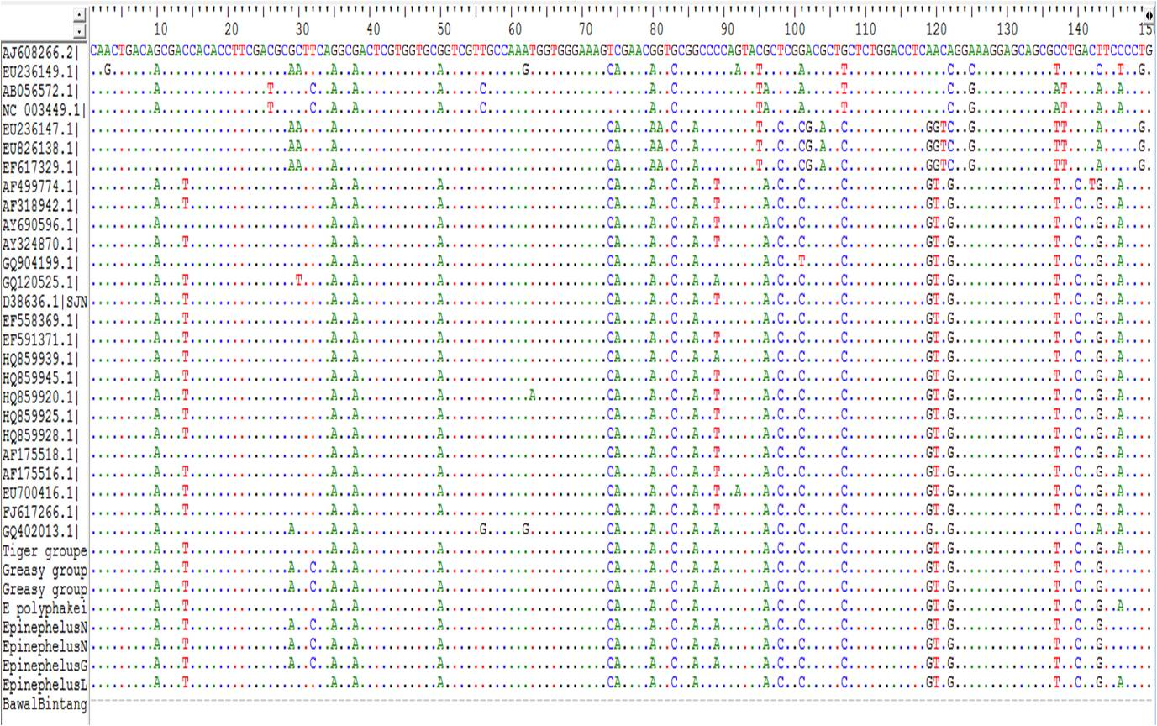
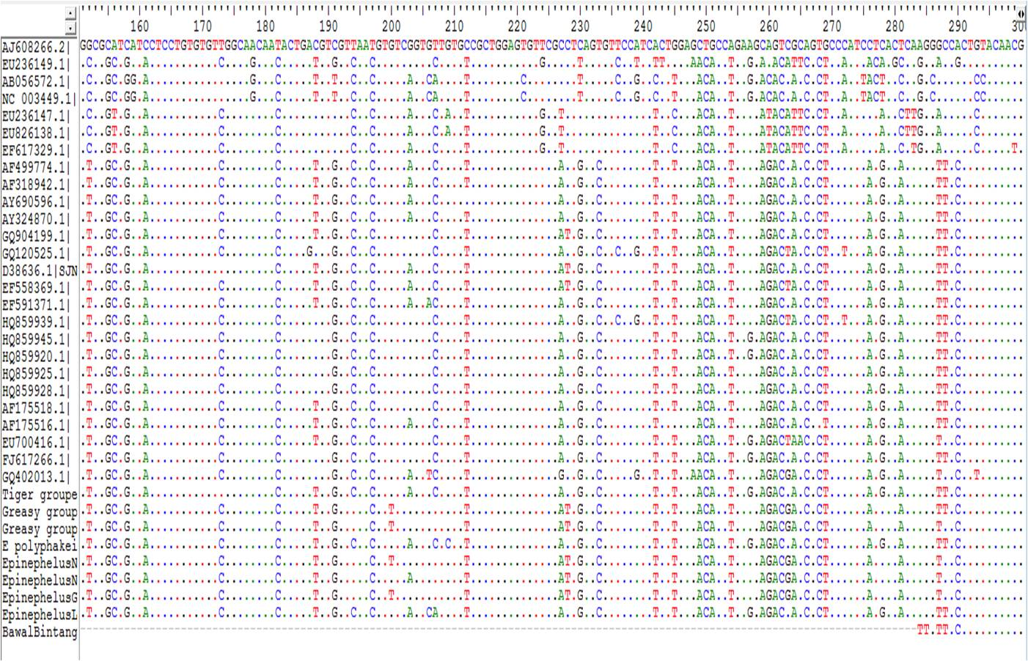

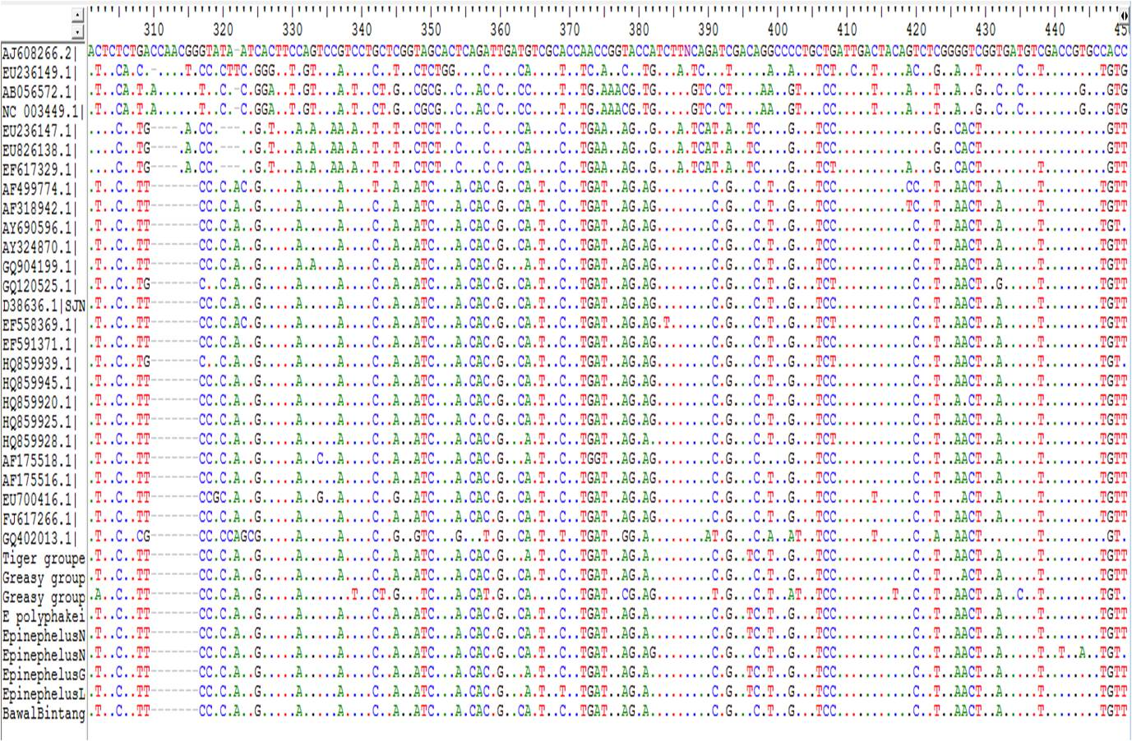
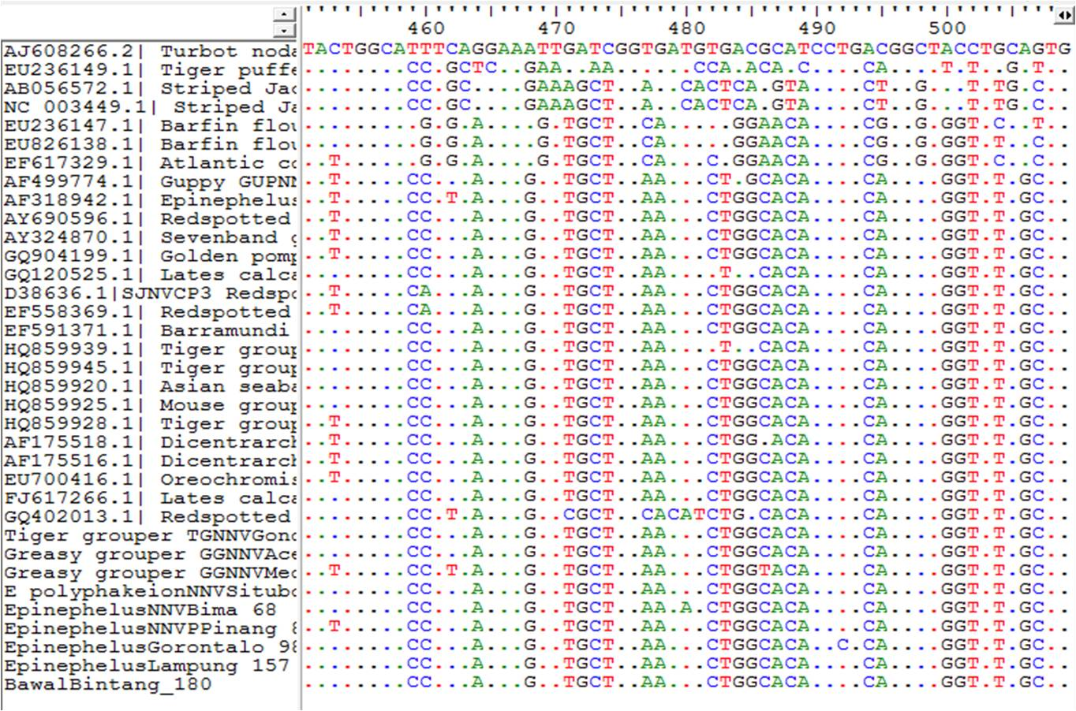

Multiple alingment asam amino
