  - 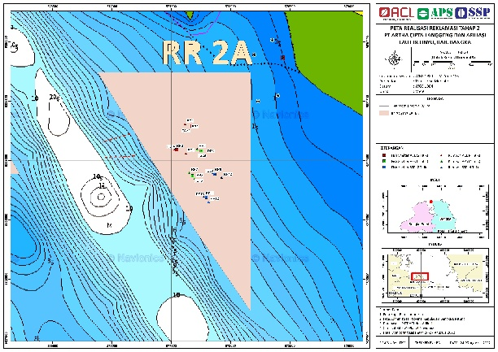
Gambar 1. Lokasi Pengambila data

Tabel 1. Posisi Geografis Lokasi Pengamatan
No | Kode | Koordinat
No | Kode | X | Y
1. | ACL 32 | 0577670 | 9829294
2. | ACL 14 | 0577547 | 9829093
3. | APS 29 | 0577752 | 9829084
4. | APS 15 | 0577680 | 9828867
5. | SSP 30 | 0577892 | 9828878
6. | SSP 16 | 0577796 | 9828686

Tabel 2. Ukuran rancang susun terumbu buatan
Posisi | Panjang (m) | Lebar (m) | Tinggi (m) | Jumlah (Unit) | Luas (m²) | Volume (m³)
Dasar | 2,5 | 2,5 | 0,5 | 25 | 6,25 | 3,125
Tengah | 2,5 | 1,5 | 0,5 | 15 | 3,75 | 1,875
Atas | 2,5 | 1 | 0,5 | 10 | 2,50 | 1,250
Total |  |  |  | 50 |  | 6,250

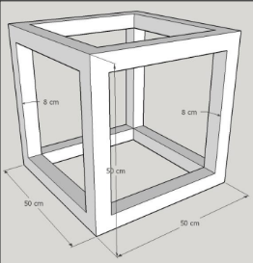
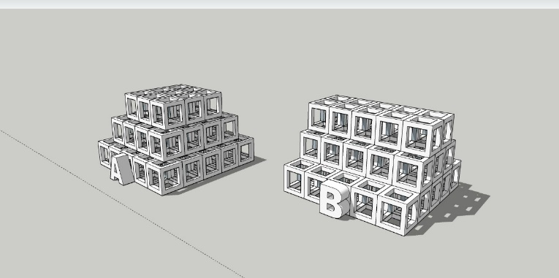
a
b

Sumber : PT. Artha Cipta Langgeng

Gambar 2. Konstruksi terumbu buatan
(a) Bentuk terumbu buatan (b) Penyusunan terumbu buatan

Tabel 4. Kelimpahan Jenis Ikan Pada Lokasi Pengamatan
No | Family | Species | ACL 14 |  | ACL 32 |  | APS 15 |  | APS 29 |  | SSP 16 |  | SSP 30
1 | Lutjanidae | Lutjanus malabricus | 3 | 0 | 8 | 0 | 4 | 0 | 4 | 0 | 6 | 0 | 4 | 0
2 | Lutjanidae | Lutjanus ehrenbergii | 20 | 1 | 60 | 3 | 20 | 1 | 2 | 0 | 12 | 1 | 2 | 0
3 | Lutjanidae | Lutjanus vitta | 70 | 4 | 500 | 27 | 70 | 4 | 80 | 4 | 120 | 6 | 80 | 4
4 | Lutjanidae | Lutjanus gibbus | 0 | 0 | 0 | 0 | 4 | 0 | 5 | 0 | 30 | 2 | 5 | 0
5 | Lutjanidae | Lutjanus fuscescens | 0 | 0 | 0 | 0 | 20 | 1 | 60 | 3 | 80 | 4 | 60 | 3
6 | Lutjanidae | Lutjanus lutjanus | 600 | 32 | 1000 | 53 | 1000 | 53 | 100 | 5 | 200 | 11 | 100 | 5
7 | Lutjanidae | Lutjanus timorensis | 0 | 0 | 0 | 0 | 400 | 21 | 0 | 0 | 0 | 0 | 3 | 0
8 | Lutjanidae | Lutjanus monostigma | 2 | 0 | 10 | 1 | 0 | 0 | 0 | 0 | 0 | 0 | 0 | 0
9 | Lutjanidae | Lutjanus fulvus | 20 | 1 | 120 | 6 | 0 | 0 | 0 | 0 | 0 | 0 | 0 | 0
10 | Apogonidae | Apogon perlitus | 1000 | 53 | 0 | 0 | 0 |  | 600 | 32 | 800 | 43 | 600 | 32
11 | Apogonidae | Apogon sp | 0 | 0 | 0 | 0 | 0 | 0 | 120 | 6 | 80 | 4 | 120 | 6
12 | Tetraodontidae | Arothron stellatus | 1 | 0 | 1 | 0 | 1 | 0 | 1 | 0 | 3 | 0 | 3 | 0
13 | Leiognathanidae | Leiognathus bindus | 300 | 16 | 0 | 0 | 150 | 8 | 200 | 11 | 300 | 16 | 200 | 11
14 | Caesionedae | Caesio cuning | 0 | 0 | 0 | 0 | 0 | 0 | 0 | 0 | 0 | 0 | 30 | 2
15 | Siganidae | Siganus javus | 10 | 1 | 12 | 1 | 0 | 0 | 12 | 1 | 0 | 0 | 12 | 1
16 | Serranidae | Epinephelus bleekeri | 0 | 0 | 2 | 0 | 0 | 0 | 0 | 0 | 0 | 0 | 6 | 0
17 | Serranidae | Epinephelus coioides | 0 | 0 | 0 | 0 | 0 | 0 | 1 | 0 | 0 | 0 | 0 | 0
18 | Serranidae | Epinephilus erythrurus | 1 | 0 | 0 | 0 | 0 | 0 | 0 | 0 | 0 | 0 | 0 | 0
19 | Serranidae | Epinephilus rivulatus | 4 | 0 | 0 | 0 | 0 | 0 | 0 | 0 | 0 | 0 | 0 | 0
20 | Serranidae | Epinephilus sexfasciatus | 2 | 0 | 4 | 0 | 0 | 0 | 0 | 0 | 0 | 0 | 0 | 0
21 | Ephippidae | Platax teira | 0 | 0 | 0 | 0 | 0 | 0 | 1 | 0 | 0 | 0 | 0 | 0
22 | Haemulidae | Diagramma pictum | 0 | 0 | 0 | 0 | 0 | 0 | 1 | 0 | 0 | 0 | 0 | 0
23 | Chaetodontidae | Parachaetodon ocellatus | 0 | 0 | 0 | 0 | 2 | 0 | 0 | 0 | 0 | 0 | 0 | 0

Tabel 5. Struktur Komunitas ikan pada lokasi pengamatan
Variabel | ACL 14 | ACL 32 | APS 15 | APS 29 | SSP 16 | SSP 30
Jumlah total ikan (ekor) | 2033 | 1717 | 1671 | 1187 | 1631 | 1225
Jumlah Spesies (spesies) | 13 | 10 | 10 | 14 | 10 | 14
Jumlah Famili (famili) | 6 | 4 | 5 | 8 | 4 | 7
Kelimpahan (ind/m³) | 325,28 | 274,72 | 267,36 | 189,92 | 260,96 | 196,00
keanekaragaman (H') | 1,27 | 1,09 | 1,15 | 1,54 | 1,55 | 1,65
keseragaman (E) | 0,49 | 0,47 | 0,50 | 0,58 | 0,67 | 0,62
dominansi (D) | 0,35 | 0,43 | 0,43 | 0,31 | 0,30 | 0,29

Gambar 3. Kelimpahan Jenis Ikan pada Terumbu Buatan

Gambar 4. Komposisi Keanekaragaman (H’), Keseragaman (E), dan Dominansi (D) Ikan

Gambar 5. Komposisi Famili Ikan Pada Terumbu Karang Buatan
Tabel 6. Famili terbanyak di terumbu buatan
No | Jumlah spesies | Kelompok | Famili Terbanyak | Peneliti
1 | 59 | MMI | Apogonidae, Pomacentridae, Chaetodontidae | Satria dan Mujiyanto, 2011
2 | 35 | TMT | Acanthuridae, Pomacentridae, Labridae, Nemipteridae | Patty et al., 2015
3 | 72 | MMT | Pomacentridae, Apogonidae, Labridae | Yanuar dan Aunurohim, 2015
4 | 53 | MTT | Pomacentridae, Ephippidae, Nemipteridae | Awuy et al., 2017
5 | 32 | TTT | Lutjanide, Siganidae, Nemipteridae, Apogonidae, Tetraodontidae | Utama et al., 2019
6 | 15 | TTM | Caesionidae, Siganidae, Pomacentridae, Apogonidae | Andrian et al., 2020
7 | 24 | MTI | Pomacentridae, Acanthuridae, Chaetodontidae | Boakes et al., 2022
8 | 23 | TMT | Lutjanidae, Apogonidae, Leiognathanidae, Siganidae, Serranidae | Penelitian ini, 2023
Keterangan: M = mayor; T = Target; I = Indikator

