Identifikasi Variabilitas Parameter Fisika, Kimia, Biologi dengan metode Spasial dan Temporal Berbagai Jenis fitoplankton di Perairan Teluk Jakarta

Identification of Variability of Physical, Chemical, Biological Parameters by Spatial and Temporal Methods of Different Types of Phytoplankton in the Waters of Jakarta Bay

Kasful Anwar ^{1*}, Abdillah Munawir ²
¹Universitas Terbuka, Tangerang Selatan, Banten, Indonesia.
² Universitas Terbuka, Tangerang Selatan, Banten, Indonesia.

*abdillahmunawir@ecampus.ut.ac.id
ABSTRACT
This study aims to determine the spatial and temporal variability of physical, chemical, biological aquatic parameters in Jakarta Bay. Experimental research methods are supported by spatial and temporal methods with calculation of physical parameters such as flow velocity, calculation of chemical parameters such as N, P, Silica, salinity, Dissolved organic nitrogen, Orthophosphate and amount of iron content in Jakarta Bay. As for the calculation of biological parameters in the form of abundance of phytoplankton communities. The results of the analysis of the spatial and temporal variability of the physical, chemical and biological parameters of the waters in Jakarta Bay have an influence on the development of phytoplankton communities in the waters. Changes in concentration and N:P ratio led to an explosion of phytoplankton populations of certain types in the waters of Jakarta Bay. Biological variability of phytoplankton types found to dominate phytoplankton communities in Jakarta Bay Waters are the genera Skeletonema, Chaetoceros, and Rhizosolenia.
Keywords: Phytoplankton, Jakarta Bay, Variability, Nutrients, Posfor

ABSTRAK
Penelitian ini bertujuan untuk mengetahui variabilitas parameter fisika, kimia, biologi perairan secara spasial dan temporal di Teluk Jakarta. Metode penelitian experimental didukung dengan metode spasial dan temporal dengan perhitungan parameter fisika berupa kecepatan arus, perhitungan parameter kimia antara lain N, P, Silika, salinitas, Dissolved organic nitrogen, Ortofosfat dan jumlah kadar besi di Teluk Jakarta. Adapun perhitungan parameter biologi berupa kelimpahan komunitas fitoplankton. Hasil analisis variabilitas parameter fisika, kimia, biologi perairan secara spasial dan temporal di Teluk Jakarta memberikan pengaruh terhadap perkembangan komunitas fitoplankton di perairan. Perubahan konsentrasi dan rasio N : P menyebabkan terjadinya ledakan populasi fitoplankton jenis tertentu di perairan Teluk Jakarta. Variabilitas biologi jenis fitoplankton yang ditemukan mendominasi komunitas fitoplankton di Perairan Teluk Jakarta adalah genus Skeletonema, Chaetoceros, dan Rhizosolenia.

Kata kunci: Fitoplankton, Teluk Jakarta, Variabilitas, Nutrien, Posfor
- Introduction
  - Background
Plankton are all collections of microscopic sized organisms, both animals and plants, that live drifting with the current (Manickam et al., 2019). Some types of plankton can only swim passively, can not move at all, and others swim quite actively (Wheeler et al., 2019; Svetlichny and Obertegger, 2023). Plankton consists of phytoplankton and zooplankton (Jakhar, 2013; Erondu and Solomon, 2017). Phytoplankton are microscopic organisms that are autotrophs or capable of producing organic matter from inorganic matter through the process of photosynthesis with the help of light, especially from the type of diatoms that have a greater contribution (Mackey et al., 2002). Therefore, phytoplankton has a role as a primary producer in the waters. Phytoplankton can also be an indicator biota in measuring the fertility level of a body of water (Ali and El Shehawy, 2017). Waters that have high primary productivity are generally characterized by a high abundance of phytoplankton (Talaber et al., 2018; Napoleon et al., 2014).
The presence of phytoplankton in a body of water is influenced by physical, chemical factors of waters. Phytoplankton has a certain tolerance limit to chemical physical factors so that it will form a different phytoplankton community structure (Sharma et al., 2016; George et al., 2012). The combination of the influence between physical and chemical factors and the abundance of phytoplankton makes the community and dominance of phytoplankton in each water not the same so that it can be used as a biological indicator of a body of water (Wan et al., 2021; Dwirastina and Makri, 2015). Nutrient availability (Fathar et al., 2023; Munawir et al., 2023), In waters will spur the growth of phytoplankton, these organisms are the main primary producers in aquatic ecosystems and can be used as an indicator of aquatic fertility (Naselli-Flores and Padisák, 2023; Rahmah et al., 2022). The higher the fertility of waters (Munawir et al., 2022a), the higher the abundance of phytoplankton in a body of water (Anggraini et al., 2022).
In marine waters, the most important type of nutrient and greatly affects the growth and development of phytoplankton is the N type nutrient (Meirinawati and Fitriya, 2018; Lin et al., 2016). This type of nutrient is a limiting factor in the sea and its existence is strongly influenced by input from land. If the input of N in marine waters exceeds the optimal limit of phytoplankton growth, the growth of these organisms will be excessive at certain times, and the most worrying thing is if the input of type N nutrients actually triggers a population explosion (blooming) of an unwanted type of phytoplankton (Rhodes, 2013; Ni et al., 2015).
Lately, the incidence of phytoplankton blooming has been seen higher throughout the world, especially in Indonesia (Husma, 2017). From 1983 to 2007 phytoplankton blooming events have occurred in several locations in Indonesia such as in the Lewotobi Strait, Kao Bay, Makassar, Nunukan, Lampung Beach, Pari Island, Ambon Bay, East Kalimantan Waters, Muara Memberamo, North Sulawesi, and Jakarta Bay (Sidabutar, 2006b). In Jakarta Bay phytoplankton blooming events have occurred several times, namely in 1995, 2004, 2005, and 2007 (Sidabutar, 2006b; P2O, 2007).
Explosions in phytoplankton populations that are excessive (blooming) often cause problems in a body of water (Putri et al., 2017). This happens if the population explosion of phytoplankton species does not benefit organisms at higher trophic levels. In addition, the occurrence of a population explosion of these organisms can cause other problems such as the process of phytoplankton photosynthesis is disrupted, the death of fish, and raises several species that contain toxins (Lopes et al., 2019; Anderson et al., 2012)
A comprehensive assessment through a study concerning the explosion of phytoplankton populations of certain types in connection with changes in the availability of nutrient inputs can be carried out in waters that receive high and continuous nutrient inputs. One of the waters that experience such conditions is the waters of Jakarta Bay. These waters receive a lot of nutrient inputs from domestic waste, industrial and agricultural activities carried through rivers, surface flows (run off), and groundwater flows (ground water). Land change (Munawir et al., 2022b), affects natural change (Munawir 2017; Munawir et al., 2019) mainly increased other chemicals, the impact of nutrient input consists of nitrogen (N), phosphorus (P), and silicate (Si). According to Damar (2003), the total nutrient input to these waters is 101606 tons per year, consisting of 19379 t NH4-N per year, 1810 t NO3-N per year, 6741 t PO4-P per year, and 5241 t Si per year. The high input of nutrients in the waters of Jakarta Bay is due to the water directly adjacent to urban areas with dense populations. About 38.5% of Jakarta's population disposes of organic waste through rivers (Rochyatun and Rozak, 2007; Damar, 2003).
Information resulting from changes in nutrient availability to excessive development or explosion of phytoplankton community structure becomes interesting and up-to-date information, especially in the waters of Jakarta Bay. This research is very important because it determines the concentration and ratio of nutrients in marine waters and their relationship to the development of phytoplankton communities.

  - Purposes
The purposes research to determine the variability of physical, chemical, biological parameters of waters spatially and temporally in Jakarta Bay. The results of this study can be used as information for current and future management of Jakarta Bay waters. In addition, it can also provide information about whether or not community activities on the mainland need to be controlled or reduced.

- METHODOLOGY
  - Location and time of research
The study was conducted in Jakarta Bay (Figure 1) from August 2009 to May 2010 (four different observation periods), equipped with 9 observation stations (Table 1). Sampling will be carried out 6 (six) times, in the east and west seasons sampling will be carried out 1 (one) time each, while in the transition season II and transition season I (unstable water conditions) sampling will be carried out 2 (two) times each.
Table 1. Data Sampling Observation Station.
Stasiun | Lintang Selatan (LS) | Bujur Timur (BT)
1 | 06º05’53,6” | 106º46’56,4”
2 | 06º05’30” | 106º54’22”
3 | 06º04’33,1” | 106º58’10,4”
4 | 06º05’34,3” | 106º46’38,2”
5 | 06º04’26,5” | 106º53’27,5”
6 | 06º03’33” | 106º58’08,7”
7 | 06º05’15” | 106º46’20”
8 | 06º04’23” | 106º52’33”
9 | 06º05’53,6” | 106º46’56,4”
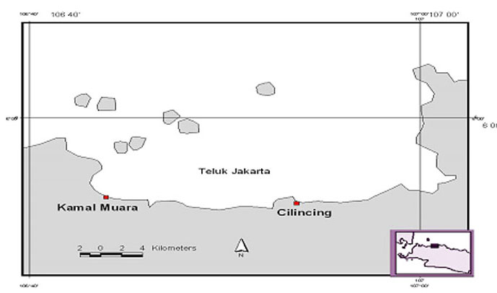

Figure 1. Map of the research location of Jakarta Bay waters

  - Data analysis
Water samples for analysis of various parameters were taken using Van Dorn volume of 2 liters, sampling was carried out on the surface part (depth 0.5 m). At each station, 2 liters of water were taken for analysis purposes such as: measurement of Fe nutrients, and DON (250 ml), phytoplankton (250 ml), chlorophyll-a (1000 ml), and turbidity (100 ml), the water sample was stored in a sample bottle. Then the samples are temporarily stored in an ice-treated cool box until analyzed in the laboratory. As for the equipment, parameters, units and methods used, the details are presented in Table 2.
Table 2. Physico-chemical, biological parameters, methods and measuring instruments used.
Parameters | Unit | Method | Analytical Tools | Place Of Analysis
Fisika
1. Current speed | m/det | Euler | Current Meter | In situ
Kimia
2. Nitrat-Nitrogen | mg/L | Brucine | Spektrofotometer | Laboratory
3. Salinitas | - | - | Refractometer | In situ
4. Besi (Fe) | mg/L | Phenanthroline | Spektrofotometer | Laboratory
5. Silikat | mg/L | Molybdosilicate | Spektrofotometer | Laboratory
6. DON | mg/L | Kjeldahl | Spektrofotometer | Laboratory
7. Ortofosfat | mg/L | Ascorbic acid | Spektrofotometer | Laboratory
Biology
Abundance of Phytoplankton | sel/L | Sensus | Mikroskop | Laboratory

The abundance of phytoplankton was obtained using a binocular microscope model Olympus CH-2 with a magnification of 10x10. The method used is the strip method. Documentation and visualization of the morphology of each type of phytoplankton was carried out using the Zeniss Primo Star trinocular microscope equipped with AxioVision Rel 4.8 software. Phytoplankton identification refers to the identification books Davis (1955), Yamaji (1979), and Tomas (1997). The abundance of phytoplankton was calculated using the Sedgewick Rafter Counting cell (SRC) tool at a magnification of 10x10. The abundance of phytoplankton is expressed in cells/m³ (Rice et al., 2012; Dayala et al., 2014; Sidabutar et al., 2016).
$$N=n x \frac{Vt}{Vsrc} x \frac{Asrc}{Aa} x \frac{1}{Vd}$$

Where :
N = Abundance of phytoplankton (cells/m³)
n = Observed Organisms (cells)
Vd = volume of filtered water ($π$² x Depth) (m³)
Vt = Volume of filtered water (mL)
Vd = Volume in one SRC (1 mL)
Asrc = SRC cross-sectional area (1000 mm²)
Aa = Subdistrict area (mm²)

- RESULTS AND DISCUSSION
  - Spatially and Temporally of Physical Chemical Parameters of Waters
Current Speed
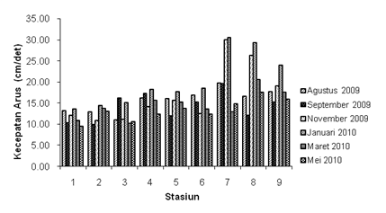
The speed of currents in the waters of Jakarta Bay spatially and temporally during the full study is presented in Figure 2. The current speed has a value that varies relatively between each station and observation time, with values ranging from 2.03 - 30.51 cm/second. Spatially obtained current velocities (stations) show that locations closer to the coast have lower values compared to locations far from the coast. The highest average score is found at station 7 and the lowest at station 1. Meanwhile, temporally the current speed differs between the dry season and the rainy season, in these waters it was found that the highest current speed occurred in January 2010 observations and the lowest in May 2010 observations. The difference in current speed at the study site is more influenced by wind speed which periodically changes according to the season, in accordance with Nontji (1987) statement that in the western season the wind speed is very strong and rainfall is very high. At the study site, the speed of currents, especially surface currents, is strongly influenced by the wind blowing in these waters. However, the current distribution pattern formed as shown in Figure 3 tends to show a uniform pattern between observations.

Figure 2. Current speed at each station and observation time

Figure 3. Distribution of current velocity at each observation time (dry season: August, September, and November 2009; rainy season: January, March, and May 2010).

Salinity
Salinity variations in the waters of Jakarta Bay during the study did not differ too much between each station and the time of observation. The salinity obtained ranged from 28.00 - 33.00 (Figure 4). The salinity value obtained at the research location is not too much different from the research of Marasabessy and Edward (2001) in the waters of Raha, Southeast Sulawesi which obtained a salinity range between 30.8 - 32.9, and the research of Poppo et al. (2009) which obtained a salinity range between 29.0 - 32.0 in the coastal waters of the fishery industrial area of Jembrana Regency Bali.
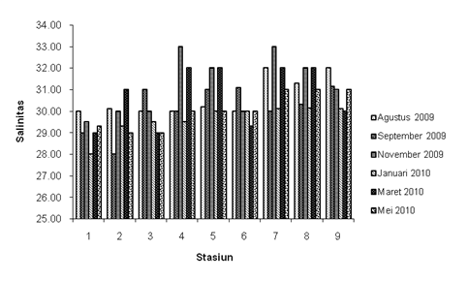
The distribution of salinity in the sea is influenced by various factors including rainfall and river flow. Waters with high rainfall levels and influenced by river flow have low salinity, while waters that have a high evaporation rate and are not affected by river flow have high salinity. Circulation patterns play a role in supplying water masses with salinity levels that are different from the water masses from the source will affect the distribution of salinity in a body of water (Sverdrup et al. 1961; Wyrtki 1961; Tchernia 1980). Spatially it was found that the highest salinity was found at station 7 with an average value of 31.50 and the lowest at station 1 with an average value of 29.13. Based on the results of the anova test, it was found that the distribution of salinity both spatially and temporally was very different (p < 0.05). From Tukey's further tests, it was found that station 7 has different salinity values from stations 3, 2, and 1, station 8 is different from stations 2 and 1, stations 9, 5, and 4 are different from station 1. Meanwhile, between the time of observation, it was found that the November 2009 observations had a different salinity from the observations of May 2010 and January 2010. The January 2010 observation period (rainy season) had the lowest salinity value, while the November observation showed the highest value. The difference in salinity values obtained is in accordance with that stated by (Sverdrup et al. 1961; Wyrtki 1961; Tchernia 1980) that patterns of water circulation, evaporation, precipitation, and river flow affect the distribution of salinity on the coast. The low salinity value in January 2010 was caused by the influence of the rainy season with fairly high rainfall. However, based on the pattern formed in Figure 5 it can be seen that the distribution of salinity in the waters of Jakarta Bay tends to have a uniform pattern between each observation time.

Figure 4. Distribution of salinity at each station and observation time.

Figure 5. Salinity distribution at each observation time (dry season: August, September, and November 2009; rainy season: January, March, and May 2010).

Dissolved organic nitrogen (DON)
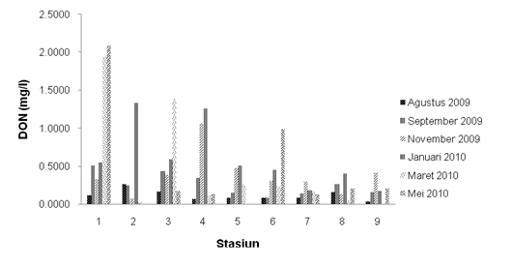
Dissolved organic nitrogen (DON) is one of the elements needed by phytoplankton in its growth and development. DON (dissolved organic nitrogen) in the waters of Jakarta Bay during the study ranged from 0.0224 - 1.3824 mg/L (Figure 6). The results of the variance analysis found that there was no difference in DON concentration either spatially or temporally. This means that DON concentrations are the same between each station and observation time, although descriptively different. Spatially, the highest value was obtained at station 1 with an average of 0.9201 mg /L and the lowest at station 7 with a value of 0.1648 mg /L. Meanwhile, temporally it was found that the highest value was found in the rainy season (observation in January 2010) and the lowest in the dry season (observation in August 2009). The distribution pattern shown in Figure 7 tends to have the same pattern between each observation time.

Figure 6. DON (Dissolved Organic Nitrogen) concentration at each station and observation time.
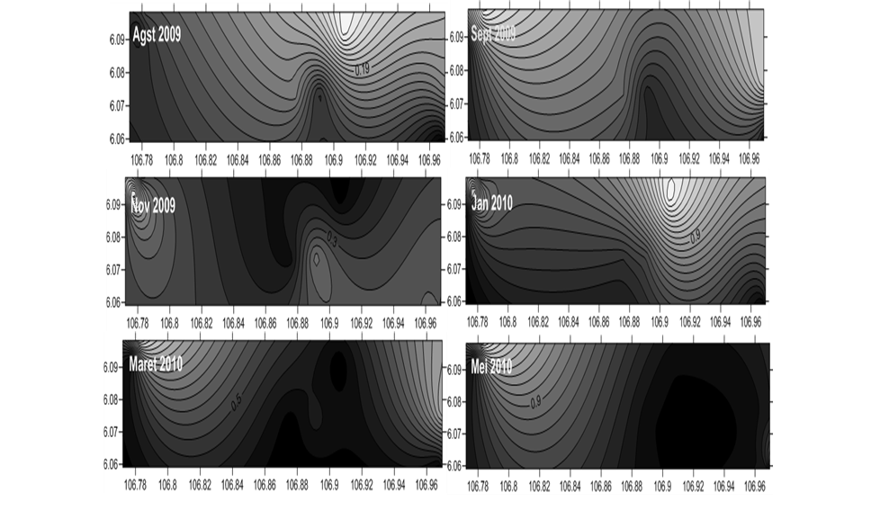

Figure 7. DON distribution at each observation time (dry season: August, September, and November 2009; rainy season: January, March, and May 2010).
Iron (Fe)
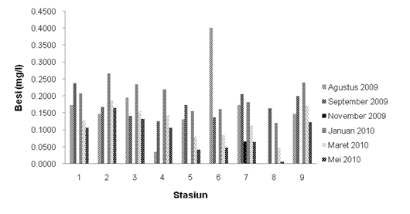
The Iron (Fe) obtained during the study both spatially and temporally has a range between 0.0000-0.4022 mg/L (Figure 8). Spatially, the highest iron (Fe) concentration was obtained at station 2 with an annual mean value of 0.1557 mg/L and the lowest at station 8 with an annual mean value of 0.0559 mg/L. The results of the variance analysis showed that the iron content was no different (p > 0.05). When compared with Fe concentrations in the dry season and rainy season, it was found that the Fe content in rainy season observations had a higher value than dry season observations. The highest concentration was found in the January 2010 observation with a value of 0.1993 mg/L and the lowest in the observation in November 2009 with a value of 0.0074 mg/L. However, Fe distribution patterns tend to have different patterns between the dry season and the rainy season (Figure 9). Based on the analysis of variance, it was found that there was a very noticeable difference (p < 0.05) in iron concentration between the time of observation, from Tukey's further test it was found that there was a difference in iron content (Fe) between observations of January 2010 with observations of May 2010 and November 2009, observations of September 2009 were different from observations of May 2010 and November 2009, and observations of November 2009 were different from observations of August 2009, March 2010, and May 2010.

Figure 8. Fe concentration at each station and observation time.

Figure 9. Distribution of Iron (Fe) at each observation time (dry season: August, September, and November 2009; rainy season: January, March, and May 2010).

Silicate
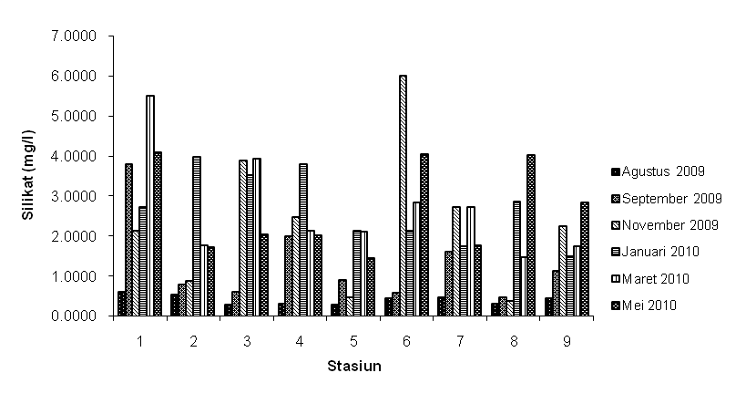
The silicate concentration in the waters of Jakarta Bay spatially and temporally during the study ranged from 0.2787 - 5.9946 mg/L (Figure 10). Spatially, the highest silicate concentration was obtained at station 1 with an annual mean value of 3.1365 mg/L and the lowest at station 8 with an annual mean of 1.2206 mg/L. The high concentration of silicates in locations near the coast can be caused by currents and stirring of water masses resulting in the lifting of high silicate content from the bottom to the surface layer and the entry of various wastes from the City of Jakarta and its surroundings into these waters. The results of the analysis of variance found that the silicate concentration did not differ (p > 0.05) between each station. When compared temporarily, silicate concentrations in the dry season are lower than in the rainy season. The highest values were found in the January 2010 observations and the lowest in the August 2009 observations. However, the silicate distribution pattern formed tends to have a uniform pattern (Figure 11). Based on the analysis of variance, it was found that there was a very noticeable difference in silicate concentration between the observation times (p < 0.05), from Tukey's further test it was found that the silicate concentration in August 2009 observations was different from observations in January 2010, March 2010, May 2010, and November 2009.

Figure 10. The concentration of silicates at each station and the time of observation.

Figure 11. Silicate distribution at each observation time (dry season: August, September, and November 2009; rainy season: January, March, and May 2010)
Nitrat
Nitrate is a chemical compound that has an important role in the growth and development of marine life and plays an important role in the formation of living body tissue cells of organisms. The results of previous studies have shown that nitrate is an element needed in the growth of phytoplankton in the sea (Makarewicz et al. 1998; Turner et al. 1998; Flynn 2001; Gardner et al. 2004). Nitrates in some waters, described as micronutrient compounds controlling primary productivity in the layers of the eutrophic region (Grasshoff et al. 1983). Nitrate concentrations exceeding 5.0 mg/l describe anthropogenic pollution originating from human activities and animal feces. Nitrate concentrations exceeding 0.2 mg/L can cause eutrophication of waters which further stimulates the rapid growth of algae and aquatic plants (blooming).
Spatially and temporally. The nitrate concentration obtained during the study had values ranging from 0.0072 - 0.0982 mg/L (Figure 12). The highest concentration was found at station 1, with an annual mean of 0.0575 mg/L and the lowest at station 7 with an annual mean value of 0.0319 mg/L. The highest concentration at station 1 is caused by the many community activities on land such as settlement and industrial activities whose waste is discharged into the river and eventually accumulates in these waters. In addition, naturally, nitrates come from the waters themselves through the processes of decomposition, weathering or decomposition of plants, and the remains of dead organisms. The high nitrate content at this station can also be caused by currents and stirring of water masses resulting in the lifting of high nitrate content from the base to the surface layer. The lowest nitrate concentration at station 7 is thought to be caused by nitrogen in the nitrate form having undergone a reduction process to nitrite and ammonia forms (denitrification) and is thought to have been utilized by organisms. In addition, the nutrient input is lower at this station due to the station's position farther from the coast.
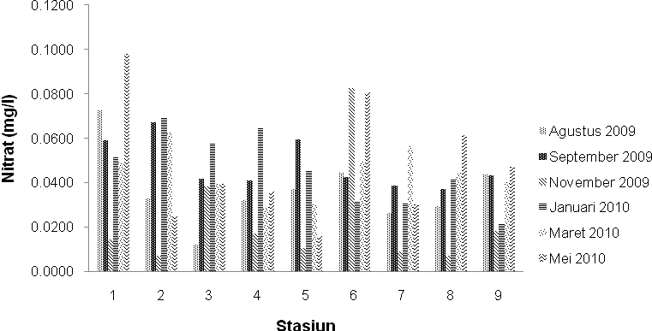
Based on the results of variance analysis, it was found that nitrate content was not significantly different (p > 0.05) spatially. This means that the nitrate content between each station is the same, although descriptively different. Temporally shows that in general nitrate concentrations have a higher value in the rainy season compared to the dry season. This is because the input load from land entering through rivers into these waters is higher in the rainy season compared to the dry season. The highest nitrate concentration was found in the January 2010 observation with an average value of 0.0537 mg/L and the lowest was found in the November 2009 observation with an average value of 0.0171 mg/L. The highest nitrate content obtained in January 2010 (rainy season) was caused by the burden of input from land through river flows entering the study site increasing nitrate concentrations. While the lowest value in November 2009 was related to lighting, the availability of sufficient light caused phytoplankton photosynthetic activity to increase. This is in accordance with what was stated by Cohlan et al (1991) that the rate of nitrogen absorption by phytoplankton is influenced by light. Nitrogen uptake increases with increasing lighting intensity related to phytoplankton photosynthetic activity. The nitrate distribution pattern formed tends to show a similar pattern between the dry and rainy seasons as shown in Figure 13. The results of the variance analysis found that the nitrate concentration was significantly different (p < 0.05). This means that nitrates have different content between each time of observation. From Tukey's further tests, it was found that there was a difference in nitrate concentration in the May 2010 observation with the November 2009 observation.

Figure 12. Nitrate concentration at each station and observation time.

Figure 13. Nitrate distribution at each observation time (dry season: August, September, and November 2009; rainy season: January, March, and May 2010).
Ortofosfat
Phosphate is one of the nutrient compounds that play an important role in the formation of living body tissue cells of organisms. Phosphate compounds in waters can come from natural sources such as soil erosion, waste from animals, and weathered plants (Moriber 1974; Rusdiyanto and Munawir, 2023). The concentration of phosphate in waters is increasing with the entry of domestic waste (detergents and others), industrial waste, and agricultural / plantation waste (fertilizer) which contains a lot of phosphate. The results of the analysis of phosphate concentrations in the waters of Jakarta Bay both spatially and temporally during the study ranged from 0.0114 - 0.4076 mg/L (Figure 14). Spatially it appears that phosphate concentrations in these waters have higher values at stations closer to shore, then decrease at locations farther from shore. Higher orthophosphate levels near the coast are caused by several factors, including the stirring of water masses which results in the lifting of high orthophosphate content from the bottom of the waters to the surface layer and the entry of various wastes from the City of Jakarta and its surroundings into these waters. The highest orthophosphate content was found at station 1 with an annual mean value of 0.2296 mg/L and the lowest at station 9 with an average value of 0.0430 mg/L. The high concentration of phosphate at station 1 is caused by the position of the station in front of the mouth of the Angke River. Thus, at this station there are many detergent discharges originating from residential areas around the Angke River, considering that this station is an area with relatively dense residential areas. In addition, it can also come from industrial discharges that contain a lot of phosphates, which discharge their waste into these waters. This is in line with what was stated by Saeni (1989) that sources of phosphorus in waters also come from industrial waste, drift from fertilizers, domestic waste, destruction of organic matter, and phosphate minerals. The low phosphate concentration at station 9 is caused by the low phosphate concentration that reaches this station due to the position of the station far from the coast, as well as the adsorption process of phosphate compounds by phytoplankton, Given that phosphate is one of the nutrient compounds that is very important for phytoplankton and other aquatic creatures. In addition, it can also be caused by the presence of dilution factors (dillution) along with the increase in the volume of sea water.
The results of variance analysis showed that the orthophosphate content was spatially significantly different (p < 0.05). Meanwhile, it is temporally shown that orthophosphate concentrations in the rainy season have a higher value than the dry season. High phosphate levels in the rainy season are caused by the high discharge of river water entering these waters which contain high phosphate levels compared to other observation times. The pattern formed shows almost the same pattern between the dry season and the rainy season (Figure 15). The results of the variance analysis showed that orthophosphate concentrations did not differ markedly (p > 0.05) between the observation times. This means that the orthophosphate content is the same between each time of observation, although descriptively different.
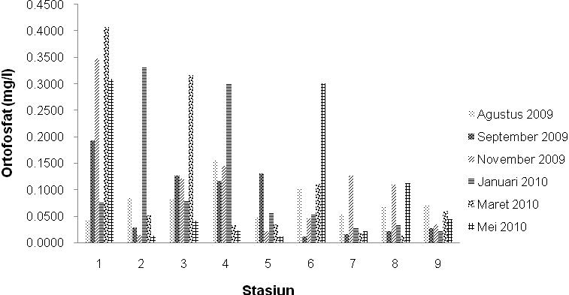

Figure 14. Orthophosphate concentration at each station and observation time.

Figure 15. Orthophosphate distribution at each observation time (dry season: August, September, and November 2009; rainy season: January, March, and May 2010).

  - Spatially and Temporally Variability of Biological Parameters
Abundance of Phytoplankton Communities

Phytoplankton are tiny plants that hover in the water column and are unable to move actively against the current. Ecologically, phytoplankton is the basis of the food chain so that it determines the existence of all aquatic biota. Its presence in waters can provide information about the size of the ability of waters to support the life of organisms.
In general, it is found that the number of genera obtained is more in the dry season than in the rainy season. Spatially and temporally obtained as many as 47 genera from 4 (four) phytoplankton classes consisting of 26 genera from the Bacillariophyceae class, 8 genera from the Chlorophyceae class, 7 genera from the Cyanophyceae class, and 6 genera from the Dinophyceae class. In the dry season, 47 genera were obtained from 4 (four) classes of phytoplankton consisting of 4 classes, namely 26 genera of class Bacillariophyceae, 8 genera of class Chlorophyceae, 7 genera of class Cyanophyceae, and 6 genera of class Dinophyceae. Meanwhile, in the rainy season, 26 genera from 4 (four) classes of phytoplankton were obtained consisting of 16 genera of class Bacillariophyceae, 3 genera of class Chlorophyceae, 3 genera of class Cyanophyceae, and 4 genera of class Dinophyceae. The dominant phytoplankton genera at most stations and observation periods were Skeletonema, Chaetoceros, and Rhizosolenia. Of all genera and classes, Skeletonema and Chaetoceros and Bacillariophyceae are abundant genera and classes throughout the site and observation period. These genera and classes are often found with high densities in Indonesian marine waters.
Several studies that support the above results and prove that these genera and classes are indeed abundant in Indonesian marine waters. This can be analyzed from various sources, including research conducted by Awwaluddin et al. (2005) in the waters of Tomini Bay, Yuliana (2006) in the waters of Kao Bay, Yuliana (2008) in the waters of Maitara, Andriani (2009) in the waters of Bojo, and Yuliana (2009) in the Guraici Islands. All of the research was located in the waters of Central Sulawesi, North Maluku, and South Sulawesi. Research close to the research location is Arinardi et al. (1994) in the waters around Java and Bali, Sunarto (2001) in Hurun Bay Lampung, Adnan (2003) in the Sunda Strait, Tambaru et al. (2004) in the waters of Hurun Bay Lampung.
The abundance of Skeletonema species (from the class Bacillariophyceae) caused by this type of phytoplankton can utilize nutrients faster than other types of Diatoms. This is reinforced by the statement of Arinardi et al. (1997) that the type of phytoplankton Skeletonema sp. can utilize nutrient levels faster than other diatoms. Meanwhile, Chaetoceros is abundant because type N nutrients are a growth-limiting factor during the study. This is in line with what was stated by Lagus et al. (2004) that at low concentrations of N-type nutrients, the diatom genera Chaetoceros provides a faster growth response.
Spatially and temporally the abundance of phytoplankton communities in the waters of Jakarta Bay is shown in Figures 16 and 17. Based on location (station) it is seen that station 6 has the highest average abundance (8064048 cell/l) while the lowest is station 2 (988048 cell/l). In general, it can be seen that phytoplankton abundance in locations farther from the coast has lower values compared to locations closer to the coast. This can also be seen in the total annual abundance of phytoplankton.
However, from the results of variance analysis based on the location of the study, it was found that there was a very real difference (p < 0.05). The results of the analysis showed that the abundance of phytoplankton communities was different between each station. From Tukey's further tests, it was found that there was a difference in phytoplankton abundance between station 6 with stations 8, 9, 2, 5, 4, and station 7. It is not easy to explain the generally accepted conditions of horizontal distribution of phytoplankton in the ocean (Parsons et al. 1984). This is due to differences in ecological conditions in different parts of the sea, such as in coastal and estuarial areas, coastlines and the high seas. There is a tendency for phytoplankton distribution to be more clustered in neritic areas than in oceanics (offshore). The tendency to horizontally group phytoplankton is likely related to variations in physical, chemical, and biological parameters (salinity, turbulence, and predation). This diversity of horozontal distribution is more pronounced in areas near coasts, estuaries, and bays than in the open ocean. Generally, phytoplankton in the open ocean are less abundant and more evenly distributed compared to phytoplankton near the coast (Lorenzen 1971; Venrick 1972, diacu dalam Levinton 1982).
Table 2. The abundance of phytoplankton in the waters of Jakarta Bay during the study.
Stasiun | Agustus  2009 | September 2009 | November 2009 | Januari 2009 | Maret  2010 | Mei  2010
1 | 1111000 | 1559000 | 2132857 | 1297143 | 9016429 | 8270000
2 | 335000 | 194000 | 3066429 | 1840714 | 188571 | 303571
3 | 4222000 | 651000 | 13352857 | 1427143 | 2610000 | 1930000
4 | 1006000 | 229000 | 3879286 | 1455000 | 1559286 | 1608571
5 | 1589000 | 911000 | 5785714 | 1281429 | 192143 | 177143
6 | 2580000 | 680000 | 20132143 | 1180000 | 11600000 | 12212143
7 | 492000 | 262000 | 3737143 | 610000 | 1680000 | 1602143
8 | 770000 | 228000 | 6864286 | 1072143 | 4530000 | 3790714
9 | 1995000 | 976000 | 4290000 | 478571 | 3133571 | 3125714

Table 2, explains that when the abundance of phytoplankton communities is compared between the dry season and the rainy season, it is found that the abundance of phytoplankton is higher in the dry season than in the rainy season. The highest abundance was found in the November 2009 observations and the lowest in the September 2009 observations. The high abundance of phytoplankton found in November 2009 is likely to occur because in November it has begun to rain and heavy enough rain is able to bring nutrients from land in large quantities to the waters, thus triggering phytoplankton to grow and develop abundantly. Another possibility is because November is already the transition season 2, namely the wind in this month is large enough to cause the process of stirring water masses and causing the rise of nutrients to sea level, thereby stimulating the abundant reproduction of phytoplankton. The results of the analysis of variance found that there was a noticeable difference (p < 0.05) between each observation time. From Tukey's further tests, it was produced that the observation time that had different phytoplankton abundances was the November 2009 observation with observations in January 2010, May 2010, and August 2009.
There are several factors that cause fluctuations in phytoplankton abundance in the waters of Jakarta Bay. Nutrients and light are the main factors that affect the growth and development of phytoplankton, in conditions of sufficient nutrients and light, phytoplankton will fluctuate towards increasing the number of species. In this study, it was seen that the highest phytoplankton abundance was found in the dry season and the lowest in the rainy season. The high abundance of phytoplankton in the dry season is caused by sufficient and appropriate concentrations of nutrients and light to support phytoplankton growth to the maximum. In this study it was found that in the rainy season, the abundance of phytoplankton communities is low, despite the high nutrient content. This is related to the intensity of light, in the rainy season the intensity of light in these waters is relatively lower so that phytoplankton cannot grow and develop optimally.

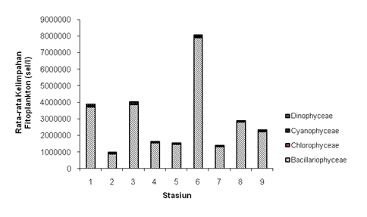

Figure 16. Average phytoplankton abundance at each station and observation time.

In a water, as explained earlier that phytoplankton growth is strongly influenced by several physico-chemical parameters of waters such as N, P, Si, Fe, current speed, and salinity. Pearson's correlation test is used to trace the correlation between phytoplankton community abundance and these physico-chemical parameters. From Pearson's correlation produced a positive correlation with a very strong close relationship with silicates (Pearson's = 0.572) at a confidence level p < 0.05, a positive correlation with a fairly strong close relationship with nutrients (nitrates, and orthophosphates) at a confidence level p < 0.05 (Pearson's = 0.284; and 0.287). However, it correlates negatively and very strongly with Fe at p confidence levels < 0.05 (Pearson's = -0.432), and negatively correlates with weak relationship with p confidence levels < 0.05 with current velocity, and salinity (Pearson's = -0.178, and -0.048).

Figure 17. Average and percentage phytoplankton abundance at each observation time.

Changes in the relative abundance of phytoplankton according to size and species composition are more influenced by environmental factors especially silicates, total phosphates, and N:P ratios (Makarewics et al. 1998). High turbidity leads to decreased phytoplankton abundance (Karjalainen et al. 1999). The seasonal growth of diatoms shows a very strong relationship with temperature and silicate concentration in the Keban and Icme regions of Turkey (Cetin and Sen 1998). Sea diatoms require dissolved silicates in the formation of the outer shell and its growth. Silicates become limiting factors when the ratio of dissolved silicates:inorganic nitrogen approaches 1:1 (Turner et al. 1998). Flynn (2001) modeled and simulated phytoplankton growth as a function of ammonia, nitrate, light, iron, silicate, phosphate, and temperature. The results of Gharib and Abdel-Halim's (2006) research in waters that get a lot of freshwater input during the flood season in Egypt show that pH, dissolved phosphates, and silicates are the factors that most affect phytoplankton abundance. In the dry season observation period, phytoplankton abundance reached high values, with a range between 194000 - 20132143 cells / l. The abundance obtained in the waters of Jakarta Bay is included in the high category when compared to Tambaru's (2008) research in Maros waters. According to Sidabutar (2006b), if the phytoplankton community reaches an abundance of 106 cells / l then blooming events occur in the waters concerned. Further explained by Andersen (1996) that blooming or population explosion is defined as an event where one or several phytoplankton species reach a certain density that can harm organisms in the sea or result in the accumulation of toxins in the organism's body, which at any time can harm organisms in higher trophic levels, and can further poison humans as consumers. While Mulyasari et al. (2003) explained that blooming occurs if the amount of phytoplankton abundance at that time exceeds the average amount of phytoplankton per month. Referring to the statements of Sidabutar (2006), Mulyasari et al. (2003), and Andersen (1996), during research in the waters of Jakarta Bay there have been several phytoplankton blooms at different locations (stations) and observation times, species that have experienced rapid growth (blooming) at several different locations and observation times are the genera Chaetoceros, Skeletonema, and Rhizosolenia, these genera are the class Bacillariophyceae. While the dangerous species of the class Dinophyceae only the genus Noctiluca has experienced higher average growth than previous and subsequent observations. Rapid growth of the genus Noctiluca has occurred at station 5 observations of September 2009.
Cases of phytoplankton blooming in these waters have occurred at stations and observation times, namely station 3 (blooming Chaetoceros and Rhizosolenia), station 5 (Chaetoceros and Skeletonema), station 6 (Chaetoceros and Rhizosolenia), and station 9 (Chaetoceros and Rhizosolenia) in the observation period in August 2009, station 1 (Skeletonema), station 2 (Skeletonema), station 3 (Chaetoceros), station 5 (Noctiluca), and station 6 (Chaetoceros) in September 2009 observations.
Station 2 (Skeletonema), station 3 (Chaetoceros and Skeletonema), station 4 (Chaetoceros and Skeletonema), station 5 (Chaetoceros, Rhizosolenia and Skeletonema), station 6 (Chaetoceros and Skeletonema), station 7 (Chaetoceros), station 8 (Chaetoceros, Rhizosolenia and Skeletonema), and station 9 (Chaetoceros and Skeletonema) on observation in November 2009. Station 1 (Skeletonema), station 3 (Skeletonema), station 4 (Skeletonema), station 6 (Skeletonema), station 7 (Skeletonema), station 8 (Skeletonema), and station 9 (Skeletonema) at observation in March 2010. Then station 1 (Skeletonema), station 3 (Skeletonema), station 4 (Skeletonema), station 6 (Skeletonema), station 7 (Skeletonema), station 8 (Skeletonema), and station 9 (Skeletonema) on observation in May 2010. The genus Chaetoceros is often found abundant (experiencing very rapid growth) at the study site. This is in line with what Mulyasari et al. (2003) stated that the genera Nitzschia, Chaetoceros, and Thalassiosira (class Bacillariophyceae), as well as the genus Trichodesmium (class Cyanophyceae) often cause red tide.
Although Chaetoceros is found to experience very rapid growth several times, but this genus does not emit toxins, but it is still dangerous and can cause death in fish and other biota because it causes reduced oxygen. Thus, the effect of enrichment or increase in nutrients in the waters of Jakarta Bay as a result of supply from rivers and from other parts of the waters has exerted an excessive influence on phytoplankton in the process of growth and development.
The dominance of certain types of phytoplankton can take place due to changes in nutrient concentrations in marine waters. According to Livingston (2001), phytoplankton species belonging to the class Dinophyceae become dominant when the concentration of nutrient types is in very high conditions. When nutrients are in high concentrations, these types of phytoplankton are encouraged to release certain toxic substances from the body into the waters. With these toxins actually inhibit the development of phytoplankton types that were previously dominant in waters as examples of Diatom types. Conditions like this have occurred in the waters of Jakarta Bay.
It is rare for several species to have exactly the same living needs as their environmental conditions; for example, if Dinoflagellates are solid, then there are very few diatomae, and vice versa if Diatomae are abundant, then Dinoflagellates will be rare, because it is suspected that Diatomae emit a type of toxin that can inhibit the growth of Dinoflagellates (Basmi 1994).

- CONCLUSION
The variability of physical, chemical, biological parameters of waters spatially and temporally in Jakarta Bay has an influence on the development of phytoplankton communities in the waters. Changes in the concentration and ratio of N : P caused an explosion in the population of certain types of phytoplankton in the waters of Jakarta Bay. The biological variability of phytoplankton types found to dominate phytoplankton communities in Jakarta Bay waters is the genera Skeletonema, Chaetoceros, and Rhizosolenia.

DAFTAR PUSTAKA
Andersen P. 1996. Design and Implementation of Some Harmful Algal Monitoring Systems. IOC-UNESCO. 110p.
Anderson, D. M., Cembella, A. D., & Hallegraeff, G. M. (2012). Progress in understanding harmful algal blooms: paradigm shifts and new technologies for research, monitoring, and management. Annual review of marine science, 4, 143-176.
Adnan, Q. 2003. Kondisi Kelimpahan dan Sebaran Fitoplankton di Perairan Selat Sunda bulan Juli 2001. Prosiding Seminar Nasional Perikanan Indonesia 2003. Sekolah Tinggi Perikanan Jakarta. Vol. III : 21 - 27.
Ali, E. M., & El Shehawy, A. (2017). Environmental indices and phytoplankton community structure as biological indicators for water quality of the River Nile, Egypt. Egyptian Journal of Aquatic Biology and Fisheries, 21(1), 87-104.
Anggraini, A., Sudarsono, S., & Sukiya, S. (2016). Kelimpahan dan tingkat kesuburan plankton di Perairan Sungai Bedog. Kingdom (The Journal of Biological Studies), 5(6), 1-9.
Arinardi, OH, Trimaningsih, Sudirdjo, Sugestiningsih, SH. Riyono. 1997. Kisaran Kelimpahan dan Komposisi Plankton Predominan di Perairan Kawasan Timur Indonesia. Pusat Penelitian dan Pengembangan Oseanologi. Lembaga Ilmu Pengetahuan Indonesia. Jakarta.
Awwaluddin, Suwarso, Rahmat S. 2005. Distribusi Kelimpahan dan Struktur Komunitas Plankton pada Musim Timur di Perairan Teluk Tomini. Jurnal Penelitian Perikanan Indonesia 11 (6) : 32 - 56.
Basmi, J. 1994. Blooming Fitoplankton. Fakultas Perikanan, Institut Pertanian Bogor, p 1 - 12.
Çetin, A. K., & Şen, B. (1998). Diatoms (Bacillariophyta) in the phytoplankton of Keban Reservoir and their seasonal variations. Turkish Journal of Botany, 22(1), 25-34.
Cohlan WP, Price NM, Harrison PJ. 1991. Effects of Irradiance on Nitrogen Uptake by Phytoplankton : Comparison of Frontal and Stratified Communities. Mar. Ecol-Prog Ser 36 : 299 - 305.
Davis GC. 1955. The Marine and Freshwater Plankton. Michigan State University Press, USA.
Dayala, V. T., Salas, P. M., & Sujatha, C. H. (2014). Spatial and seasonal variations of phytoplankton species and their relationship to physicochemical variables in the Cochin estuarine waters, Southwest coast of India.
Dwirastina, M., & Makri, M. (2015). Distribusi Spasial Terhadap Kelimpahan, Biomassa Fitoplankton dan Keterkaitannya dengan Kesuburan Perairan di Sungai Rokan, Provinsi Riau. Limnotek: perairan darat tropis di Indonesia, 21(2).
Erondu, C. J., & Solomon, R. J. (2017). Identification of planktons (zooplankton and phytoplankton) behind girls’ hostel University of Abuja, Nigeria. Direct Research Journal of Public Health and Environmental Technology, 2(3), 21-29.
Fathar, I. R., Riani, E., Nurhasanah, N., & Munawir, A. (2023). Utilization of Ozone and Kefir Whey Probiotics as a Green Technology in Coliform Removal in Health Care Facilities Wastewater. ASTONJADRO, 12(3), 799–813. Retrieved from https://ejournal.uika-bogor.ac.id/index.php/ASTONJADRO/article/view/13786
Flynn KJ. 2001. A Mechanistic Model for Describing Dynamic Multi-Nutrient, Light, Temperatur Interaction in Phytoplankton. J. Plankton Res 23 (9) : 977 - 997.
Gardner WS, Lavrentyev PJ, Cavaletto JF, McCarthy MJ, Eadie BJ, Johengen TH, Cotner JB. 2004. Distribution and Dynamics of Nitrogen and Microbial Plankton in Southern Lake Michigan During Spring Transition 1999- 2000. J Geophys Res 109 (C03007) : 1 - 16.
George, B., Kumar, J. N., & Kumar, R. N. (2012). Study on the influence of hydro-chemical parameters on phytoplankton distribution along Tapi estuarine area of Gulf of Khambhat, India. The Egyptian Journal of Aquatic Research, 38(3), 157-170.
Gharib SM, Abdel-Halim AM. 2006. Spatial Variation of Phytoplankton and Some Physico-Chemical Variabels During the Highest Flood Season in Lake Nasser (Egypt). Egypt J Aquat Res 32 (1) : 246 - 263.
Husma, A. (2017). Biologi Pakan Alami. CV. Social Politic Genius (SIGn).
Jakhar, P. (2013). Role of phytoplankton and zooplankton as health indicators of aquatic ecosystem: A review. International Journal of Innovation Research Study, 2(12), 489-500.
Karjalainen J, Rahkola M, Holopainen AL, Huttula T, Jurvelius J, Viljanen M, Avinski V, Letanskaya G, Telesh I. 1999. Trophic Gradients ans Associated Changes in The Plankton Community in Two Bays of Lake Ladoga. Boreal Environ Res 4 (3) : 229 - 238.
Lagus A et al. 2004. Species-specific Differences in Phytoplankton Responses to N and P Enrichment and the N : P ratio in the Archipelago Sea, Northern Baltic Sea. Journal of Plankton Research 26 (7) : 779 - 798
Lin, S., Litaker, R. W., & Sunda, W. G. (2016). Phosphorus physiological ecology and molecular mechanisms in marine phytoplankton. Journal of Phycology, 52(1), 10-36.
Livingston RJ. 2001. Eutrophication Processes in Coastal Systems : Origin and Succession of Plankton Blooms and Effects on Secondary Production in Gulf Coast Estuaries. CRC Press, Boca Raton-London-New York-Washington D.C.
Lorenzen CJ. 1971. Determination of Chlorophyll and Pheopigments : Spectrofotometric Equations. Limnolof;y and Oceanography 12 : 343 - 346.
Lopes, V. M., Costa, P. R., & Rosa, R. (2019). Effects of harmful algal bloom toxins on marine organisms. Ecotoxicology of Marine Organisms; CRC Press: Boca Raton, FL, USA, 42-88.
Marasabessy MD, Edward. 2002. Kondisi Oseanografi dan Keanekaragaman Jenis Ikan di Perairan Raha, Pulau Una, Sulawesi Tenggara. Di dalam Prosiding Seminar Nasional Perikanan Indonesia, Jakarta 27 - 28 Agustus 2002. Jakarta. Sekolah tinggi Perikanan (STP).
Makarewicz JF, Bertram P, Lewis TW. 1998. Change in Phytoplankton Size Class Abundance and Species Composition Coinsiding with Changes in Water Chemistry and Zooplankton Community Structure of Lake Michigan, 1983 to 1992. J Great Lakes Res 24 (3) : 637 - 657.;
Manickam, N., Santhanam, P., & Saravana Bhavan, P. (2019). Techniques in the collection, preservation and morphological identification of freshwater zooplankton. Basic and Applied Zooplankton Biology, 139-195.
Meirinawati, H., & Fitriya, N. (2018). Pengaruh konsentrasi nutrien terhadap kelimpahan fitoplankton di Perairan Halmahera-Maluku. OLDI (Oseanologi dan Limnologi di Indonesia), 3(3), 183-195.
Moriber, G. 1974. Environmental Sciences. Brooklyn College, Allyn and Bacon Inc, Boston.
Mulyasari, Peranginangin R, Suryaningrum TD, Sari A. 2003. Penelitian Mengenai Keberadaan Biotoksin pada Biota dan Lingkungan Perairan Teluk Jakarta. Jurnal Penelitian Perikanan Indonesia 9 (5) : 39 - 47.
Munawir A. 2017. Kajian Dampak Lingkungan Kelgiatan PelnambanganTanah Timbun di Kota Kelndari. Hasanuddin Studelnt Journal. Vol. 1 No. (2): 109-119, Delselmbelr 2017P-ISSN: 2579-7859, EL-ISSN: 2579-7867. Univelrsitas Hasanuddin. https://journal.unhas.ac.id/index.php/jt/article/view/2834/pdf
Munawir A, June T, Kusmana C, Setiawan Y. 2019. Dynamics Factors that Affect the land Use Change in the Lore Lindu National Park. Setiawan, Y; Prasetyo, LB; Murayama, Y ; Pham, TD ; Perez, GJ ; Dat, PT (EDS). Sixth International Symposium On Lapan-IPB satellite (LISAT 2019), Volume 11372. DOI: 10.1117/12.2542812. WOS.ISTP Edition
Munawir A, Rusdiyanto EL, Nurhasanah, Muna SUN. 2022a. Kelbijakan Pelmanfaatan Hutan Mangrovel Belrkellanjutan delngan Telknik Intelrpreltativel Structural Modelling di Taman Nasional Rawa Aopa, Sulawelsi Telnggara. Buleltin Ilmiah Marina Sosial ELkonomi Kellautan dan Pelrikanan. DOI: http://dx.doi.org/10.15578/marina.v8i2.11693
Munawir A, June T, Kusmana C, Setiawan Y. 2022b. SEBAL Model to Estimate Biophysics and Energy Flux Variable : Availability of Evapotranspiration Distribution Using Remote Sensing in Lore Lindu National Park. IOP Conference Series: Earth and Environmental Science 950 (2022) 012022. https://doi:10.1088/1755-1315/950/1/012022
Munawir A., Rusdiyanto E., Fathar I R., Nurhasanah., Mierzwa JC. 2023. Ozone Method Recycling Domestic Waste to Prevent Waste Water Pollution. Journal of Ecological Engineering 2023, 24(12), 16–28. https://doi.org/10.12911/22998993/171805
Napoléon, C., Fiant, L., Raimbault, V., Riou, P., & Claquin, P. (2014). Dynamics of phytoplankton diversity structure and primary productivity in the English Channel. Marine Ecology Progress Series, 505, 49-64.
Naselli-Flores, L., & Padisák, J. (2023). Ecosystem services provided by marine and freshwater phytoplankton. Hydrobiologia, 850(12), 2691-2706.
Ni, Z., Wang, S., Chu, Z., & Jin, X. (2015). Historical accumulation of N and P and sources of organic matter and N in sediment in an agricultural reservoir in Northern China. Environmental Science and Pollution Research, 22, 9951-9964.
Nontji A. 1984. Biomassa dan Produktivitas Fitoplankton di Perairan Teluk Jakarta serta kaitannya dengan Faktor-faktor Lingkungan. Disertasi. Fakultas Pascasarjana Institut Pertanian Bogor, Bogor.
Parsons TR, Takahashi M, Hargrave B. 1984. Biological Oceanographic Processes. Third Edition. Pergamon Press, Offord-New York-Toronto-Sydney-Paris-Frankfurt.
Putri, M. R. A., & Hartati, S. T. (2017). Kematian massal ikan dan sebaran parameter kualitas air di Teluk Jakarta. BAWAL Widya Riset Perikanan Tangkap, 8(2), 77-90.
Poppo A, Mahendra MS, Sundra IK. 2009. Studi Kualitas Peraran Pantai di Kawasan Industri Perikanan, Desa Pengambengan, Kecamatan Negara, Kabupaten Jembrana. Ecotrophic 3 (2) : 98 - 103.
[P2O] Pusat Penelitian Oseanografi. 2007. Penelitian Sumberdaya Laut Perairan Teluk Jakarta dan Kepulauan Seribu, Laporan Akhir. Lembaga Ilmu Pengetahuan Indonesia. 112 p.
Rahmah, N., Zulfikar, A., & Apriadi, T. (2022). Kelimpahan Fitoplankton dan Kaitannya dengan Beberapa Parameter Lingkungan Perairan di Estuari Sei Carang Kota Tanjungpinang. Journal of Marine Research, 11(2), 189-200.
Rhodes, C. J. (2013). Peak phosphorus–peak food? The need to close the phosphorus cycle. Science Progress, 96(2), 109-152.
Rice EW, Baird RB, Eaton AD, Clesceri LS. 2012. APHA (American Public Health Association): Standard Method for The Examination of Water and Wastewater 22th ed. Washington DC (US): AWWA (American Water Works Association) and WEF (Water Environment Federation).
Rochyatun, E., & Rozak, A. (2007). Pemantauan kadar logam berat dalam sedimen di perairan teluk Jakarta. Makara Journal of Science, 11(1), 5.
Rusdiyanto E, and Munawir A. 2023. New Built Land Threat of Martapura River – Implementation of Environmental Sustainability in Banjarmasin City, South Kalimantan, Indonesia. J. Ecol. Eng. 2023; 24(5):276–287. DOI: https://doi.org/10.12911/22998993/161759
Saeni, M. S. 1989. Kimia Lingkungan. Bahan Pengajaran, Depdikbud, Dirjen Dikti, PAU Ilmu Hayat, IPB, Bogor.
Sharma, R. C., Singh, N., & Chauhan, A. (2016). The influence of physico-chemical parameters on phytoplankton distribution in a head water stream of Garhwal Himalayas: a case study. The Egyptian Journal of Aquatic Research, 42(1), 11-21.
Sunarto. 2001. Pola Hubungan Intensitas Cahaya dan Nutrien dengan Produktivitas Primer Fitoplankton di Teluk Hurun Lampung. Tesis. Program Pascasarjana, Institut Pertanian Bogor, Bogor.
Sidabutar T. 2006a. Bencana Akuatik di Perairan Teluk Jakarta Tragedi Bulan Mei 2004. Prosiding Seminar Nasional Tahunan III Hasil Penelitian Perikanan dan Kelautan. Jurusan Perikanan dan Kelautan Fakultas Pertanian, Universitas Gadjah Mada. p : 128 - 139.
Sidabutar T. 2006b. Fenomena Red Tide yang Dapat Mengakibatkan Kerugian pada Sektor Perikanan. Prosiding Seminar Nasional Tahunan III Hasil Penelitian Perikanan dan Kelautan. Jurusan Perikanan dan Kelautan Fakultas Pertanian, Universitas Gadjah Mada. p : 114 - 126.
SIDABUTAR, T., BENGEN, D. G., WOUTHUYZEN, S., & PARTONO, T. (2016). The abundance of phytoplankton and its relationship to the N/P ratio in Jakarta Bay, Indonesia. Biodiversitas Journal of Biological Diversity, 17(2).
Svendrup HU, Johnson MW, Fleming R. 1961. The Ocean Their Physics, Chemistry and General Biology. Prentice Hall Inc., Englewood Cliffs, New York.
Svetlichny, L., & Obertegger, U. (2023). Swimming behavior and energy metabolism of the calanoid copepod invader Sinodiaptomus sarsi. Zoology, 159, 126107.
Talaber, I., Francé, J., Flander-Putrle, V., & Mozetič, P. (2018). Primary production and community structure of coastal phytoplankton in the Adriatic Sea: Insights on taxon-specific productivity. Marine Ecology Progress Series, 604, 65-81.
Tchernia P. 1980. Descriptive Regional Oceanography. New York. Pergamon Press Ltd.
Tomas CR. 1997. Identifying Marine Phytoplankton. Academic Press Harcourt & Company, San Diego-New York-Boston-London-Sydney-Tokyo-Toronto. 858 p
Tambaru R, Enan MA, Richardus FK. 2004. Hubungan antara Produktivitas Primer Fitoplankton dan Intensitas Cahaya di Perairan Teluk Hurun. Jurnal Torani, Ilmu Kelautan Unhas No. 4 Vol 14
Tambaru R. 2008. Dinamika Komunitas Fitoplankton dalam Kaitannya dengan Produktivitas Perairan di Perairan Pesisir Maros Sulawesi Selatan. Disertasi. Sekolah Pascasarjana, Institut Pertanian Bogor, Bogor.
Turner RE, Qureshi N, Rabalais NN, Dortch Q, Justic D, Shaw RF, J Cope. 1998. Fluctuating Silicate, Nitrate, Ratios and Coastal Plankton Food Webs. Proc Natl Acad Sci USA 95 (22) : 13048 – 13051.
Wan, X., Yang, T., Zhang, Q., Wang, W., & Wang, Y. (2021). Joint effects of habitat indexes and physic-chemical factors for freshwater basin of semi-arid area on plankton integrity–A case study of the Wei River Basin, China. Ecological Indicators, 120, 106909.
Wheeler, J. D., Secchi, E., Rusconi, R., & Stocker, R. (2019). Not just going with the flow: The effects of fluid flow on bacteria and plankton. Annual review of cell and developmental biology, 35, 213-237.
Wyrtki K. 1961. Physical Oceanography of The South East Asian Waters. Naga Report. Vol 2. Scripps Institution of Oceanography. La Jolla, California. The University of California.
Yamaji CS. 1979. Illustration of the Marine Plankton of Japan Hoikiska Publ. Co. Ltd.Japan.
Yuliana. 2006. Produktivitas Primer Fitoplankton pada Berbagai Periode Cahaya di Perairan Teluk Kao, Kabupaten Halmahera Utara. Journal of Fisheries Sciences 8 (2) : 215 - 222.
Yuliana. 2008. Kelimpahan Fitoplankton di Perairan Maitara, Kota Tidore Kepulauan. Journal of Fisheries Sciences 10 (2) : 232 - 241.
Yuliana. 2009. Komposisi dan Kelimpahan Plankton di Kepulauan Guraici Kabupaten Halmahera Selatan, Maluku Utara. Lutjanus, Jurnal Teknologi Perikanan dan Kelautan, Politeknik Pertanian Negeri Pangkep 14 (1) : 49 - 53.

