DESIGN AND CONSTRUCTION OF WATER QUALITY FILTERING AND MONITORING TOOLS IN IOT-BASED FISHERIES CULTIVATION SYSTEM

I Gusti Made Ngurah Desnanjaya¹, I Made Aditya Nugraha^{2,*}, and Anak Agung Gde Ekayana¹

¹Department of Computer System Engineering, Institute of Business and Technology Indonesia, Denpasar, Indonesia
²Department of Fisheries Mechanization, Marine and Fisheries Polytechnic of Kupang, Kupang,
Indonesia

*Correspondence: made.nugraha@kkp.go.id

(Submitted: 25 March 2025; Final revision: 19 June 2025; Accepted: 19 June 2025)

ABSTRACT

Maintaining optimal water quality is essential in fish farming, as fluctuations in key parameters such as pH, turbidity, and dissolved substance content can cause stress, disease, and even death in fish. This study aims to design and develop an internet of things (IoT)-based water quality monitoring and filtration system that can operate in real-time to support the sustainability of aquaculture. This system integrates pH, turbidity, total dissolved solids (TDS), and ultrasonic sensors with Arduino Uno and ESP32 microcontrollers. Sensor data is transmitted in real-time to an Android application and displayed via LCD, allowing users to monitor water quality and receive alerts when parameters deviate from optimal thresholds. The test results showed a high level of sensor accuracy, namely 96.51% for pH, 98.19% for TDS, and 97.03% for turbidity, based on comparisons with laboratory equipment, commercial devices, and manual measurements. The effectiveness of the filtration system was also proven to be significant: turbidity was reduced by an average of 58.87%, TDS decreased by 26.80%, and pH values ​​became more stable within the optimal range for aquaculture with an improvement of 7.3%. This system has met the provisions of Government Regulation No. 22 of 2021 and Regulation of the Minister of Health No. 492 of 2010 for the quality of raw and drinking water. This system has proven to be more efficient than conventional methods because it reduces the need for labor and provides early warning of changes in water quality.

KEYWORDS: automatic monitoring; fish farming; IoT; water filtration; water quality

ABSTRAK: Desain dan Konstruksi Alat Penyaringan dan Pemantauan Kualitas Air pada Sistem Budidaya Perikanan Berbasis IoT

Menjaga kualitas air yang optimal sangat penting dalam budidaya ikan, karena fluktuasi parameter utama seperti pH, kekeruhan, dan kandungan zat terlarut dapat menyebabkan stres, penyakit, hingga kematian pada ikan. Penelitian ini bertujuan untuk merancang dan mengembangkan sistem pemantauan dan penyaringan kualitas air berbasis internet of things (IoT) yang dapat beroperasi secara real-time untuk mendukung keberlanjutan akuakultur. Sistem ini mengintegrasikan sensor pH, turbiditas, total dissolved solids (TDS), dan sensor ultrasonik dengan mikrokontroler Arduino Uno dan ESP32. Data sensor ditransmisikan secara real-time ke aplikasi Android dan ditampilkan melalui LCD, memungkinkan pengguna memantau kualitas air dan menerima peringatan ketika parameter menyimpang dari ambang batas optimal. Hasil pengujian menunjukkan tingkat akurasi sensor yang tinggi, yaitu 96,51% untuk pH, 98,19% untuk TDS, dan 97,03% untuk kekeruhan, berdasarkan perbandingan dengan alat laboratorium, perangkat komersial, dan pengukuran manual. Efektivitas sistem filtrasi juga terbukti signifikan: kekeruhan berkurang rata-rata 58,87%, TDS menurun sebesar 26,80%, dan nilai pH menjadi lebih stabil dalam kisaran optimal untuk akuakultur dengan perbaikan sebesar 7.3%. Sistem ini telah memenuhi ketentuan Peraturan Pemerintah No. 22 Tahun 2021 dan Peraturan Menteri Kesehatan No. 492 Tahun 2010 untuk kualitas air baku dan minum. Sistem ini terbukti lebih efisien dibanding metode konvensional karena mengurangi kebutuhan tenaga kerja dan memberikan peringatan dini terhadap perubahan kualitas air.

KATA KUNCI: budidaya perikanan; filtrasi air; IoT; kualitas air; pemantauan otomatis

INTRODUCTION
Aquaculture or fisheries cultivation has a crucial role in supporting global food security and makes a significant contribution to national economic growth (Adhawati & Nuryanti, 2021; Cokrowati et al., 2023). One of the determining factors for success in aquaculture activities is water quality, because water is the main medium that greatly affects the health, growth, and productivity of fish (Hakim et al., 2023). Decreased water quality, either due to the accumulation of organic waste or fluctuations in physical and chemical parameters such as temperature, pH, and dissolved oxygen (DO), can cause stress in fish, increase the risk of disease attacks, and even cause mass mortality. Therefore, effective and efficient water quality management is a vital aspect in the fish farming system.
Conventional methods in water quality management generally rely on mechanical filtration to reduce residual feed, feces, and other dissolved organic matter (Ariadi et al., 2023; Boyd & McNevin, 2021). However, this system still relies heavily on manual monitoring which is prone to delays in decision making and waste of resources. As technology advances, the use of the internet of things (IoT) in aquaculture and water management systems has evolved as a solution for automatic and real-time water quality monitoring. This system allows the integration of various sensors—such as temperature, pH, DO, TDS, and turbidity—connected to a cloud platform to send data directly to user devices (Arepalli & Naik, 2024; Desnanjaya & Nugraha, 2022; Desnanjaya et al., 2024; Xu et al., 2023; Yuniarti et al., 2021). Unfortunately, most IoT-based systems currently only focus on monitoring functions, without integrating automatic and adaptive water treatment or filtration processes.
Various previous studies have been conducted to develop IoT-based water quality monitoring systems. Lubis & Pulungan (2023), for example, developed a well water quality monitoring system based on pH, turbidity, and temperature sensors using Arduino Uno and NodeMCU ESP8266 connected to the Blynk application. The results show that this tool is capable of carrying out real-time monitoring with fairly high accuracy, although the pH sensor has an average error of 2.6% (Lubis & Pulungan, 2023). The research of Hariyadi et al. (2020) focuses on a pH measuring device for drilled well water using a liquid pH sensor, but has not integrated technology for further water treatment (Hariyadi et al., 2020). Zaenurrohman et al. (2023) developed an automatic water purification system using repeated filtration with activated carbon media, manganese sand, and cotton, as well as monitoring based on turbidity and ultrasonic sensors. This system succeeded in increasing water clarity by up to 47.56% and can be controlled via the Blynk application (Zaenurrohman et al., 2023). Meanwhile, Latukolan and Wastumirad (2024) developed a river water quality monitoring system that can measure temperature, pH, salinity, and turbidity accurately and display data in real-time via LCD, Blynk application, and Telegram Bot (Latukolan & Wastumirad, 2024). Similar research by Bareta (2021) in the field of ornamental fish aquariums also showed that a monitoring system based on pH, temperature, and humidity sensors was able to provide accurate data after the calibration process (Bareta et al., 2021).
Although the five studies show advances in water monitoring technology, there is still a significant gap, namely the absence of a system that fully integrates monitoring with automatic filtration holistically for household needs or communal housing such as boarding houses. Therefore, this study takes further steps by designing an IoT-based water quality monitoring and filtration system equipped with pH, ​​turbidity, TDS, and ultrasonic sensors, and utilizing an Android application called WaMoS as a control and monitoring medium. This system will be applied to a 50-L well water tank, using five of the seven simple filter media—namely cotton, silica sand, activated carbon, gravel, and zeolite—to improve water quality to the point where it is suitable for use. The main objective of this innovation is to provide an integrated solution to maintain the cleanliness and suitability of water in fisheries cultivation. In the long term, this system is expected to be further developed with artificial intelligence (AI) to be able to predict changes in water quality and take corrective actions automatically. Thus, this research not only provides theoretical contributions in the field of water monitoring and treatment technology, but also has a practical impact in supporting the sustainability of safe and efficient access to clean water for the wider community.

MATERIALS AND METHODS
The research was conducted in 2024, with the research location on the biofloc system in a fisheries cultivation unit that will be designed using IoT-based water filtration and monitoring technology in Bali. The location selection was based on the characteristics of the cultivation system that requires high efficiency in water quality management.
Data collection was carried out systematically and standardized to obtain accurate and relevant information for the research objectives. The data collected were used to test previously formulated hypotheses. This study used primary and secondary data collection methods. Primary data were obtained through direct observation of water conditions in the biofloc system, including changes in water color, clarity, and the presence of suspended particles. In addition, measurements of water quality parameters such as temperature, pH, total dissolved solids (TDS), and turbidity were carried out using IoT-based sensors controlled by the Arduino Uno microcontroller and NodeMCU ESP32.
The sensors used in this system include a turbidity sensor to measure the level of water turbidity, a PH-4502C sensor to measure water pH, and a TDS sensor to detect the total amount of dissolved substances in water. In addition to sensory and instrumental observations, interviews were also conducted with fish farmers to determine the obstacles in water quality management and the effectiveness of the filtration technology applied.
The system design consists of a combination of hardware and software components. The Arduino Uno and ESP32 microcontrollers act as the center for processing sensor data and IoT connectivity. The system is also equipped with a solenoid valve and water pump, each controlled through 4 channel relays, allowing the system to automatically regulate water flow based on sensor readings. For power requirements, a 12V 20A power supply is used, the voltage of which is then adjusted using a buck converter to be compatible with other components. Monitoring results are displayed via a 16x2 LCD and also sent to an Android application in real-time, and stored in a cloud-based database for further analysis. System programming is done using C language for microcontrollers and Python for data integration and IoT interfaces.
System testing is carried out in several stages to evaluate the effectiveness of the filtration device and water quality monitoring system. The first stage is sensor calibration using a standard solution to ensure the accuracy of data readings, which are compared with conventional measuring instruments as a comparison. The second stage is filtration performance testing, by measuring water quality parameters before and after passing through the filtration system, to assess efficiency based on reduced turbidity and TDS levels, as well as improvements in water quality in general. Furthermore, IoT integration testing is carried out to ensure that sensor data can be sent and displayed in real-time in the Android application, as well as to test the system's automatic response to changes in water parameters.

Filtration System
Water filtration technology is an important method in providing clean water, especially in areas with limited access to modern water treatment systems (Sasmoko et al., 2019; Sofarini et al., 2022; Utari et al., 2022). This process works by separating solid particles and various contaminants from water through a series of layers of filter media arranged in a tiered manner. Each layer of media has a specific function that complements each other to produce clearer and more usable water. In the simple filtration system used in this study, there are five main layers, namely cotton, activated carbon, silica sand, zeolite, and gravel. The first layer is cotton, which functions as an initial filter to capture coarse dirt and sediment in water. With high porosity, cotton is able to retain solid particles on its surface while allowing water to flow through it (Iskandar et al., 2022; Zahra et al., 2023). The second layer is activated carbon, which is carbon that has been activated through chemical treatment or high temperature heating to increase its surface area and absorption capacity. Activated carbon is effective in absorbing various organic and inorganic compounds, including heavy metal ions, dyes, unpleasant odors, and hazardous chemicals (Purwanti et al., 2021; Zaenurrohman et al., 2023). The third layer is silica sand which is composed of silica crystals (SiO₂). This media functions to filter fine particles and helps to precipitate small dirt, thereby increasing water clarity (Utari et al., 2022). The fourth layer is zeolite, which is an aluminosilicate mineral with a very small micropore structure. Zeolite has excellent ability to absorb heavy metals, pesticides, detergents, and remove microbiological contaminants such as bacteria and viruses (Onyutha et al., 2024; Velarde et al., 2023). Meanwhile, the last layer is gravel, which not only acts as a filtering medium for large particles, but also functions to support the overall structure of the filter layer and create space for stable water flow. The combination of these five media forms a simple yet very effective filtration system in filtering various types of contaminants from water. Several studies support the effectiveness of this media combination, including showing that the use of activated carbon and silica sand can reduce TDS and increase water clarity, while the integration of zeolite has been shown to accelerate the removal of heavy metals and pathogenic microorganisms. With easily available materials, low cost, and high effectiveness, this filtration system can be the right solution in providing clean water, especially for people in areas that do not yet have access to complex water treatment technology.
The filtration system in IoT-based fish farming uses two types of filters with different sizes and paths to maximize the water filtration process. The first filter is larger and is used as the initial stage of filtration, where large particles such as leftover feed and fish waste will be filtered first. The second filter, which is smaller, acts as a secondary filter to ensure that only small particles remain before the water is returned to the cultivation system. Both filters are designed with special paths that allow the water flow to run efficiently and optimally, so that the filtration process becomes more effective and produces clean and high-quality water.

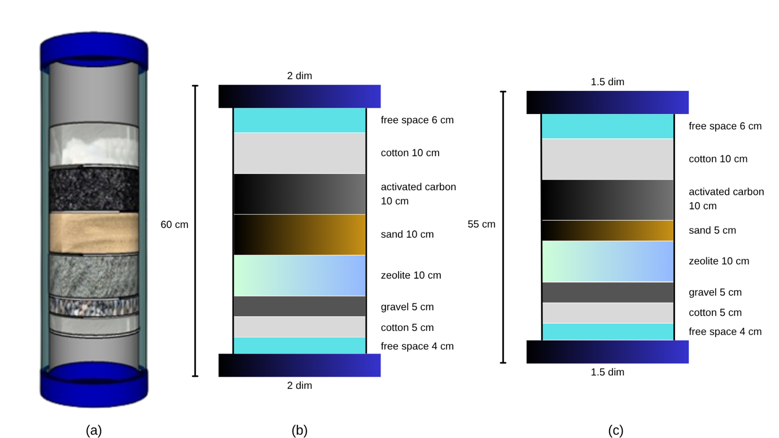
Figure 1. Filter design. (a) Display of contents in the filter; (b) Filter design 1; and (c) Filter design 2

In this research activity, two water filtration units with different sizes and paths have been successfully implemented to maximize the effectiveness of the filtration process. The strategy of using two filters with different characteristics aims to create a layered filtration system, which is not only able to filter large particles, but also ensures that the water produced has a high level of clarity and quality. The first filter has a larger dimension and functions as an initial filtration stage. In this filter, large particles contained in the water will be filtered first, so that the workload on the second filter can be reduced significantly. Meanwhile, the second filter is smaller and is designed for a further filtration process, where small particles that pass through the first filter will be filtered more finely to produce truly clean water.
Based on the results of the implementation of the system, the first filter tool shown in Figures 1 and 1a has a length of 60 cm with a pipe diameter of 2 inch. This filter consists of several layers of media arranged vertically to support the gradual filtration process. The first layer is a 6 cm high free space that functions as the initial distribution space for water before entering the filter media. Next, the water passes through a 10 cm thick cotton layer that plays a role in filtering large to small particles. Underneath it is a 1 kg layer of activated carbon that is responsible for absorbing organic matter, unpleasant odors, and bad tastes in the water. After activated carbon, the water is flowed through a 10 cm thick layer of sand that is effective in holding mud deposits or suspended particles. The next layer is a 10 cm thick zeolite media that functions to reduce the levels of magnesium ions and other heavy metals in the water. Then, the water passes through a 5 cm thick layer of gravel that helps smooth the flow of water and prevents blockages due to deposits. As a final filter, this filter is equipped with another 5 cm thick layer of cotton that functions to capture fine particles that are still left over from the previous layer. The second filter shown in Figure 1b is 55 cm long with a pipe diameter of 1½ inch. Although smaller in size, the arrangement of the filter media is relatively similar to the first filter, but with slight differences in the thickness of several layers. At the beginning, the water also passes through a 6 cm high empty space as a flow stabilizer before entering the 10 cm thick cotton layer. This cotton is again tasked with filtering large and small particles. Next, there is a layer of 1 kg of activated carbon with a similar function, namely absorbing organic matter and eliminating odor and taste. The sand layer on this filter is thinner, namely 5 cm thick, enough to hold mud and suspended particles. Furthermore, the water is flowed through a 10 cm thick zeolite layer for the process of removing heavy metals and hazardous substances. Then there is a 5 cm thick layer of gravel, which functions to keep the flow smooth. As the final stage of filtration, another 5 cm thick layer of cotton is used to filter fine particles that may still be carried over from the previous process.
The combination of these two filters, with different sizes and characteristics of the media in them, has been proven to be able to filter water gradually and optimally. The filtration results show an increase in water quality in terms of clarity and a decrease in contaminant levels, and support the effectiveness of the monitoring sensor performance used in the system. This system is not only structurally efficient, but also provides consistent and reliable filtration results in various water source conditions.
The selection of filter media such as cotton, activated carbon, silica sand, zeolite, and gravel is carefully considered to create a multi-layered filtration system with multiple barriers that target different types and sizes of contaminants, ensuring thorough water purification. Cotton acts as the primary mechanical filter, capturing larger suspended solids and particulate matter. Its fibrous structure effectively traps debris, preventing clogging of subsequent media layers and protecting the activated carbon and finer filter layers from overloading. Activated carbon plays a critical role in adsorbing dissolved organic compounds, chlorine, unpleasant odors, and tastes that cannot be removed by mechanical filtration alone. Its high surface area and porous nature make it highly effective in improving water quality by reducing chemical contaminants and enhancing the sensory qualities of the water. Silica sand provides further mechanical filtration by capturing smaller particles and sediments that pass through the cotton and activated carbon layers. The granular nature of the sand supports the development of biofilms, which can aid in the biodegradation of certain pollutants, further enhancing water purification. Zeolite is used for its ion exchange properties, specifically its ability to adsorb ammonia, heavy metals (such as magnesium and other harmful ions), and other dissolved inorganic contaminants. This makes zeolite important in reducing toxic substances that can have a detrimental effect on aquatic life and water quality. The gravel serves primarily as a support layer that stabilizes the filter media above it and ensures even distribution and smooth flow of water throughout the filter. The gravel also helps prevent clogging by providing sufficient space for water to pass through, thereby maintaining filter efficiency over time. Together, these media form a synergistic filtration system, where each layer targets specific contaminants and protects the next layer, resulting in gradual, effective, and reliable water purification. This combination is based on well-established filtration principles and is supported by numerous studies demonstrating the individual and collective efficacy of these materials in aquaculture and water treatment applications.

Reservoir Height Design
The water reservoir in this system is used to store water before and after the filtration process. Each reservoir has a capacity of 50 L and functions as a temporary storage container so that the filtration process runs more smoothly and efficiently (Figure 2). The water that enters the filtration system comes from the initial reservoir, then after going through the filtration process, clean water will be flowed to the final reservoir before being reused in fish farming. To ensure that the water supply remains available, this system is equipped with an automatic filling mechanism. If the water level in the tank drops to a certain limit, the system will automatically refill the water until it reaches the optimal capacity. Thus, the sustainability of the water cycle in fisheries cultivation is maintained without the need for excessive manual intervention.
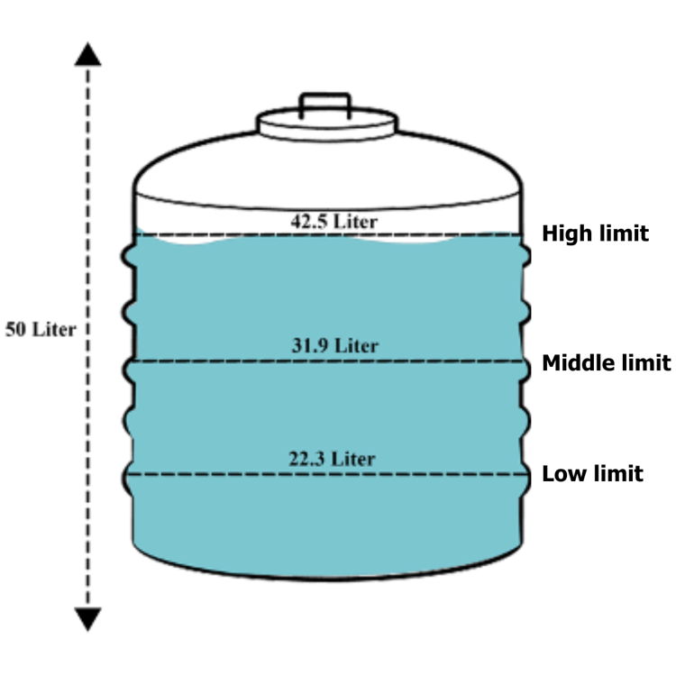
Figure 2. Resevoir design of internet of things (IoT)-based water quality monitoring system

System Analysis
System analysis is essential to support system performance, ensuring that the system created is in accordance with the needs of fisheries cultivation. In addition, this analysis also aims to support the achievement of the main objectives of the system in increasing the efficiency of water quality management. Based on the results of interviews and technical studies, in building and designing IoT-based water quality filtration and monitoring tools in fisheries cultivation systems, several hardware and software components are required.
In supporting this design, several things are needed such as functional and non-functional needs in making the system. Several components are needed in the functional needs analysis. The non-functional needs analysis is carried out to assess factors outside the main system that support the operation of the tool. These needs include analysis of hardware, software, and user needs (brain-ware). In designing and building water quality filtration and monitoring tools in IoT-based fisheries cultivation systems, various hardware and software components are required as listed in Tables 1 and 2. The description of the functional needs analysis can be seen in the following description:
- Using Arduino Uno and NodeMCU ESP32 modules as the system processing center and as a link between the tool and the application via WiFi connectivity.
- Using a turbidity sensor to measure the level of water turbidity in the cultivation system.
- Using a PH-4502C sensor to measure the pH level of the water to ensure optimal conditions for the fish.
- Using a TDS sensor to measure the amount of dissolved solids in the water.
- Displaying real-time water quality monitoring results via an Android-based application.
- Using a water pump to flow the filtered water back into the cultivation pond.

Table 1. Tools and materials of internet of things (IoT)-based water quality monitoring system
Tools and materials | Quantity
½” PVC pipe | 3 m
2” PVC pipe | 1 m
1 ½” PVC pipe | 1 m
L ½” pipe | 12 pcs
Pipe glue | 1 pcs
Cotton | 2 packs
Activated carbon | 2 kg
Sand | 1 kg
Zeolite | 1 kg
Gravel | 1 kg
Laptop | 1 unit

Table 2. Electronic Components of internet of things (IoT)-based water quality monitoring system
Electronic component | Quantity
Arduino Uno | 1 pcs
NodeMCU ESP32 | 1 pcs
Ultrasonic sensors | 1 pcs
Turbidity sensors | 1 pcs
PH-4502C sensor | 1 pcs
TDS sensor | 1 pcs
Selenoid valve | 2 pcs
Water pump | 2 pcs
4 channel relay | 1 pcs
LCD 16x2 | 1 pcs
Power supply 12V 20A | 1 pcs
Buck converter | 1 pcs

The software used in this study consists of various applications and programs to support the monitoring system and sensor data processing. This system uses C and Python-based programming to integrate sensors with microcontrollers. Monitoring data is displayed through an Android-based application that allows real-time monitoring and is stored in a cloud database for further analysis.

Block Diagram
Block diagram is one of the most important parts in system design. This diagram is used to understand the overall workflow of the process implemented in the IoT-based fisheries monitoring and filtration system. Figure 3 shows a block diagram of the design of the water monitoring and filtration tool applied in the fisheries cultivation system. This system consists of several main components that are interconnected. Arduino Uno is given voltage by a 12V power supply which is then reduced to 4.9V using a buck converter. Some of the main sensors used in this system include the Turbidity sensor, PH-4502C sensor, Ultrasonic sensor, and TDS sensor. Arduino Uno is responsible for processing data from these sensors and sending output in real-time to the 16x2 LCD. Meanwhile, NodeMCU ESP32 functions to send measurement results to Android-based applications.
This system is also equipped with actuators that function to maintain the balance of water quality in fisheries cultivation. The solenoid valve will be activated when the ultrasonic sensor detects the water level below the specified limit. In addition, the relay and water pump will be activated if the pH-4502C sensor, turbidity sensor, or TDS sensor detect an imbalance in water quality, so that the filtration system can work to maintain optimal water parameters.

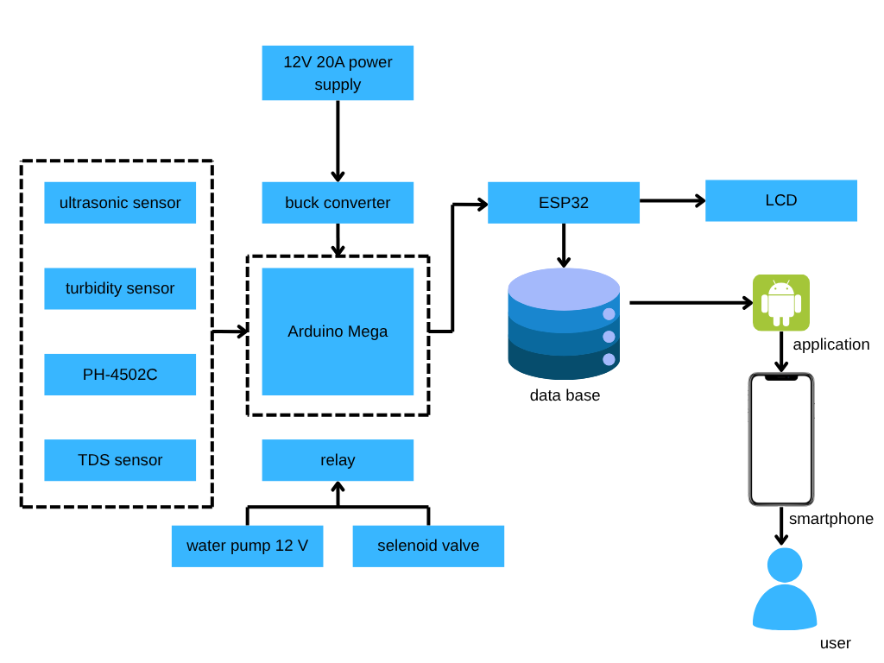
Figure 3. Block diagram of internet of things (IoT)-based water quality monitoring system

Schematic
Figure 4 shows the Proteus schematic that illustrates the entire tool "Design and Construction of Water Quality Filtering and Monitoring Tools in IoT-Based Fisheries Cultivation Systems". This schematic shows how the pH-4502C sensor, turbidity sensor, TDS sensor, and ultrasonic sensor are connected to the Arduino Uno. In addition, the NodeMCU ESP32 is used to retrieve output data from the Arduino Uno and display the results on an Android-based monitoring application.

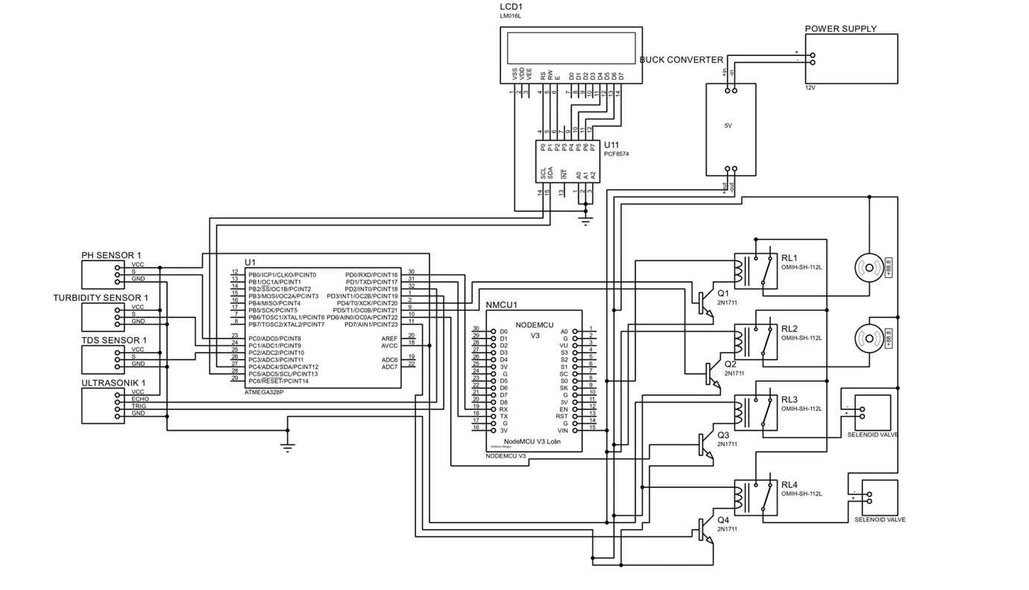
Figure 4. Schematic of internet of things (IoT)-based water quality monitoring system

Measurement of Water Level and Water Quality Parameters
In finding the water level and water quality, several approaches are used, primarily through sensor-based data acquisition and subsequent computational analysis. The calculations for water level are shown in equations 1 and 2, while water quality calculations are detailed in equation 3. To validate the measurements, this research refers to water quality standards from two main national regulations in Indonesia. First, the Regulation of the Ministry of Health of the Republic of Indonesia Number 492/MENKES/PER/IV/2010 concerning the Requirements for Drinking Water Quality is used as a benchmark. This regulation sets maximum allowable limits for various physical and chemical parameters of water—such as turbidity, pH, color, odor, taste, and TDS—to ensure safety and potability (Table 3). Second, to expand the applicability beyond potable water, this research also refers to Government Regulation Number 22 of 2021 concerning the Implementation of Environmental Protection and Management. This regulation establishes Environmental Quality Standards for various classes of surface water. Specifically, Water Class I is used as a reference because it represents the most stringent standard, intended for water sources used as raw water for drinking purposes. Parameters such as temperature deviation (± 3°C from ambient air), turbidity (≤25 NTU), pH (6.0–9.0), TDS (≤1000 mg L⁻¹), as well as allowable concentrations of metals like aluminum (0.2 mg L⁻¹), iron (0.3 mg L⁻¹), manganese (0.4 mg L⁻¹), and copper (2.0 mg L⁻¹), are all regulated under this framework (Menteri Kesehatan Republik Indonesia, 2010; Presiden Republik Indonesia, 2021).
By combining both regulations, this study provides a dual benchmark to evaluate whether the water quality measured by the internet of things (IoT)-based monitoring system aligns with both potable water safety requirements and broader environmental water quality standards. This approach ensures that the developed system is applicable not only in aquaculture but also in environmental monitoring and water resource management contexts.

$Vb =Kt ×15\%$ …………………………. 1
$Vt=Kt-Vb$ ……………………………... 2
$Ta=\left(\frac{Vt}{Kt}\right)× Tt$ ………………………………. 3

Formula description:
Vb = Volume of reduced water
Vt = Remaining water volume
Kt = Total capacity of the reservoir (L)
Ta = Remaining water height (cm)
Tt = Total height of the reservoir

Table 3. Water quality parameters based on Minister of Health Regulation No. 492/2010 and PP no. 22/2021 of internet of things (IoT)-based water quality monitoring system

Parameter | Unit | Permenkes 492/2010 | PP 22/2021 (Class I)
Physical parameters
Odor | - | Odorless | Odorless
Color | TCU | 15 | 50
Total dissolved solids (TDS) | mg L⁻¹ | 500 | 1000
Turbidity | NTU | 5 | 25
Taste | - | Tasteless | -
Temperature | °C | ± Air temperature | ±3 from ambient
Chemical parameters
pH | - | 6.5-8.5 | 6.0-9.0
Aluminum (Al) | mg L⁻¹ | 0.2 | 0.2
Iron (Fe) | mg L⁻¹ | 0.3 | 0.3
Manganese (Mn) | mg L⁻¹ | 0.4 | 0.4
Zinc (Zn) | mg L⁻¹ | 3.0 | 5.0
Copper (Cu) | mg L⁻¹ | 2.0 | 2.0
Ammonia (NH₃-N) | mg L⁻¹ | 1.5 | 0.5
Chloride (Cl⁻) | mg L⁻¹ | 250 | 600
Sulfate (SO₄²⁻) | mg L⁻¹ | 250 | 400
Hardness (as CaCO₃) | mg L⁻¹ | 500 | -

Flowchart
At this stage, a flowchart is designed to describe and simplify the series of processes or procedures in the filtration system and water quality monitoring in the IoT-based fisheries cultivation system. This flowchart aims to facilitate understanding of the system workflow and how each component interacts in the processing and monitoring of water quality.
From Figure 5, it can be explained how the system works as a whole. The first stage is sensor initialization, where sensor readings are carried out alternately. The first sensor to be read is the ultrasonic sensor, then the pH-4502C sensor, followed by the turbidity sensor, and finally the TDS sensor. Each sensor data is displayed in real-time on the LCD that has been installed in the monitoring system. Each sensor has its own conditions in the system. The ultrasonic sensor is used to detect the water level in the reservoir. If the water level in reservoir 1 is less than 15%, the solenoid valve will open to fill water into the reservoir. Otherwise, the solenoid valve remains closed. A similar process occurs in tank 2, but in this tank a water pump is used to regulate the water flow. The pH-4502C sensor functions to detect the pH level of water with a normal range of 6.5-8.0. If the pH value is outside this limit, the system will give a warning to the monitoring application. The Turbidity sensor is used to measure the turbidity level of water with a normal range of 5-25 NTU. If the turbidity level exceeds the specified limit, the system will activate the filtration process. The TDS sensor is used to measure the total dissolved solids in water with a normal range of 300-600 mg L⁻¹. If the TDS value is outside the limit, the system will automatically turn on the water pump to channel water into the filter for the filtration process. After the filtration process is complete, the water in the tank will be monitored again to ensure that the water quality parameters are in accordance with the standards set in fish farming. If all parameters have met the standards, the water is considered suitable for reuse in the cultivation system. All data obtained from the sensor will be displayed in real-time on the Android-based application, so that users can easily monitor water conditions and take action if necessary.

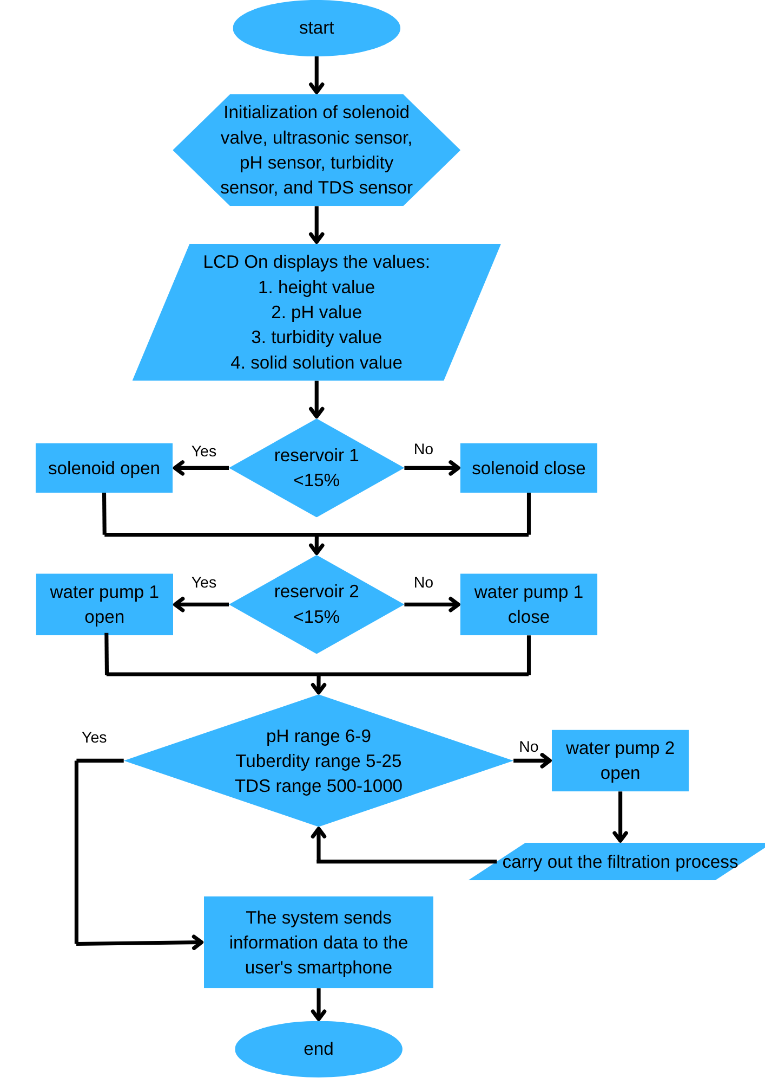
Figure 5. Flowchart of Internet of Things (IoT)-based water quality monitoring system

Overall Design and Placement
The design of an IoT-based water quality monitoring and filtration system in fisheries cultivation is carried out to ensure efficiency and effectiveness in monitoring and managing water. This system consists of various hardware and software components designed to work in an integrated manner, allowing users to monitor water quality in real-time through an Android application (Figure 6).
In the developed Android application system, there is one main type of user, namely User, who has access to monitoring features and water quality history information. The Use Case Diagram illustrates user interaction with the system. Users can access the main page of the application which contains the menu options Tank 1, Tank 2, and Monitoring History. Users can view water quality data, including parameters pH, turbidity, TDS, and water level in the tank in real-time. In addition, users can also access the history page that stores monitoring data with updates every 30 minutes. This system does not allow users to control the device directly, but only functions as a monitoring tool and provides warnings if the water quality parameters are outside normal limits.
To store data obtained from sensors, the system uses a database designed with entity relationship diagram (ERD). This database consists of two main tables, namely Tandon and Riwayat. The Tandon table is used to store water quality data obtained from sensors, including Tandon ID, water pH, turbidity, total dissolved solids (TDS), and water level. This data is updated in real-time to provide an overview of water conditions in the cultivation system. Meanwhile, the Riwayat table functions to store historical data from water quality parameters, such as Tandon ID, water pH, turbidity, TDS, time and date of recording, and water status (suitable or unsuitable). Storing this historical data is useful for analyzing trends in water quality changes over a certain period of time.
Data flow diagram (DFD) is used to describe the flow of data in the system. The level 0 DFD of this application shows how sensor data is collected and processed to be displayed to the user. The data collection process is carried out with sensors that read water quality parameters periodically, then send data to the processing system using Arduino and ESP32 microcontrollers. The data obtained is then stored in a database and displayed on an Android application. In the monitoring process, users can open the application to view water parameters in real time. If one of the parameters exceeds the specified limit, the system will provide a notification to the user. Historical data can also be accessed for further analysis.
The design of the user interface (UI) aims to provide an intuitive and easy-to-use display. When first opened, the application will display a loading screen before entering the main page. The main page has a main menu consisting of Tank 1, Tank 2, and Monitoring History. The monitoring page displays water quality data for each tank, including water pH, turbidity, TDS, and water level, which are updated in real time based on sensor readings. In addition, the monitoring history page displays a history of changes in water quality based on the data that has been collected. Warning notifications are given if the water quality parameters exceed normal limits, and the data is updated every 30 minutes to provide an overview of the water conditions in the cultivation system.

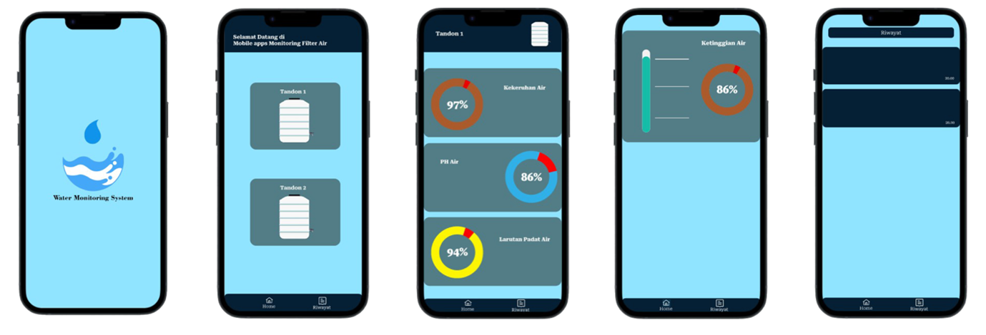
Figure 6. Page view on smartphone of internet of things (IoT)-based water quality monitoring system
This research has successfully designed and realized a sensor-based water quality monitoring and filtration system on a laboratory scale with a fully integrated structure and devices. This system consists of several main components designed to support the layered water filtration process and real-time water quality monitoring. The water used in the system comes from a well and is stored in a main tank with a capacity of 350 L with a height of 3.5 m from the ground. This main tank is designed with an automatic filling system that allows water to refill when its volume is below a certain threshold, thus ensuring a stable and efficient water supply during the filtration process.
Furthermore, water from the main tank is channeled to the filtration system through a mechanism controlled by a solenoid valve, which functions as an automatic tap. The first stage of filtration is carried out with the help of Water Pump 1 which pushes water towards Water Filter 1. Water that has passed through the first filter then enters Tank 1 with a capacity of 50 liters. If the filtration results do not meet quality standards, the water will be reprocessed by Water Pump 2 and channeled to Water Filter 2 for further filtration. The results of this process are then collected in a temporary reservoir which is used as a medium for reading sensor data before the water is used further.
This system is also equipped with various sensors installed to monitor water quality directly. These sensors include pH sensor, turbidity sensor, TDS sensor, and ultrasonic sensor, each of which is installed on Tank 1 and Tank 2 to detect water quality parameters such as acidity, turbidity, dissolved substance levels, and water level in the tank. Data from these sensors is displayed via a 16x2 LCD installed on the panel box, which is also the control center of the entire monitoring system.
The entire system is built in one sturdy and compact frame unit, with the main frame size being 83 cm (width), 61 cm (length), and 120 cm (height). Meanwhile, the system box used to place electronic devices and controls has dimensions of 20 cm (width), 15 cm (length), and 25 cm (height). The integration between the filtration system and the monitoring system makes this device not only effective in purifying water, but also capable of providing real-time water quality data that can be used for continuous evaluation and control of water quality. With the success of this implementation, the filtration and monitoring system developed in this study can be used as a basic model for applications on a wider scale, such as households, agriculture, and small industries.

System Testing Scenario
The system testing stage is carried out to evaluate the performance of the filtration device and the IoT-based water quality monitoring system. This test aims to ensure that the system runs according to the design and can provide accurate and efficient results. The following are the stages of the test scenario carried out:
- Arduino Uno and ESP32 testing
In the first stage, a connection test was carried out between the Arduino Uno and ESP32. The purpose of this test is to ensure that the Arduino Uno can process data from the sensor and send the results to the ESP32, which will then send the data to the Android-based monitoring application. The expected result is that the system can send all sensor data in real-time without interruption. In these sensor tests, the test was carried out for 135 seconds, where data was taken every 15 seconds to obtain the results of each test.
- Sensor testing and calibration
The second stage is testing all sensors used, including the pH-4502C sensor, turbidity sensor, TDS sensor, and ultrasonic sensor. Each sensor is tested and calibrated to ensure that the data produced is accurate and in accordance with the specified standards. The expected result is that the sensor can read water quality parameters with a high level of accuracy. As a comparison tool for the IoT-based water quality monitoring system used in this study, several conventional methods and other tools that have proven their accuracy were also applied. First, conventional laboratory testing was carried out for pH, TDS, and turbidity parameters, using standard tools such as digital pH meters, TDS meters, and turbidimeters with high precision. Second, the measurement results were compared with other commercial water quality monitoring systems that are already available on the market and have a good reputation, such as AquaMonitor and Sensorex. These systems were chosen because they have been widely used in automatic water quality monitoring and are considered to have a high level of accuracy. Third, verification was also carried out through manual measurements using a laboratory kit simultaneously with data collection from the IoT system. The purpose of this step is to test the validity of the data generated by the IoT-based system through comparison with standardized manual methods.
- Water pump and relay testing
In the third stage, testing was carried out on the water pump system and the relay which functions as an automatic switch to activate and deactivate the water flow in the filtration system. The purpose of this test is to ensure that the water pump can work according to the programmed conditions based on data from the sensor.
- Testing the effectiveness of filtration
The fourth stage is testing the performance of the filtration system by comparing the quality of water before and after going through the filter. The parameters measured include turbidity levels, pH, and TDS content. The expected result is that water that has gone through the filtration process has better quality than before being filtered, in accordance with water quality standards for fish farming. In this testing process, the system also calculates the level of accuracy and the difference between the sensor readings and the reference values ​​obtained from the standard tool. Two main formulas are used in this test. First, to calculate the difference, equation 4 is used. Where Measured is the value obtained from the sensor, and Reference is the reference value from the standard tool used as a comparison. Furthermore, to calculate the level of accuracy, equation 5 is used, which shows the percentage of sensor accuracy. The higher the percentage of accuracy, the more precise the sensor reading is to the reference value. With this method, the reliability of the system can be evaluated quantitatively before being fully used in the water monitoring and filtration process. In the effectiveness of filtration tests carried out for 7 days. From these results, further analysis was carried out by comparing the values ​​before and after filtration and then readjusted with references from Permenkes No. 492 of 2010 and PP No. 22 of 2021.

$Difference = Measured – Reference$ ………………………………….. 4
$Accuracy (\%) = (1 - (Difference / Reference)) × 100$ ……….. 5

- Overall system testing
The final stage is testing the entire system, including the monitoring application, sensor data processing system, and filtration equipment. The purpose of this test is to ensure that all components work in an integrated manner and provide results that are in accordance with the designed specifications. The expected result is that the system can help users monitor water quality accurately and ensure that the filtration process runs optimally according to predetermined standards.

RESULTS AND DISCUSSION
This study was carried out to design and develop an automatic filtration device and an internet of things (IoT)-based water quality monitoring system applied in a fish farming system. The developed system integrates several air quality sensors, namely pH sensors, turbidity sensors, and TDS sensors, which are connected to actuators in the form of water pumps and solenoid valves. These components are controlled automatically and will only be active when the air quality parameters are detected to be outside the safe threshold. Thus, this system is able to maintain optimal air quality to support fish growth.
The sensors used in this system are able to send data in real time to the Android application and display it on the LCD screen. This allows users to maintain air conditions continuously without the need for manual measurements. The results of the sensor test showed good and accurate performance. The pH sensor recorded values ​​between 6.1 and 6.7 with an accuracy of 96.51%. This range has largely met the water quality standard requirements according to Minister of Health Regulation (Permenkes) No. 492 of 2010 which stipulates the ideal pH between 6.5 to 8.5, and Government Regulations (PP) No. 22 of 2021 which stipulates the pH of class I air between 6.0 to 9.0. The TDS sensor shows a value between 601 to 690 ppm with an accuracy of 98.19%. Although this value exceeds the maximum limit of 500 ppm for direct drinking water according to Permenkes No. 492 of 2010, it is still below the maximum limit of 1000 ppm for raw water according to PP No. 22 of 2021, so it is still safe for use in fish farming. The turbidity sensor recorded a value between 2.1 to 5.5 NTU (accuracy 97.03%), where a small number of values ​​exceeded the limit of 5 NTU according to Permenkes, but all were still below the maximum limit of 25 NTU according to PP No. 22 of 2021. The explanation of these values ​​can be clearly seen in Figures 7 to 12.
The designed filtration system has proven to be effective in improving air quality. After the filtration process, the air turbidity level decreased by 58.87%, TDS level decreased by an average of 26.80%, and the pH value became more stable with a pH improvement of 7.3%. This shows that this system is able to maintain air quality parameters within optimal limits and in accordance with applicable regulations. In addition, the automatic operation of pumps and solenoid valves ensures the availability of clean water without manual intervention. This system is also considered more efficient than conventional monitoring methods because it can reduce the need for labor, save air and energy usage, and provide early warning if there is a significant change in air quality.
Although the system has shown positive results, there are several challenges faced in development, especially related to sensor durability in environments with high organic content, as well as decreased accuracy if the sensor is not calibrated regularly. Therefore, further development is recommended to add additional sensors such as DO and ammonia sensors, as well as implementing artificial intelligence (AI) technology to analyze air quality change patterns and provide automatic action recommendations. In addition, the use of renewable energy such as solar panels can also increase overall energy efficiency. This effort is in line with the concept of the blue economy which is part of the Indonesian government's policy, especially the Ministry of Maritime Affairs and Fisheries, in encouraging sustainable and environmentally friendly aquaculture practices.
Overall, the IoT-based air quality monitoring and filtration system developed in this study has been proven to be able to maintain air quality parameters within safe limits in accordance with PP No. 22 of 2021 as raw water, and in many cases also meets the standards of Permenkes No. 492 of 2010 for drinking water. With broad development potential, this system is very suitable for application in the modern aquaculture industry that prioritizes efficiency, insecticides, and environmental protection.

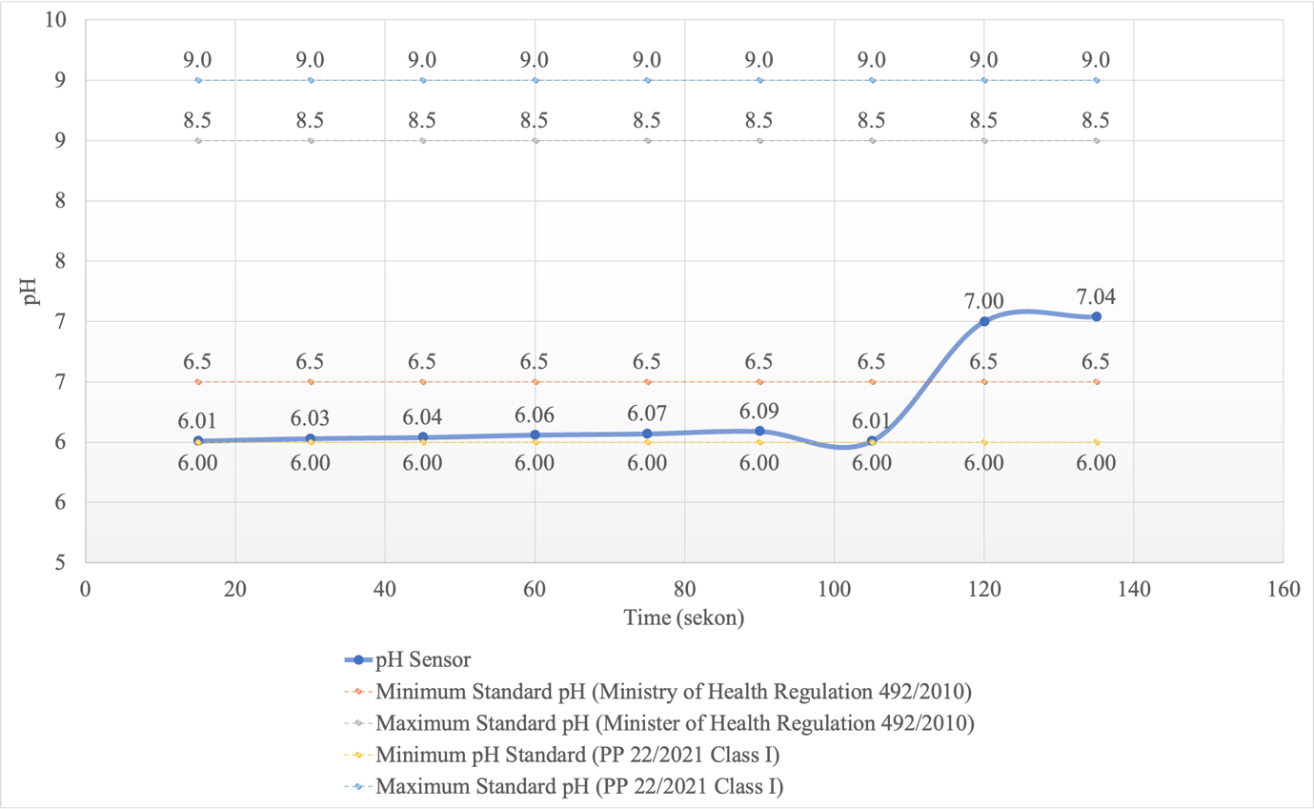
Figure 7. Comparison of pH sensor readings with regulatory standard ranges over time

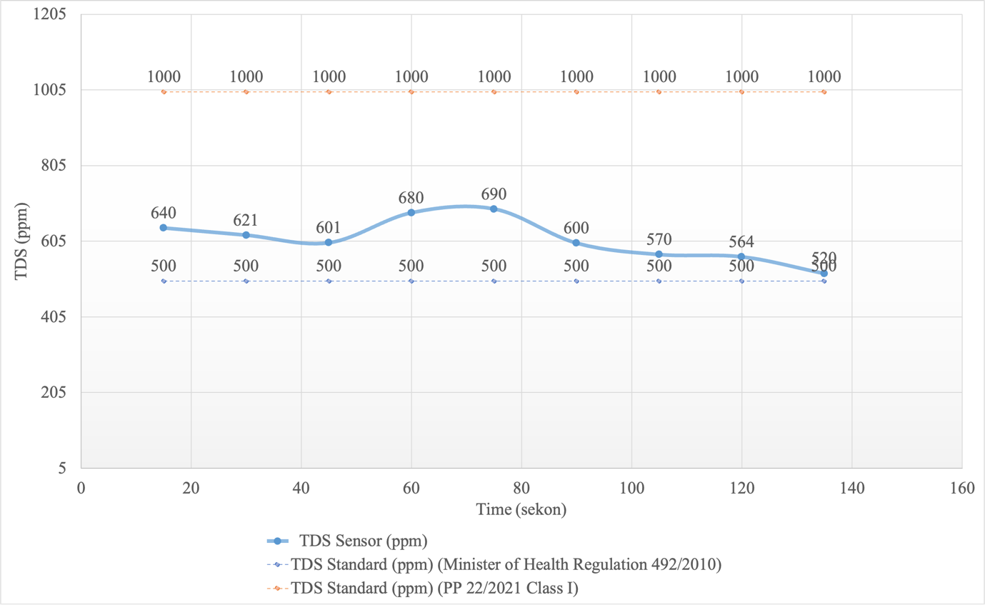
Figure 8. Comparison of total dissolved solids (TDS) sensor readings with regulatory standards over time

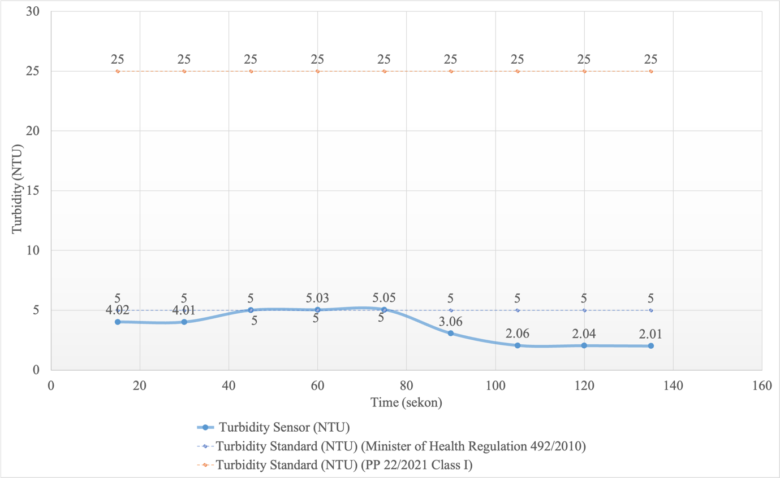
Figure 9. Comparison of turbidity sensor readings with regulatory standards over time

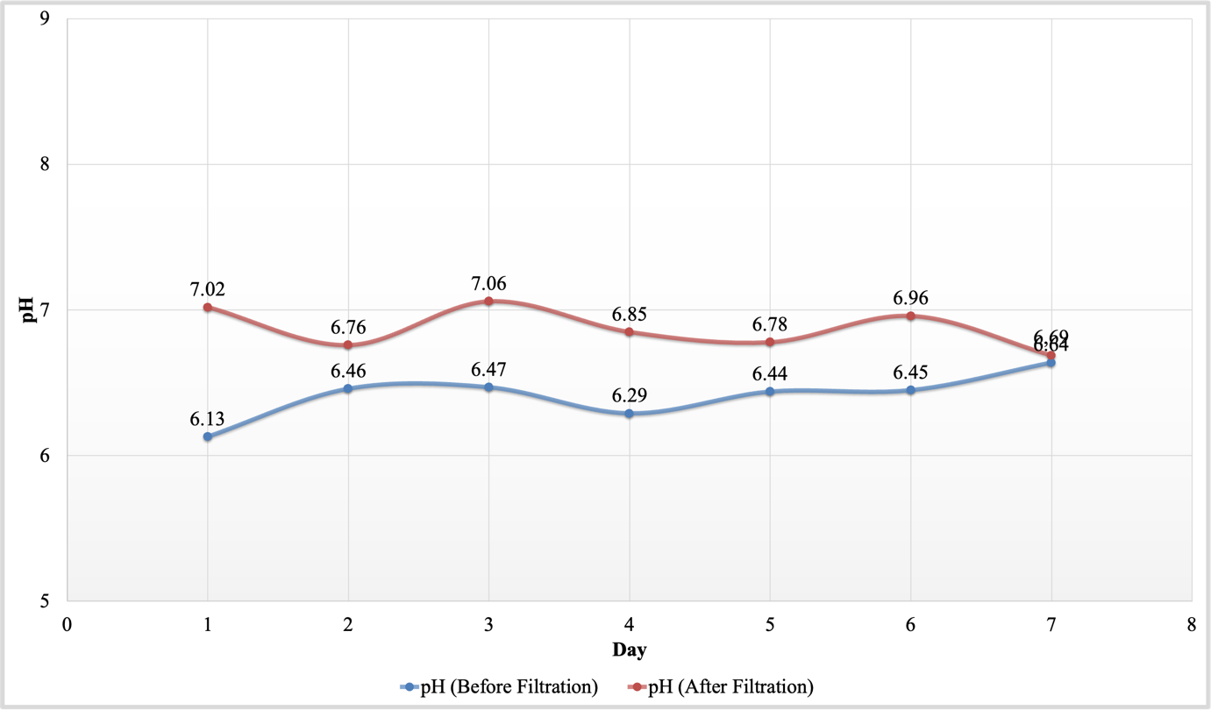
Figure 10. Comparison of water pH levels before and after filtration

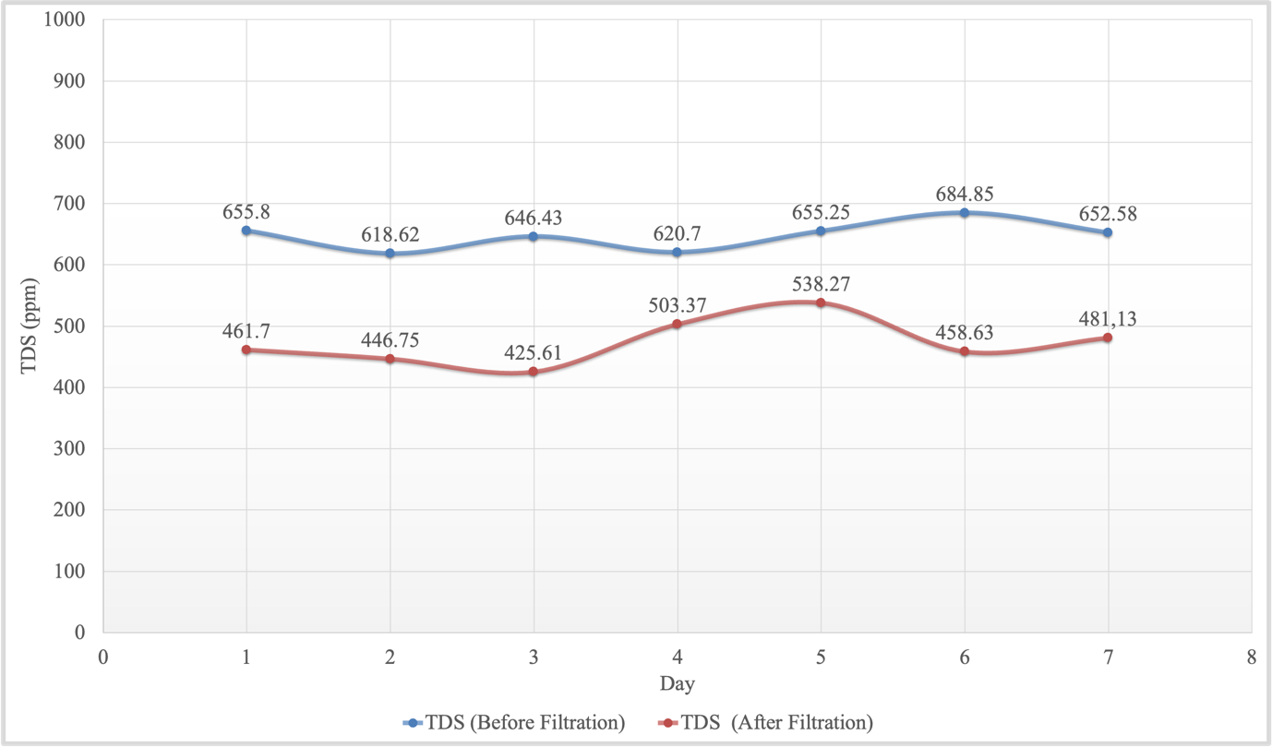
Figure 11. Comparison of total dissolved solids before and after filtration

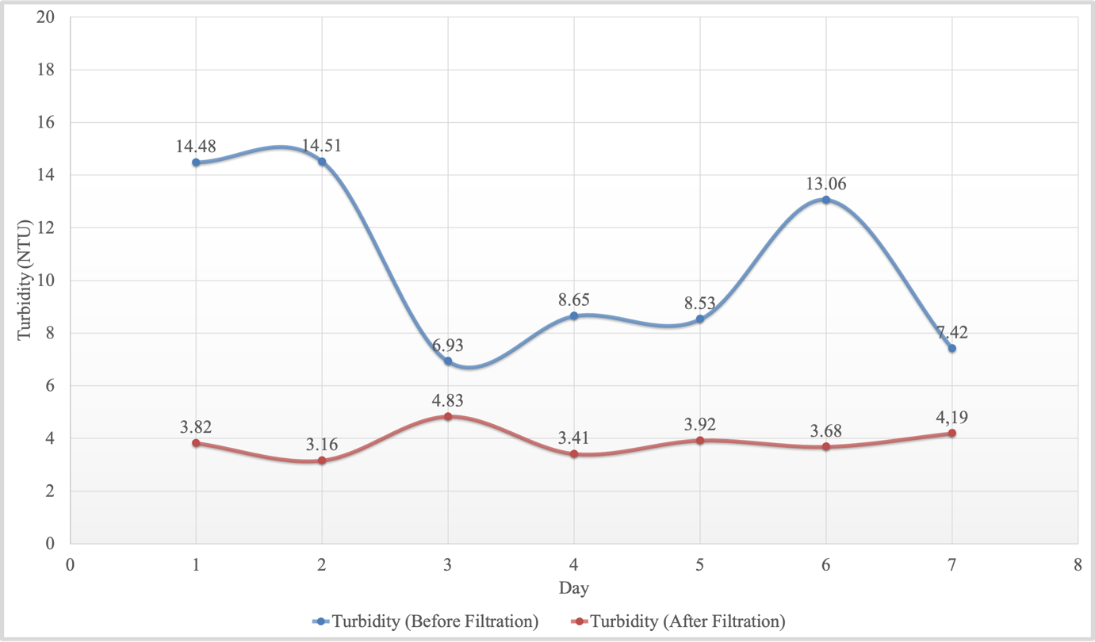
Figure 12. Comparison of water turbidity levels before and after filtration

CONCLUSIONS
This research successfully designed and developed an automatic filtration system and water quality monitoring based on the internet of things (IoT) applied to the fish farming system. This system is able to monitor and control water quality in real-time through the integration of pH, turbidity, and TDS sensors, which are connected to actuators in the form of water pumps and solenoid valves. This actuator works automatically when the water quality parameters are outside the safe limits. The test results show that this system is effective in improving water quality, as indicated by a decrease in turbidity levels of 58.87%, an average decrease in TDS of 26.80%, and stability of pH values ​​with an improvement of 7.3%. These values ​​have complied with water quality standards based on Government Regulation No. 22 of 2021 as raw water, and in many cases also meet the Regulation of the Minister of Health No. 492 of 2010 for drinking water. The effectiveness of the sensors used is also quite high, with the pH sensor showing an accuracy of 96.51%, the TDS sensor having an accuracy of 98.19%, and the turbidity sensor being able to record consistent results even though some of the values ​​slightly exceed the limits of the Minister of Health Regulation, but still below the maximum limit of Government Regulation No. 22 of 2021. This shows that the developed water quality monitoring system is able to provide accurate and reliable measurement results to support the automatic filtration process. This system has also proven to be more efficient than conventional methods because it can reduce the need for labor, save water and energy usage, and provide early warning if there is a significant change in water quality. Support for data display via Android applications and LCD screens makes it easier for users to monitor. Overall, this system has great potential to be implemented in the modern aquaculture industry that prioritizes efficiency, sustainability, and environmental protection, in line with the blue economy concept which is a priority of the Indonesian government.

ACKNOWLEDGMENTS
Thank you to the Ministry of Marine Affairs and Fisheries and Institute of Business and Technology Indonesia for all the support they have provided.

FUNDING
The funds for this research came from the authors' personal funds.

AUTHOR CONTRIBUTION
IGMND: Conceptualization, data curation, formal analysis, funding acquisition, investigation, methodology, project administration, resources, software, supervision, and validation; IMAN: data curation, formal analysis, funding acquisition, investigation, methodology, project administration, resources, supervision, validation, visualization, writing – original draft, and writing – review and editing; AAGE: data curation, formal analysis, funding acquisition, investigation, methodology, project administration, resources, software, supervision, and validation.

DECLARATION OF COMPETING INTEREST AND USE GENERATIVE AI
The authors declare no competing interests.
REFERENCES
Adhawati, S. S., & Nuryanti, D. M. (2021). Economic valuation of seaweed cultivation in mangrove ecosystem waters Nunukan district: The outer islands of the Indonesia-Malaysia border. Plant Archives, 21(1), 1924–1928. https://doi.org/10.51470/plantarchives.2021.v21.s1.312
Arepalli, P. G., & Naik, K. J. (2024). A deep learning-enabled IoT framework for early hypoxia detection in aqua water using light weight spatially shared attention-LSTM network. Journal of Supercomputing, 80(2), 2718–2747. https://doi.org/10.1007/s11227-023-05580-x
Ariadi, H., Linayati, & Mujtahidah, T. (2023). Oxygen transfer rate efficiency of paddle wheel aerators in intensive shrimp ponds. BIO Web of Conferences, 74, 01012. https://doi.org/10.1051/bioconf/20237401012
Bareta, B. P. C., Harijanto, A., & Maryani. (2021). Rancang bangun alat ukur sistem monitoring pH, temperatur, dan kelembapan akuarium ikan hias berbasis Arduino Uno. Jurnal Pembelajaran Fisika, 10(1), 1–7. https://doi.org/10.19184/jpf.v10i1.21900
Boyd, C. E., & McNevin, A. A. (2021). Aerator energy use in shrimp farming and means for improvement. Journal of the World Aquaculture Society, 52(1), 6–29. https://doi.org/10.1111/jwas.12753
Cokrowati, N., Risjani, Y., Andayani, S., & Firdaus, M. (2023). The potential and development of seaweed cultivation in Lombok: A review. Jurnal Biologi Tropis, 23(1), 202–212. https://doi.org/10.29303/jbt.v23i1.4654
Desnanjaya, I. G. M. N., & Nugraha, I. M. A. (2022). Design and build body temperature detection and personal identity recognition through E-ID card and photo based on IoT. International Symposium on Electronics and Smart Devices (pp. 1-5). IEEE. https://doi.org/10.1109/ISESD56103.2022.9980725
Desnanjaya, I. G. M. N., Wiguna, I. K. A. G., Putra, I. D. P. G. W., & Nugraha, I. M. A. (2024). Peningkatan kualitas dan ekonomi nelayan melalui pelatihan penggunaan alat pengering ikan (dryfitech) menggunakan teknologi IoT. Jurnal Masyarakat Mandiri, 8(5), 5224–5236. https://doi.org/https://doi.org/10.31764/jmm.v8i5.26445
Hakim, A. R., Fauzi, A., Hidayat, F., Handoyo, W. T., & Waryanto. (2023). Application of automated paddlewheel aerator in shrimp culture pond; effect on water quality, energy cost and biomass. BIO Web of Conferences, 74, 01007. https://doi.org/10.1051/bioconf/20237401007
Hariyadi, H., Kamil, M., & Ananda, P. (2020). Sistem pengecekan ph air otomatis menggunakan sensor ph probe berbasis arduino pada sumur bor. Rang Teknik Journal, 3(2), 340–346. https://doi.org/10.31869/rtj.v3i2.1930
Iskandar, Y., Wahyuni, R. S., Rohmat, R., Darwis, R., & Oktaviani, I. (2022). Filtrasi air dengan menggunakan alat sederhana untuk menghasilkan air bersih bagi warga desa Cikurutug kecamatan Cireunghas. PengabdianMu: Jurnal Ilmiah Pengabdian Kepada Masyarakat, 7(1), 74–79. https://doi.org/10.33084/pengabdianmu.v7i1.2301
Latukolan, G. J., & Wastumirad, A. W. (2024). Rancang bangun sistem monitoring kualitas air sungai berbasis aplikasi smartphone. Jurnal Teknologi Informasi dan Komunikasi), 8(2), 255–264. https://doi.org/10.35870/jti
Lubis, I., & Pulungan, A. B. (2023). Rancang bangun alat monitoring kualitas air berbasis online. Jurnal Teknik Elektro Indonesia, 4(2), 462–472. https://doi.org/10.24036/jtein.v4i2.398
Menteri Kesehatan Republik Indonesia. (2010). Peraturan Menteri Kesehatan Republik Indonesia Nomor 492/MENKES/PER/IV/2010 tentang Persyaratan Kualitas Air Minum. Kementerian Kesehatan Republik Indonesia.
Onyutha, C., Okello, E., Atukwase, R., Nduhukiire, P., Ecodu, M., & Kwiringira, J. N. (2024). Improving household water treatment: Using zeolite to remove lead, fluoride and arsenic following optimized turbidity reduction in slow sand filtration. Sustainable Environment Research, 34(1), 1–15. https://doi.org/10.1186/s42834-024-00209-x
Presiden Republik Indonesia. (2021). Peraturan Pemerintah Republik Indonesia Nomor 22 Tahun 2021 tentang Penyelenggaraan Perlindungan Pengelolaan Lingkungan Hidup.
Purwanti, E., Ramdani, D., Rahmadewi, R., Nugraha, B., Efelina, V., & Dampang, S. (2021). Sosialisasi manfaat karbon aktif sebagai media filtrasi air guna meningkatkan kesadaran akan pentingnya air bersih di SMK PGRI Cikampek. Selaparang Jurnal Pengabdian Masyarakat Berkemajuan, 4(2), 381–386. https://doi.org/10.31764/jpmb.v4i2.4389
Sasmoko, D., Rasminto, H., & Rahmadani, A. (2019). Rancang bangun sistem monitoring kekeruhan air berbasis IoT pada tandon air warga. Jurnal Informatika Upgris, 5(1), 25–34. https://doi.org/10.26877/jiu.v5i1.2993
Sofarini, D., Yunandar, Y., & Nurhidayah, R. (2022). Perbaikan kualitas air kolam budidaya ikan dengan sistem filtrasi di kecamatan Bakumpai Barito Kuala Kalimantan Selatan. Jurnal Abdi Insani, 9(4), 1486–1494. https://doi.org/10.29303/abdiinsani.v9i4.789
Utari, P., Masrullita, Ibrahim, I., Suryati, & Sulhatun. (2022). Efektifitas pengolahan air sumur menggunakan media zeolit, pasir silika dan karbon aktif pada alat roughing filter aliran horizontal. Chemical Engineering Journal Storage, 2(3), 127–142. https://doi.org/10.29103/cejs.v2i3.6023
Velarde, L., Nabavi, M. S., Escalera, E., Antti, M. L., & Akhtar, F. (2023). Adsorption of heavy metals on natural zeolites: A review. Chemosphere, 328, 138508. https://doi.org/10.1016/j.chemosphere.2023.138508
Xu, Y., Jin, J., Zeng, S., Zhang, Y., & Xiao, Q. (2023). Development and evaluation of an IoT-based portable water quality monitoring system for aquaculture. Inmateh - Agricultural Engineering, 70(2), 359–368. https://doi.org/10.35633/inmateh-70-35
Yuniarti, N., Hariyanto, D., Yatmono, S., & Abdillah, M. (2021). Design and development of IoT based water flow monitoring for Pico hydro power plant. International Journal of Interactive Mobile Technologies, 15(7), 69–80. https://doi.org/10.3991/ijim.v15i07.18425
Zaenurrohman, Susanti, H., Hazrina, F., & Rahmat, S. (2023). Sistem penjernih air otomatis dengan filtrasi berulang dan monitoring kekeruhan berbasis IoT. Infotronik : Jurnal Teknologi Informasi dan Elektronika, 8(1), 1–11. https://doi.org/10.32897/infotronik.2023.8.1.2725
Zahra, A., Mansyur, K., & Putra, A. E. (2023). Pengaruh filter berbeda terhadap parameter kualitas air media pemeliharaan ikan mas (Cyprinus carpio). Jurnal Ilmiah AgriSains, 24(2), 92–102. https://doi.org/10.22487/jiagrisains.v24i2.2023.92-102

