AUTHORSHIP STATEMENT

Manuscript title : Dietary Chitosan/Nano-chitosan of Black Soldier Fly Larvae Improves Growth and Physiological indices of Clarias gariepinus
__________________________________________________________________

I, the undersigned and on behalf of all the authors listed below declared that all authors have contributed, read and approve the written research work described in this manuscript to be submitted to the Jurnal Riset Akuakultur. We also acknowledge that the copyright of this article will be transferred to the journal once accepted for publication.
We confirm that the role of each author (abbreaviate name) as the following based on CRedit taxonomy (https://credit.niso.org/):
RA performed literature analysis, experimental activities, writing of the manuscript, and critically analyzed the manuscript. NM contributed to the experimental activities, literature analysis, data collection, and writing of the manuscript. RR collected, handled, and validated the data. HM prepared the experimental activities, data handling, and validation. RAN performed the experiments and wrote the manuscript.

Retno Aryani | Corresponding and Co-Author
Nawwar Mardianto | First author
Rudianto Rudianto | Co-Author
Hetty Manurung | Co-Author
Rudy Agung Nugroho | Co-Author

Sincerely,
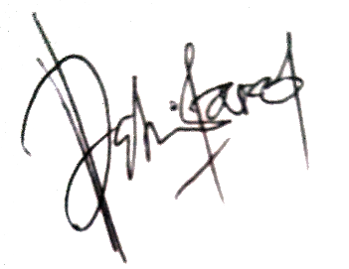
Corresponding Author

Retno Aryani

