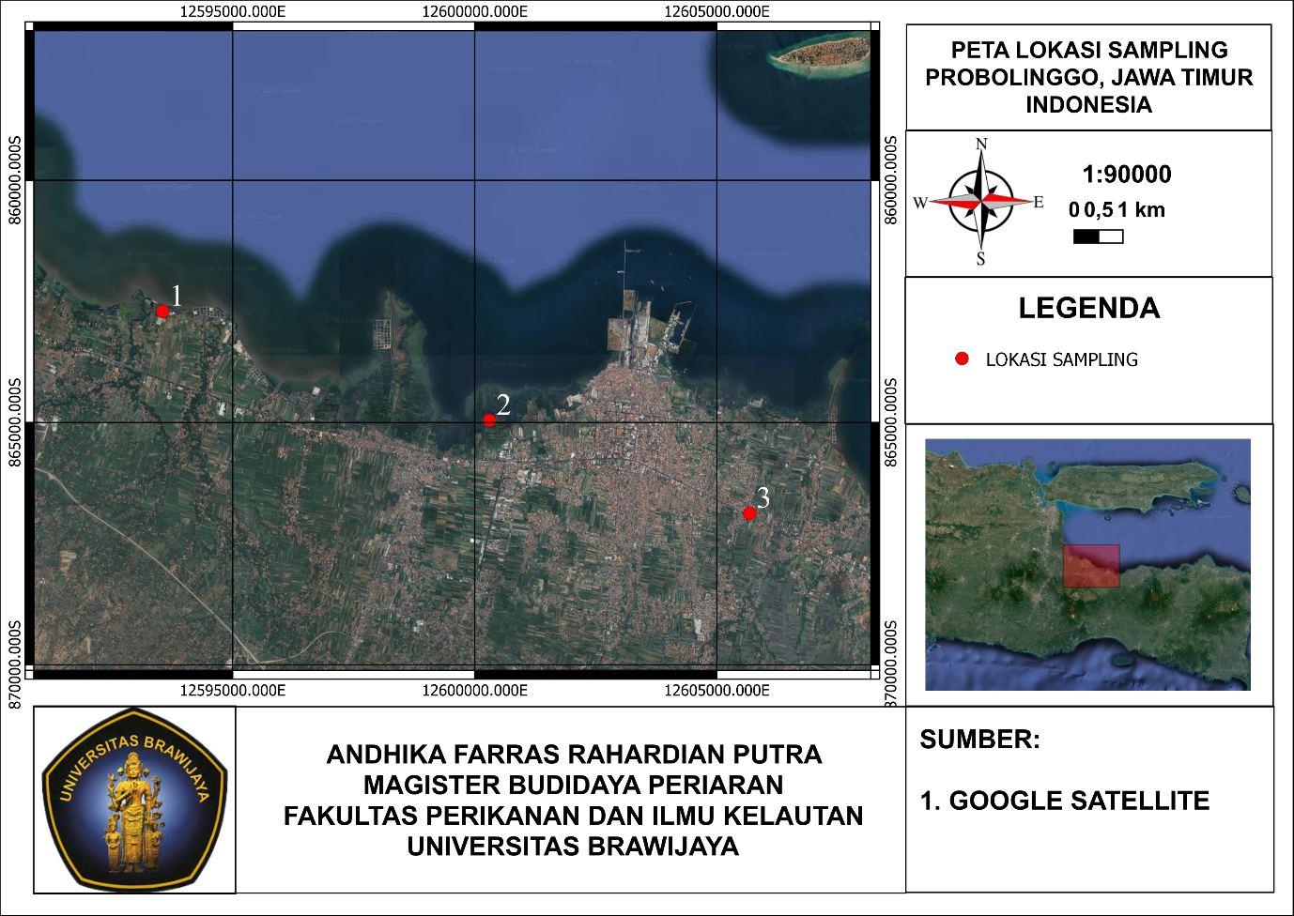
Gambar 1. Lokasi Pengambilan Sampel Penelitian

Figure 1. Research Sampling Location

Tabel 1. Interpretasi Nilai r Korelasi Spearman
Table 1. Interpretation of Spearman Correlation r Value

Nilai r | Interpretasi
0,00-1,199 | Sangat rendah
0,20-0,399 | Rendah
0,40-0,599 | Sedang
0,60-0,799 | Kuat
0,800-1,000 | Sangat kuat

Tabel 2. Kelimpahan Mikroplastik pada Organ Insang dan Usus Udang Vannamei
Table 2. Abundance of Microplastics in the Gills and Intestines of Vannamei Shrimp

Lokasi | Sampling | Kelimpahan Mikroplastik (Partikel/gr)
Lokasi | Sampling | Insang | Usus
Tambak 1 | 1 | 77.05 | 1736.43
Tambak 1 | 2 | 86.35 | 1987.95
Tambak 1 | 3 | 93.88 | 2075.42
Tambak 2 | 1 | 71.43 | 1359.29
Tambak 2 | 2 | 85.24 | 1711.06
Tambak 2 | 3 | 85.81 | 1834.67
Tambak 3 | 1 | 55.56 | 1497.84
Tambak 3 | 2 | 83.51 | 1558.65
Tambak 3 | 3 | 91.27 | 1931.08

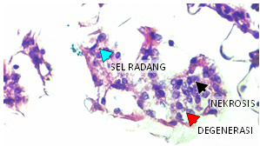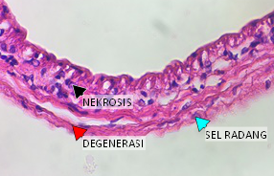
b)
a)
Gambar 2. a) Histopatologi Kerusakan Organ Insang, b) Histopatologi Kerusakan Organ usus

Figure 2. a) Histopathology of Gill Organ Damage, b) Histopathology of Intestinal Organ Damage

Tabel 3. Tingkat Kerusakan Organ pada Insang dan Usus Udang Vannamei
Table 3. Level of Organ Damage to Gills and Intestines of Vannamei Shrimp

Tambak | Sampling | Skor Insang | Degenerasi | Nekrosis | Inflamasi
1 | 1 | 1 | 1.6 | 1 | 1.4
1 | 2 | 1.8 | 2.2 | 2.2 | 1.4
1 | 3 | 1.4 | 3 | 2.6 | 2.6
2 | 1 | 0.8 | 1.6 | 1.4 | 1.4
2 | 2 | 1.4 | 1.8 | 1.6 | 1.6
2 | 3 | 2.8 | 2.2 | 2.2 | 1.8
3 | 1 | 0.8 | 1.2 | 1.4 | 1
3 | 2 | 1.2 | 1.4 | 1.6 | 1.4
3 | 3 | 2.2 | 2.2 | 2.2 | 2.2

