AUTHORSHIP STATEMENT

Manuscript title :
Modelling Dissolved Oxygen Dynamics In Intensive Aquaculture Systems : A Comparative Study Of Linear Regression And Random Forest Approaches _________________________________________________________________________

I, the undersigned and on behalf of all the authors listed below declared that all authors have contributed, read and approve the written research work described in this manuscript to be submitted to the Jurnal Riset Akuakultur. We also acknowledge that the copyright of this article will be transferred to the journal once accepted for publication.
We confirm that the role of each author (abbreaviate name) as the following based on CRedit taxonomy (https://credit.niso.org/):
AY: conceptualization, formal analysis, funding acquisition, investigation, resources, validation, writing, writing review, supervision, and editing.; AWP: conceptualization, formal analysis, writing, writing review, supervision, validation, and editing; HP: conceptualization, resources, formal analysis, writing review, writing, funding acquisition, and editing; AF: conceptualization, resources, formal analysis, writing, writing review, validation, and editing; R: conceptualization, data curation, methodology, data analysis, visualization, writing, writing review, software, validation, and editing.

Full Name of Author | Role (Corresponding/Co-Author)
Ahmad Yani | Corresponding Author
Asthervina W.Puspitasari | Co-Author
Hendra Poltak | Co-Author
Ahmad Fahrizal | Co-Author
Rusli | Co-Author

Sincerely,
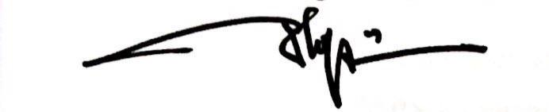
First/Corresponding Author

[Ahmad Yani]

