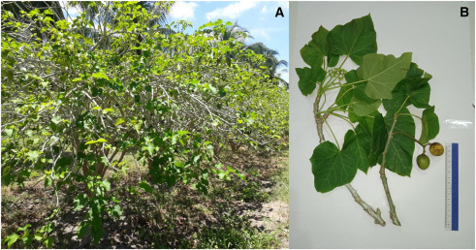
Gambar 1. Tanaman Jarak pagar (Jatropha curcas) (Kamaruddin et al., 2024)
Figure 1. Jatropha curcas Plant

