AUTHORSHIP STATEMENT

Manuscript title :
DISEASE DYNAMICS OF BARRAMUNDI (Lates calcarifer) IN FLOATING NET CAGES OF AMBON BAY, MALUKU
__________________________________________________________________________

I, the undersigned and on behalf of all the authors listed below declared that all authors have contributed, read and approve the written research work described in this manuscript to be submitted to the Jurnal Riset Akuakultur. We also acknowledge that the copyright of this article will be transferred to the journal once accepted for publication.
We confirm that the role of each author RRB, JMFS, SMAR, RHST and JT as the following based on CRedit taxonomy (https://credit.niso.org/):
RRB: Conceptualization, Data curation, Formal Analysis, Funding acquisition, Investigation, Methodology, Project administration, Resources, Software, Supervision, Validation, Visualization, Writing – original draft, Writing – review & editing; JMFS: Formal Analysis, Investigation, Methodology, Project administration, Resources, Writing – original draft, Writing – review & editing; SMAR: Writing – original draft, Writing – review & editing; RHST: Formal Analysis, Writing – original draft, Writing – review & editing; JT: Software, Visualization,

Full Name of Author | Role (Corresponding/Co-Author)
Ruku Ratu Borut | Corresponding Author
Jacqueline M. F. Sahetapy | Author
Stefanno M. A. Rijoly | Author
Ruslan H. S. Tawari | Author
Julian Tuhumury | Author

Sincerely,
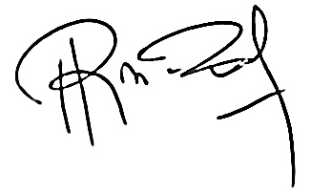
Corresponding Author

Ruku Ratu Borut

