Dear Editor-in-Chief, Jurnal Riset Akuakultur

We wish to submit an original research article entitled “Screening of Phytochemical and Antibacterial Activity of Tengkawang Bukit (Shorea beccariana) Stem Extract Against Vibrio parahaemolyticus” for publication consideration in the Jurnal Riset Akuakultur.
We confirm that this work is original and has not been published elsewhere, nor is it currently under consideration for publication elsewhere.
This study evaluated the antibacterial potential of tengkawang bukit (Shorea beccariana) stem extract as a natural alternative to control Vibrio parahaemolyticus infection that often occurs in intensive mariculture. Phytochemical screening results indicated the presence of bioactive compounds such as alkaloids, flavonoids, saponins, tannins, and steroids. Disc diffusion tests indicated an increase in the zone of inhibition as the extract concentration increased, with inhibition diameters ranging from 9.04 ± 0.48 mm to 10.75 ± 0.26 mm. With an extract yield of 17%, this extract has the potential to be a safe and sustainable antibacterial alternative to reduce the use of synthetic antibiotics in mariculture.

Therefore, we believe this manuscript fits the focus and scope of your journal.

29 September 2025
Sincerely,
First Author
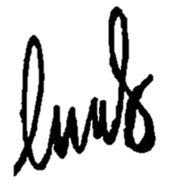

Hosia Anisa

