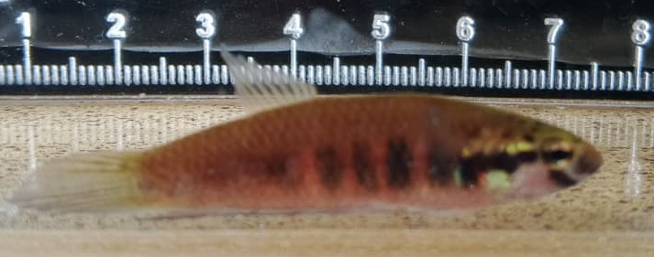
Figure 1. Jielabu fish (Betta dennisyongi Tan, 2013)

