AUTHORSHIP STATEMENT

Manuscript title:
The Effect of Black Tea (Camellia sinensis) Solution with Different Doses and Immersion Times on the Egg Adhesiveness of Walking Catfish (Clarias batrachus)
I, the undersigned and on behalf of all the authors listed below declared that all authors have contributed, read and approve the written research work described in this manuscript to be submitted to the Jurnal Riset Akuakultur. We also acknowledge that the copyright of this article will be transferred to the journal once accepted for publication.
We confirm that the role of each author (abbreaviate name) as the following based on CRedit taxonomy (https://credit.niso.org/) as follows:
Full Name of Author | Contribution (CRediT Taxonomy)
Minal Kaumizzolimin | Conceptualization; Methodology; Investigation; Data curation; Formal analysis; Writing – original draft; Visualization.
Nuraini | Supervision; Validation; Methodology; Writing – review & editing.
Sukendi | Supervision; Validation; Writing – review & editing.
All authors have read and approved the final version of this manuscript before submission and agree to be accountable for all aspects of the work.
Sincerely,
First/Corresponding Author
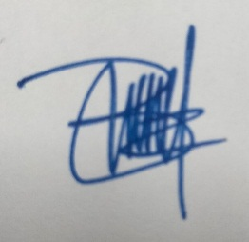
Minal Kaumizzolimin

