AUTHORSHIP STATEMENT

Manuscript title:
Feed Enrichment with a Combination of Pangasius Waste Oil and Squid Oil on the Growth and Survival of Asian Redtail Catfish Larvae (Hemibagrus nemurus)
I, the undersigned and on behalf of all the authors listed below declared that all authors have contributed, read and approve the written research work described in this manuscript to be submitted to the Jurnal Riset Akuakultur. We also acknowledge that the copyright of this article will be transferred to the journal once accepted for publication.
We confirm that the role of each author (abbreaviate name) as the following based on CRedit taxonomy (https://credit.niso.org/) as follows:

Full Name of Author | Contribution (CRediT Taxonomy) | Role (Corresponding/Co-Author)
Zulfahmy Ramadhan | Conceptualization; Methodology; Investigation; Data curation; Formal analysis; Writing – original draft; Visualization. | Berperan dalam konseptualisasi, analisis formal, penulisan draf awal, visualisasi, penulisan tinjauan, dan pengeditan.
Netti Aryani | Supervision; Validation; Methodology; Writing – review & editing. | Berperan dalam supervisi, metodologi, validasi, penulisan tinjauan, dan pengeditan.
Nuraini | Supervision; Validation; Writing – review & editing. | Berperan dalam supervisi, metodologi, validasi, penulisan tinjauan, dan pengeditan.

All authors have read and approved the final version of this manuscript before submission and agree to be accountable for all aspects of the work.
Sincerely,
First/Corresponding Author
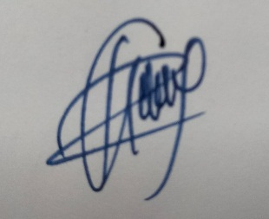
Zulfahmy Ramadhan

