AUTHORSHIP STATEMENT

Manuscript title:
Revealing The Dietary Combination of Animal- and Plant-based Oils: Effects on Pre-gonadal Maturation of Male Asian Redtail Catfish (Hemibagrus nemurus)

I, the undersigned and on behalf of all the authors listed below declared that all authors have contributed, read and approve the written research work described in this manuscript to be submitted to the Jurnal Riset Akuakultur. We also acknowledge that the copyright of this article will be transferred to the journal once accepted for publication.
We confirm that the role of each author (abbreaviate name) as the following based on CRedit taxonomy (https://credit.niso.org/):
TM: conceptualization, formal analysis, supervision and writing – review and editing; SSQT: conceptualization, methodology, and writing – original draft preparation; MA: methodology, formal analysis, and visualization; SJR, MASO, RTA, and AF: investigation, project administration, and writing original draft preparation.

Full Name of Author | Role (Corresponding/Co-Author)
Tholibah Mujtahidah | First Author
Shobrina Silmi Qori Tartila | Corresponding Author
Muh. Azril | Co-Author
Sultan Jibran Risqulloh | Co-Author
Muhammad Abizar Sakti Oktovian | Co-Author
Rifky Tsabitul Azmi | Co-Author
Amelia Fatikasari | Co-Author

Sincerely,
First/Corresponding Author
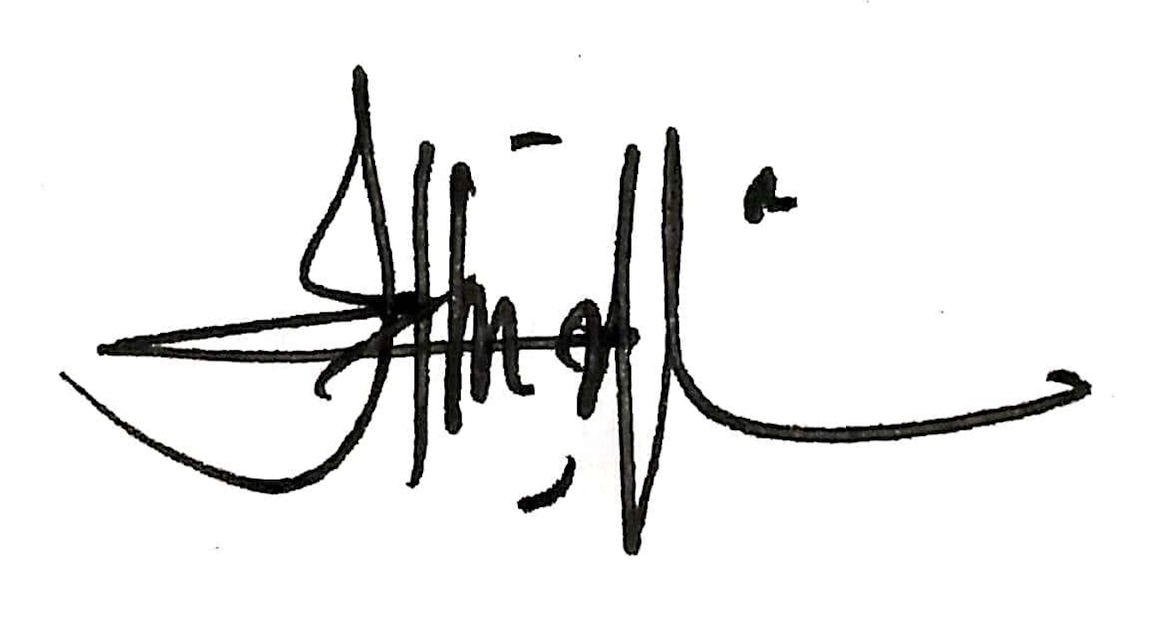
Tholibah Mujtahidah

