Dear Editor-in-Chief, Jurnal Riset Akuakultur

We are pleased to submit our original research article entitled “Improvement of Production Performance of Soft Shell Crab Farming in RAS Apartment Boxes with High Dose Purslane Administration” for your consideration for publication in the Jurnal Riset Akuakultur.
We confirm that this manuscript is an original work that has not been published previously and is not under consideration for publication elsewhere.
This study investigates the effect of high-dose purslane (Portulaca oleracea) administration on the production performance of soft-shell crab (Scylla spp.) reared in Recirculating Aquaculture System (RAS) apartment boxes. The research focuses on evaluating growth performance, molting rate, survival, and water quality parameters to determine the optimal purslane supplementation strategy for enhancing the sustainability and productivity of soft-shell crab culture in controlled environments.
We believe that this study aligns well with the focus and scope of the Jurnal Riset Akuakultur, particularly in advancing innovative aquaculture practices, improving production efficiency, and promoting sustainable farming systems.
We appreciate your consideration of our manuscript and look forward to your favorable response.

5 November 2025
Sincerely,
Corresponding Author
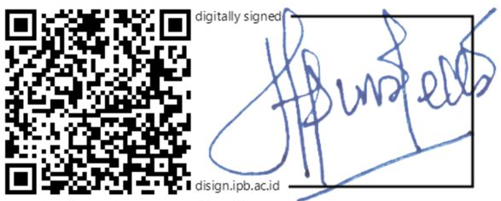
[Dinamella Wahjuningrum]

