AUTHORSHIP STATEMENT

Manuscript title : Improvement of Production Performance of Soft-Shell Crab Culture Through Dietary Supplementation of High Dose of Purslane in Recirculating Aquaculture System Using Apartment Box

___________________________________________________________________________

I, the undersigned and on behalf of all the authors listed below declared that all authors have contributed, read and approve the written research work described in this manuscript to be submitted to the Jurnal Riset Akuakultur. We also acknowledge that the copyright of this article will be transferred to the journal once accepted for publication.
We confirm that the role of each author (abbreaviate name) as the following based on CRedit taxonomy (https://credit.niso.org/):
IR: conceptualization, validation, review, and editing; RAP: research execution, investigation, analysis, and draft writing; DMW: conceptualization, supervision, validation, review, and editing; MAM: supervision, validation, and writing – review and editing; BAT: writing and editing; TC: writing and editing
https://credit.niso.org/]

Full Name of Author | Role (Corresponding/Co-Author)
Irzal Effendi | Conceptualization, validation, review, and editing
Risma Amelia Putri | Research execution, investigation, analysis, and draft writing
Dinamella Wahjuningrum | Conceptualization, supervision, validation, review, and editing
Muhammad Arif Mulya | Supervision, validation, and writing – review and editing
Bagus Ansani Takwin | writing ‒ review, and editing
Thavasimuthu Citarasu | writing ‒ review, and editing

Sincerely,
Corresponding Author
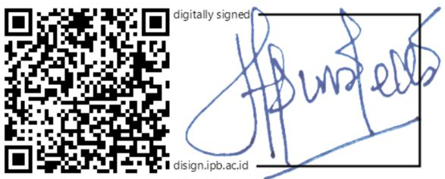
[Dinamella Wahjuningrum]

