Lampiran 1. Komponen dan Profil Reaksi PCR

Komposisi Reaksi PCR
Komponen | Volume (50 μL Reaksi)
My Taq HS Red Mix | 25 μL
Primer Forward (20 μM) | 1 μL
Primer Reverse (20 μM) | 1 μL
DNA cetakan (200 ng) | 1 μL
Deion (ddH₂O) | Hingga 50 μL

Profil PCR
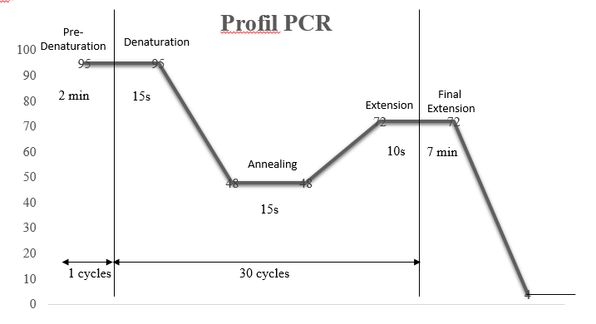

Lampiran 2. Rumus Bilangan Avogadro

Jumlah kopi DNA = $\frac{(Jumlah DNA (ng) * 6.022 x {10}^{23}) }{(Panjang \left(bp\right) *1 x {10}^{9}* 650)}$

Keterangan:
- Jumlah DNA = Jumlah DNA (Plasmid, primer, dll) dalam satuan nanogram
- 6.022 x 10²³ = Bilangan Avogadro (molekul/mol)
- Panjang = Panjang fragmen DNA dalam pasang basa.
- 1 x 10⁹ = Bilangan untuk konversi jawaban ke nanogram
- 650 g/mol = Berat rata-rata pasangan basa tunggal DNA (bp)

Lampiran 3. Hasil BLAST Primer SWP-EHP1 dan Primer SWP-EHP3
Hasil BLAST Primer SWP-EHP1 Forward
Deskripsi | Skor maks | Skor total | Query cover | E value | Identity | No. Akses
Enterocytozoon hepatopenaei spore wall protein 1 (SWP1) mRNA, complete cds | 42.1 | 42.1 | 100% | 0.075 | 100% | MG015710.1
Enterocytozoon hepatopenaei spore wall protein gene, partial cds | 42.1 | 42.1 | 100% | 0.075 | 100% | KY593132.2
Enterocytozoon hepatopenaei spore wall protein 1 gene, partial cds | 42.1 | 42.1 | 100% | 0.075 | 100% | KY674357.1
Enterocytozoon hepatopenaei spore wall protein gene, partial cds | 42.1 | 42.1 | 100% | 0.075 | 100% | KY593133.1
Enterocytozoon hepatopenaei isolate EHP1SWP spore wall protein 1 gene, partial cds | 42.1 | 42.1 | 100% | 0.075 | 100% | KY483639.1
Enterocytozoon hepatopenaei spore wall protein 1 (SWP) gene, partial cds | 42.1 | 42.1 | 100% | 0.075 | 100% | KX258197.1
Enterocytozoon hepatopenaei spore wall protein gene, partial cds | 42.1 | 42.1 | 100% | 0.075 | 100% | KY593129.1

Hasil BLAST Primer SWP-EHP1 Reverse
Deskripsi | Skor maks | Skor total | Query cover | E value | Identity | No. Akses
Enterocytozoon hepatopenaei spore wall protein 1 (SWP1) mRNA, complete cds | 44.1 | 44.1 | 100% | 0.019 | 100% | MG015710.1
Enterocytozoon hepatopenaei spore wall protein gene, partial cds | 44.1 | 44.1 | 100% | 0.019 | 100% | KY593132.2
Enterocytozoon hepatopenaei spore wall protein 1 gene, partial cds | 44.1 | 44.1 | 100% | 0.019 | 100% | KY674357.1
Enterocytozoon hepatopenaei spore wall protein gene, partial cds | 44.1 | 44.1 | 100% | 0.019 | 100% | KY593133.1
Enterocytozoon hepatopenaei spore wall protein gene, partial cds | 44.1 | 44.1 | 100% | 0.019 | 100% | KY593129.1
Enterocytozoon hepatopenaei isolate EHP1SWP spore wall protein 1 gene, partial cds | 44.1 | 44.1 | 100% | 0.019 | 100% | KY483639.1
Enterocytozoon hepatopenaei spore wall protein 1 (SWP) gene, partial cds | 44.1 | 44.1 | 100% | 0.019 | 100% | KX258197.1

Hasil BLAST Primer SWP-EHP3 Forward
Deskripsi | Skor maks | Skor total | Query cover | E value | Identity | No. Akses
Enterocytozoon hepatopenaei spore wall protein 1 (SWP1) mRNA, complete cds | 44.1 | 44.1 | 100% | 0.019 | 100% | MG015710.1
Enterocytozoon hepatopenaei spore wall protein gene, partial cds | 44.1 | 44.1 | 100% | 0.019 | 100% | KY593132.2
Enterocytozoon hepatopenaei spore wall protein 1 gene, partial cds | 44.1 | 44.1 | 100% | 0.019 | 100% | KY674357.1
Enterocytozoon hepatopenaei spore wall protein gene, partial cds | 44.1 | 44.1 | 100% | 0.019 | 100% | KY593133.1
Enterocytozoon hepatopenaei spore wall protein gene, partial cds | 44.1 | 44.1 | 100% | 0.019 | 100% | KY593129.1
Enterocytozoon hepatopenaei isolate EHP1SWP spore wall protein 1 gene, partial cds | 44.1 | 44.1 | 100% | 0.019 | 100% | KY483639.1
Enterocytozoon hepatopenaei spore wall protein 1 (SWP) gene, partial cds | 44.1 | 44.1 | 100% | 0.019 | 100% | KX258197.1

Hasil BLAST Primer SWP-EHP3 Reverse
Deskripsi | Skor maks | Skor total | Query cover | E value | Identity | No. Akses
Enterocytozoon hepatopenaei spore wall protein 1 (SWP1) mRNA, complete cds | 46.1 | 46.1 | 100% | 0.007 | 100% | MG015710.1
Enterocytozoon hepatopenaei spore wall protein gene, partial cds | 46.1 | 46.1 | 100% | 0.007 | 100% | KY593132.2
Enterocytozoon hepatopenaei spore wall protein 1 gene, partial cds | 46.1 | 46.1 | 100% | 0.007 | 100% | KY674357.1
Enterocytozoon hepatopenaei spore wall protein gene, partial cds | 46.1 | 46.1 | 100% | 0.007 | 100% | KY593133.1
Enterocytozoon hepatopenaei spore wall protein 1 (SWP) gene, partial cds | 46.1 | 46.1 | 100% | 0.007 | 100% | KX258197.1

Lampiran 4. Pensejajaran Sekuen Asam Amino pGEM-HP1 dan pGEM-HP3 dengan SWP EHP Kode Lainnya

Sekuen Asam Amino pGEMHP1 dan pGEMHP3
>SWP_EHP_pGEMHP1
HWSNTISNTVNLKALKRDDIYTDTAFVGYELSNTVGDKQLKEVCNDFSKAYECISEDKRKMNEKMGDIFEELSILKKKCKQIDHQRKTVNNLRYDLEEILQSNIYKEDQKENLEKKLGETSEKTLVEMDEFM

>SWP_EHP_pGEMHP3
SNTISNTVNLKALKRDDIYTDTAFVGYELSNTVGDKQLKEVCNDFSKAYECISEDKRKMNEKMGDIFEELSILKKKCKQIDHQRKTVNNLRYDLEEILQSNIYKEDQKENLEKKLGETSEKTLVEMDEFMHLSMING

