STUDY OF CARRYING CAPACITY AND DEVELOPMENT STRATEGY OF CORAL GARDEN BASED ECOEDUTOURISM IN CEMARA BESAR ISLAND, KARIMUNJAWA NATIONAL PARK, JEPARA, CENTRAL JAVA

Yeremia Edgar Aprilio¹, Muhammad Arif Asadi¹ and Yulius²
¹ Brawijaya University
² Marine Research Center, Marine and Fisheries Research and Human Resources Agency, MMFA
yeremia_edgar@ub.ac.id

ABSTRACT
The purpose of this study was to see the area carrying capacity for eco-edutourism based on coral gardens on Cemara Besar Island that can be accommodated, analyze development strategies for program development, and find out the recommendation spots. The calculation of the carrying capacity of the area is calculated through 3 considerations, there are Physical Carrying Capacity (PCC), Real Carrying Capacity (RCC) and Effective Carrying Capacity (ECC), where the results obtained through the PCC> RCC> ECC format in the utilization zone it is 2472> 97> 42 people per day, while in the protection zone it is 670 > 30 > 15 people per day. In the analysis of tourism development strategies, a SWOT analysis is used that produced 15 alternative regional development strategies, with the number one strategic priority is “the development of the concept of coral garden tourism”. From the analysis of the strategy, it is also concluded that the regional management planning strategy is inclined towards an aggressive strategy Observation of the 5 recommendation spots was carried out using the time swimming method using a snorkel for ± 10 minutes in an area of 10 × 10 m per point. Recommendation points are marked with points A, B, C, D, and E, where points B and D are designated as highly recommended points. to apply the concept of eco-edutourism based on coral gardens.

Keywords: Cemara Besar Island, Ecoedutourism, Coral Garden, Carrying Capacity, SWOT Anlysis.

INTRODUCTION

Tourism is one of the industrial and business sectors that has the highest growth index in the world. The growth of the tourism sector globally shows a figure of 4% per year (WTO, 2000), while the growth of Indonesia's national tourism sector has touched 8% per year since the launching of the Wonderful Indonesia program by highlighting local brands and local tourist destinations that are still natural (Kemenpar, 2016 in Kumaat et al. al., 2017). Tourism development is one way of developing an area or region. This tourism development cannot be separated from the existence of natural resources and artificial resources as regional potentials owned by an area or region. The potential of the area is one of the leading sources of tourism assets, both in the form of natural beauty, cultural heritage of the past (cultural tourism) as well as from superior commodities that are unique to the region (Lintong et al., 2019).
One alternative tourism that can be done is the coral garden program tour. Coral Garden or Coral Garden is defined as a coral reef restoration activity in an area that does not have coral cover for some reason using sexual (juvenile) and asexual methods (Transplantation) (Epstein et al., 2001 in Luthfi, 2016). Coral gardens are carried out using an iron framework in the form of a hemispherical or dome which is placed various life forms of living coral fragments. The fragments are tied using cable ties to prevent them from falling under the current. A good method used in making coral gardens is the PRA or Participatory Rural Apparaisal approach, namely in making coral gardens it involves the community directly (Luthfi, 2016).
Tourism development can be done with the concept of ecoedutourism. Ecoedutourism is an environmental-based tourism activity that is packaged in an educational project. Ecoedutourism was developed from Education and Ecotourism. Education in ecoedutourism is one way of learning that can be launched by managers through an ecotourism activity. Ecotourism itself is an environmental conservation and rescue activity that is packaged in tourist trips to natural areas so that they are able to provide livelihoods for local residents (Nugroho, 2011 in Setiawan and Hutagaol, 2017).
An analysis of the carrying capacity of the area is carried out to determine the maximum number of visitors that can be tolerated in a tourist area. The value of the carrying capacity of the area is very important to know so that tourism activities can take place comfortably and sustainably (preservation of the area is maintained). Depending on certain types of tourism, the value of the carrying capacity of the area can vary depending on the area of tourism activities and the correction factor (Pasak et al., 2017).

METHODOLOGY

In the study, the recommendation area data was taken using the observation method, which is a way of collecting data by direct observation and systematic recording of the object to be studied. Observations were carried out by researchers by observing and recording the condition of the location that had been determined and considered to have the potential for ecoedutourism points based on coral gardens so that recommendations for tourist areas could be generated.

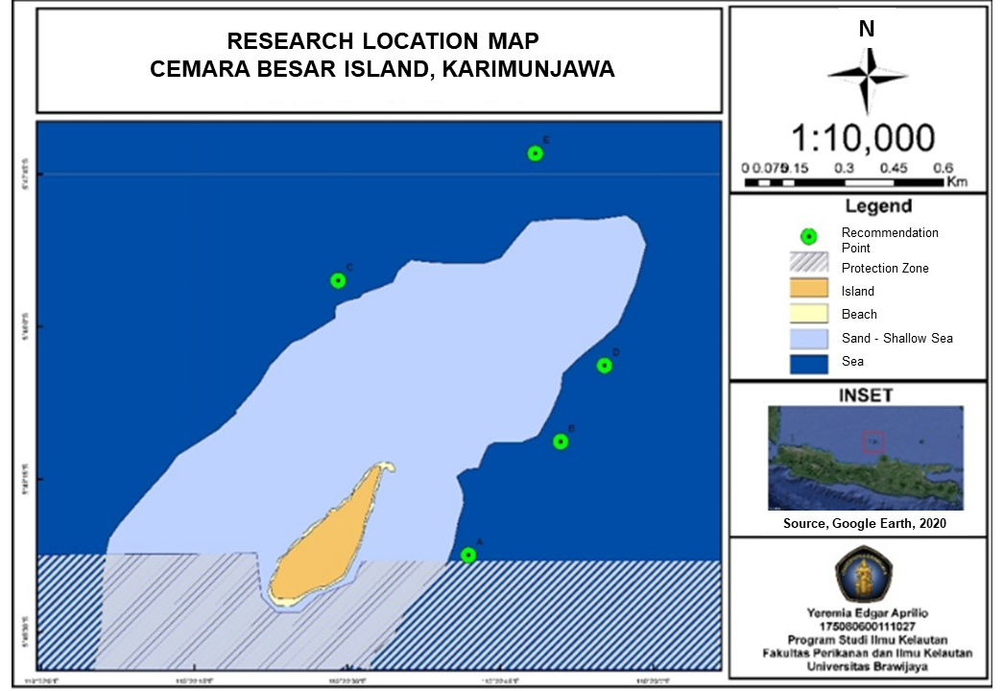

Figure 1. Research Location Map.
Based on the coordinate map of the recommended points for the coral garden tourism area, there are 5 coordinate points symbolized by point A, point B, point C, point D, and point E. Point A has coordinates -5.80624, 110.3783, point B has coordinates -5.80314, 110.38081 , point C has coordinates -5.79874, 110.37475, point D has coordinates -5.80106, 110.38201, and point E has coordinates -5.79527, 110.38012 (Figure 1).

Data Collecting Method
The data used in this study are primary data and secondary data. Secondary data collection is done by collecting documents from related journals and the results of studies/research from related agencies. Primary data obtained from direct observation to the field. Primary data in the form of a questionnaire which is used as a tool in the process of identifying the value of benefits and the value of the present condition. The object studied in this research is coral reef tourism on Cemara Besar Island key person (related agency). The observation method is a method of systematically observing and recording a symptom that appears on the object of research (Sutrisno Hadi, 1987 in Prastowo, 2010).

Analysis Method
Observation of the condition of coral reef tourism recommendation points based on coral gardens is carried out by the time swimming method or exploring using a snorkel. This method is carried out by researchers by diving near the surface of the water with a certain time span (10-30 minutes per point) at coordinates with an area of 10 × 10 m per point that has been determined to make a brief identification of coral species and the presence of biota associated with coral reefs and research documentation.
There are five parameters used by researchers in determining the recommendation for coral garden tourism points, namely the condition of coral reefs, pelagic biota conditions, demersal biota conditions, water brightness conditions, and current conditions.
The method introduced to calculate the carrying capacity of natural ecotourism development is to use the concept of Regional Carrying Capacity (RCC). The calculation of Regional Carrying Capacity is based on consideration of three main levels, namely physical carrying capacity (Physical Carrying Capacity/PCC), real carrying capacity (Real Carrying Capacity/RCC) and effective carrying capacity (ECC).
PCC is calculated using the following formula:
$$PCC=A×\frac{V}{a} ×Rf$$
Notation A = area available for tourism use, V = a tourist, a = area needed by tourists, and Rf = Rotation Factor of Wp/Wt (Simanjuntak et al., 2015).
RCC is calculated using the following formula:
$$RCC=PCC×Cf1×Cf2×Cf3…×Cfn$$
$$Cfn=1-(\frac{Lm}{Tm})$$
Notation PCC = Physical Carrying Capacity, Cf = Correction Factor, Lm = limiting magnitude of the variable, and Tm = total magnitude (total magnitude) of the variable (Herlambang et al., 2016)
$$ECC=RCC×MC$$
$$MC=\frac{existing employees}{staff needed} ×100\%$$
Notation RCC = Real Carrying Capacity, and MC = Management correction factor.
The strategies for developing coral reef tourism in Cemara Besar Island can be determined using a SWOT analysis through an analysis of the Benefit Level (TM) and Current Condition (KS).
The SWOT analysis was carried out as follows:
- Identify key factors. Key factors in this study include Natural Resources (NR), Human Resources (HR), infrastructure, regulations, and potential tourists.
- Determine the key person for conducting interviews or filling out questionnaires so that the determination of the SWOT class can be done subjectively.
- Identification of internal and external factors based on factor weight analysis from interviews or questionnaires.
The method of determining internal and external strategic factors is as follows (Simanjuntak et al., 2015);
- Determine the factors that are the strengths and weaknesses of coral reef tourism development activities on Cemara Besar Island.
- Giving weight to each of these factors according to their level of importance or level of benefit. The weight is generated from the average level of benefit of each factor divided by the average number of levels of benefit of all factors then multiplied by 100%. The sum of all weights must be 100% or 1.00 using a paired comparison table in the IFE and EFE matrices (Basuki, 2005 in Rakhmawaty, 2009).
- Calculate the rating or suitability value for each factor based on the influence/response of these factors on the development of mangrove tourism on Kemujan Island (score: 5 = very suitable, 4 = suitable, 3 = quite suitable, 2 = not suitable, 1 = very inappropriate).
- Multiply the weight by the rating or Conformity Value to obtain a weighted score for each factor.
After obtaining the internal factors and external factors and identifying their weaknesses and strengths, then these factors are linked in a SWOT matrix to obtain alternative strategies (Table 1).

Table 1. SWOT Matrix.

Internal  Eksternal | Strength (S)  Internal Strength Factor | Weakness (W)  Internal Weakness Factor
Opportunity (O)  Eksternal Strength  Factor | Strategy S-O  (Strategy using strengths to take advantage of opportunities) | Strategy W-O  (Strategies to minimize weaknesses to take advantage of opportunities)
Threat (T)  Eksternal Weakness  Factor | Strategy S-T  (Strategies using strength to overcome threats) | Strategy W-T  (Strategies using strength to overcome threats)
Source: Simanjuntak (2015)

Furthermore, after obtaining alternative strategies, then the alternative strategies are sorted by priority through the calculation of scores by adding up the total score of the factors involved in an alternative strategy.
After obtaining strategic priorities, the determination of alternative management strategies is calculated to show the condition or situation of the agency or area against known alternative strategies. Alternative management strategies are divided into 4 quadrants where the results depend on the X axis (difference in scores of internal factors between strengths and weaknesses) and Y (difference in scores of external factors between opportunities and threats) (Putridhanti, 2013).

RESULTS AND DISCUSSION

Water Quality
Observations of water parameters at 5 recommendation points were also carried out together with the survey team of the Jakarta Marine Research Center. Observational data can be seen as follows (Table 2):

Table 2. Recommended Point and Water Quality Data.
Station | Latitude | Longtitude | Time | Turb | pH | Temperature | Salinity
A | -5.80624 | 110.3783 | 9.34 | 0 | 7.75 | 29.5 | 31.3
B | -5.80314 | 110.38081 | 9.39 | 0 | 7.92 | 29.5 | 31.3
C | -5.79874 | 110.37475 | 9.54 | 0 | 7.82 | 29.5 | 31.4
D | -5.80106 | 110.38201 | 10.14 | 0 | 7.67 | 29.5 | 31.4
E | -5.79527 | 110.38012 | 10.30 | 0 | 7.86 | 29.5 | 31.4

- Temperature
The results of temperature measurements in the waters of Cemara Besar Island show a relatively similar number, namely 29.5 oC. The measurement results show good water temperature results where the optimum temperature for coral reefs is 25-30 oC, because most corals will lose their ability to catch food at temperatures <16oC and >33.5 oC (Tito et al., 2013)
- Turbidity
Turbidity measurements showed relatively the same number at 0 NTUs. The measurement results show that the waters around Cemara Besar Island are very clean and not cloudy. Turbidity directly affects coral reefs because the grains of sediment that are uplifted and are no longer floating will settle to the bottom of the water, these grains will cover coral polyps which can cause corals to be stressed. Meanwhile, the turbidity indirectly through the sediment grains will affect the zooxanthellae microalgae which are symbiotic with corals by blocking the intensity of sunlight as a photosynthesis material (Rauf et al., 2015).
- pH
The measurement results show a number that is not much different between 7.67 – 7.92. The pH measurement results show a stable number so that the pH of the waters can be said to be good because changes in pH affect the chemical and biological processes of organisms in the waters. pH affects the toxicity of a chemical compound in the waters. The pH value greatly affects the biochemical processes of the waters (Rauf et al., 2015).
- Salinity
Based on the measurement results, it can be seen that the salinity of the waters at the recommendation point shows the results of 31.3 – 31.4 o/oo. The measurement results show a good number between 29 - 33 o/oo, this is because if the salinity drops it will affect coral fertility by up to 86%. Salinity is able to affect the respiratory system and the rate of photosynthesis of corals by decreasing the amount of chlorophyll per algae per cell (Rauf et al., 2015).

From the observations, it can be concluded that the recommendation points for coral garden ecoedutourism with the recommendation matrix are as follows (Table 3);

Table 3. Recommendation Table Matrix

No | Parameter | Point A |  | Point B |  | Point C |  | Point D |  | Point E
1 | Coral Reefs |  | √ |  | - |  | √ |  | - |  | √
2 | Pelagic Biota |  | √ |  | √ |  | - |  | - |  | √
3 | Demersal Biota |  | - |  | - |  | √ |  | - |  | -
4 | Turbidity |  | √ |  | √ |  | √ |  | - |  | √
5 | Current Condition |  | √ |  | √ |  | - |  | √ |  | √
Conclusion |  | Not recommended for coral garden tourism program, but recommended for snorkeling and diving tourism programs |  | Recommendations for coral garden tourism programs but not recommendations for snorkeling and diving tourism programs. |  | Not recommended for coral garden tourism program, but recommended for snorkeling and diving tourism programs |  | Recommendations for coral garden tourism programs but not recommendations for snorkeling and diving tourism programs. |  | Not recommended for coral garden tourism program, but recommended for snorkeling and diving tourism programs

There are 2 points that are recommended as the application of the concept of ecoedutourism based on coral gardens or coral gardens, namely point B and point D because in these two areas the condition of coral reefs is not too good and requires restoration.
After obtaining the recommendation points, then looking for alternative development strategies through SWOT analysis (Table 4 and Table 5).
Table 4. Internal Strategy Factors.

Internal Strategy Factors | ID | Value Current Condition | Benefit Rate Value | Information
Strength
- Density of coral reefs on Cemara Besar Island | A | 3.75 | 4.25 | Priority Maintained
- Diversity of Coral Reefs | B | 3.50 | 4.25 | Priority Maintained
- Diversity of Aquatic Biota | C | 3.50 | 4.50 | Priority Maintained
- Quality of human resources in handling domestic tourists | D | 3.50 | 4.50 | Priority Maintained
- Quality of human resources for education and conservation tourism | E | 3.50 | 4.25 | Priority Maintained
- Area Cleanliness | F | 3.75 | 4.00 | Priority Maintained
- Accessibility to coral tourism areas | G | 3.50 | 4.00 | Priority Maintained
- Reef tourism facilities | H | 3.50 | 4.00 | Priority Maintained
Weakness
- Presence of Dangerous Biota | I | 2.75 | 2.25 | Not a Development Priority
- Condition of coral reefs on Cemara Besar Island | J | 3.00 | 4.75 | Development Priority
- Coral Reef Tourism | K | 3.00 | 3.75 | Development Priority
- The Presence of Typical Animals | L | 2.50 | 3.75 | Development Priority
- Existence of Area Management | M | 1.75 | 4.75 | Development Priority
- The quality of human resources in handling foreign tourists | N | 3.00 | 4.75 | Development Priority

Table 5. External Strategy Factor.
External Strategy Factors | ID | Value Current Condition | Benefit Rate Value | Information
Opportunities
- Potential for domestic tourists | O | 4.25 | 4.50 | Priority Maintained
- The potential of foreign tourists | P | 3.75 | 4.25 | Priority Maintained
- Security of tourist sites (criminality) | Q | 4.25 | 4.50 | Priority Maintained
- Availability of Communication Facilities | R | 4 | 4.75 | Priority Maintained
- The existence of special souvenirs | S | 2.50 | 3.50 | Priority Maintained
- Community support for coral reef tourism | T | 4.25 | 4.50 | Priority Maintained
- Condition of electricity infrastructure | U | 2.50 | 3.50 | Priority Maintained
- Cemara Besar Island tourism promotion | V | 3.50 | 4.00 | Priority Maintained
- The existence of law enforcement or sanctions against environmental destroyers | W | 3.75 | 4.00 | Priority Maintained
- Worthy means of transportation | X | 3.50 | 4.25 | Priority Maintained
- Adequate means of transportation | Y | 4.25 | 4.25 | Priority Maintained
- Condition of infrastructure leading to tourist areas (waves, etc.) | Z | 3.50 | 3.50 | Priority Maintained
- Logistics supply (foodstuffs, etc.) | A1 | 3.25 | 3.50 | Priority Maintained
- Existence of interesting culinary tourism | B1 | 3.25 | 4.25 | Priority Maintained
- Availability of facilities and photo points for tourists | C1 | 4.00 | 4.50 | Priority Maintained
- Vulnerability and disaster management on Cemara Besar Island | D1 | 3.25 | 3.75 | Priority Maintained
Threat
- Availability of tourism objects supporting coral reef tourism on Cemara Besar Island | E1 | 3.00 | 3.75 | Development Priority
- The existence of other superior tourist objects besides coral reef tourism | F1 | 3.00 | 3.75 | Development Priority
- Availability of health facilities | G1 | 2.25 | 3.50 | Development Priority
- Availability of public facilities (toilet and gazebo) | H1 | 3.00 | 4.25 | Development Priority
- Availability of lodging facilities | I1 | 2.50 | 4.75 | Development Priority
- Condition of clean water infrastructure | J1 | 3.00 | 3.50 | Development Priority
- Port Availability | K1 | 2.25 | 3.75 | Development Priority
- Government support (financial and policy) | L1 | 3.00 | 4.25 | Development Priority
- Availability of new job opportunities | M1 | 2.25 | 4.50 | Development Priority

After that, scoring is done using the IFE and EFE matrix (Table 6 and Table 7).
Table 6. IFE matrix.

Internal Strategy Factors | Weight | Benefit Rate Value | Score
Strength
- Density of coral reefs on Cemara Besar Island | 0.074 | 4.25 | 0.315
- Diversity of Coral Reefs | 0.069 | 4.75 | 0.326
- Diversity of Aquatic Biota | 0.063 | 3.75 | 0.237
- Quality of human resources in handling domestic tourists | 0.063 | 4.25 | 0.269
- Quality of human resources for education and conservation tourism | 0.085 | 4.5 | 0.383
- Area Cleanliness | 0.058 | 3.75 | 0.216
- Accessibility to coral tourism areas | 0.060 | 2.25 | 0.136
- Reef tourism facilities | 0.071 | 4.75 | 0.339
Total | 0.544 |  | 2.222
Weakness
- Presence of Dangerous Biota | 0.044 | 4.5 | 0.198
- Condition of coral reefs on Cemara Besar Island | 0.104 | 4.75 | 0.496
- Coral Reef Tourism | 0.088 | 4.25 | 0.374
- The Presence of Typical Animals | 0.044 | 4 | 0.176
- Existence of Area Management | 0.104 | 4 | 0.418
- The quality of human resources in handling foreign tourists | 0.071 | 4 | 0.286
Total | 0.456 |  | 1.946
Total |  |  |  | 4.168

Table 7. EFE matrix.

External Strategy Factors | Weight | Benefit Rate Value | Score
Opportunities
- Potential for domestic tourists | 0.048 | 4.5 | 0.214
- The potential of foreign tourists | 0.046 | 4.25 | 0.195
- Security of tourist sites (criminality) | 0.029 | 4.5 | 0.131
- Availability of Communication Facilities | 0.038 | 4.75 | 0.178
- The existence of special souvenirs | 0.020 | 3.5 | 0.070
- Community support for coral reef tourism | 0.051 | 4.5 | 0.229
- Condition of electricity infrastructure | 0.038 | 3.5 | 0.134
- Cemara Besar Island tourism promotion | 0.039 | 4 | 0.157
- The existence of law enforcement or sanctions against environmental destroyers | 0.046 | 4 | 0.183
- Worthy means of transportation | 0.035 | 4.25 | 0.149
- Adequate means of transportation | 0.031 | 4.25 | 0.131
- Condition of infrastructure leading to tourist areas (waves, etc.) | 0.032 | 3.5 | 0.111
- Logistics supply (foodstuffs, etc.) | 0.034 | 3.5 | 0.120
- Existence of interesting culinary tourism | 0.025 | 4.25 | 0.106
- Availability of facilities and photo points for tourists | 0.041 | 4.5 | 0.184
- Vulnerability and disaster management on Cemara Besar Island | 0.047 | 3.75 | 0.175
Total | 0.598 |  | 2.466
Threat
Availability of tourism objects supporting coral reef tourism on Cemara Besar Island | 0.043 | 3.75 | 0.163
The existence of other superior tourist objects besides coral reef tourism | 0.043 | 3.75 | 0.159
Availability of health facilities | 0.047 | 3.5 | 0.163
Availability of public facilities (toilet and gazebo) | 0.047 | 4.25 | 0.198
Availability of lodging facilities | 0.034 | 4.75 | 0.162
Condition of clean water infrastructure | 0.045 | 3.5 | 0.158
Port Availability | 0.047 | 3.75 | 0.175
Government support (financial and policy) | 0.056 | 4.25 | 0.237
Availability of new job opportunities | 0.041 | 4.5 | 0.184
Total | 0.402 |  | 1.599
Total |  |  |  | 4.065

The IFE matrix (Table 6) shows that the total score on the strength factor is 2,222 which is greater than the total score on the weakness factor of 1,946. This shows that in the management of tourism potential and resources on Cemara Besar Island, the strength factor is more influential than the weakness factor. The EFE matrix (Table 7) shows that the total score on the opportunity factor is 2,466 which is greater than the total score on the threat factor of 1,599. This shows that in the management of tourism potential and resources on Cemara Besar Island, the opportunity factor is more influential than the threat factor.

After knowing the IFE and EFE matrices, then look for alternative strategies through the SWOT matrix (Table 8);

Table 8. SWOT matrix.

INTERNAL  EXTERNAL | Strength | Weakness
INTERNAL  EXTERNAL | - Density of coral reefs on Cemara Besar Island  - Diversity of Coral Reefs  - Diversity of Aquatic Biota  - Quality of human resources in handling domestic tourists  - Quality of human resources for education and conservation tourism  - Area Cleanliness  - Accessibility to coral tourism areas  - Reef tourism facilities | - Presence of Dangerous Biota  - Condition of coral reefs on Cemara Besar Island  - Coral Reef Tourism  - The Presence of Typical Animals  - Existence of Area Management  - The quality of human resources in handling foreign tourists
Opportunities | SO Strategy | WO Strategy
- Potential for domestic tourists  - The potential of foreign tourists  - Security of tourist sites (criminality)  - Availability of Communication Facilities  - The existence of special souvenirs  - Community support for coral reef tourism  - Condition of electricity infrastructure  - Cemara Besar Island tourism promotion  - The existence of law enforcement or sanctions against environmental destroyers  - Worthy means of transportation  - Adequate means of transportation  - Condition of infrastructure leading to tourist areas (waves, etc.)  - Logistics supply (foodstuffs, etc.)  - Existence of interesting culinary tourism  - Availability of facilities and photo points for tourists  - Vulnerability and disaster management on Cemara Besar Island | - Human Resources Development (counseling and training) (D, E, O, P, T, B1))  - Development of Coral Reef Tourism Promotion (A, B, C, O, P, V, B1, C1)  - Development of tour packages (coral reef and non-coral reef tourism) (A, B, C, F, G, H, O, P, V)  - Development of tourist facilities (F, G, H, Q, R, U, W, X, Y, Z, C1)  - Culinary Development (D, H, A1, B1) | - Mitigation Development (I, N, O, P, D1)  - Development of the concept of coral garden tourism (J, K, M, O, P, T, V, X, Y)  - Development of Cemara Besar Island Area Management (J, K, O, P, Q, R, U, V, W, D1)  - Development of souvenirs and special animals (L, S, O, P, V, A1)
Threat | ST Strategy | WT Strategy
- Availability of tourism objects supporting coral reef tourism on Cemara Besar Island  - The existence of other superior tourist objects besides coral reef tourism  - Availability of health facilities  - Availability of public facilities (toilet and gazebo)  - Availability of lodging facilities  - Condition of clean water infrastructure  - Port Availability  - Government support (financial and policy)  - Availability of new job opportunities | - Development of supporting infrastructure (F, G, H, F1, G1, H1, I1, J1, K1, L1, M1)  - Development of supporting tourism objects (A, B, C, H, E1, F1, L1, M1)) | - Utilization of Dangerous Biota (I, F1)

The priority of alternative strategies is calculated based on the linkage of alternative strategies to the building factors. The following is the result of calculating the priority of alternative strategies (Table 9):

Table 9. Strategy Alternative Priority

No | SWOT | Linkages | Total Score | Priority
 | SO Strategy
1 | Human Resources Development (counseling and training) | D, E, O, P, T, B1 | 1.395 | VIII
2 | Development of Coral Reef Tourism Promotion | A, B, C, O, P, V, B1, C1 | 1.734 | VII
3 | Development of tour packages (coral reef and non-coral reef tourism) | A, B, C, F, G, H, O, P, V | 2.135 | III
4 | Development of tourist facilities | F, G, H, Q, R, U, W, X, Y, Z, C1 | 1.893 | VI
5 | Culinary Development | D, H, A1, B1 | 0.834 | XI
 | WO Strategy
1 | Mitigation Development | I, N, O, P, D1 | 1.067 | IX
2 | Development of the concept of coral garden tourism | J, K, M, O, P, T, V, X, Y | 2.361 | I
3 | Development of Cemara Besar Island Area Managemen | J, K, O, P, Q, R, U, V, W, D1 | 2.237 | II
4 | Development of souvenirs and special animals | L, S, O, P, V, A1 | 0.931 | X
 | ST Strategy
1 | Development of supporting infrastructure | F, G, H, F1, G1, H1, I1, J1, K1, L1, M1 | 2.128 | IV
2 | Development of supporting tourism objects | A, B, C, H, E1, F1, L1, M1 | 1.961 | V
 | WT Strategy
1 | Utilization of Dangerous Biota | I, F1 | 0.357 | XII

Furthermore, the determination of alternative management strategies is carried out. Determination of alternative management strategies is calculated based on the coordinates of the x and y axes where the x axis is obtained through the difference in scores of internal factors between strengths and weaknesses, while the y axis is obtained through the difference in scores of external factors between opportunities and threats.
The X (horizontal) axis can be obtained based on:
X = 2.222 – 1.946 = 0.275
Y axis (vertical) can be obtained based on:
Y = 2.466 – 1.599 = 0.867
In the alternative management planning strategy diagram, the coordinate points (0.275; 0.867) can be described as follows:
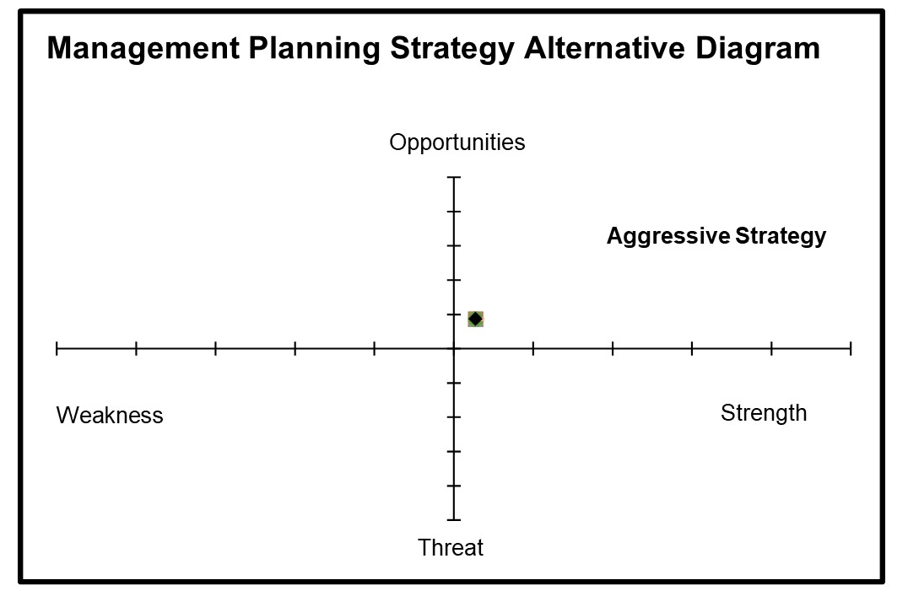
Figure 2. Management Planning Strategy Alternative Diagram
From the diagram above (Figure 2), it can be concluded that from the results of the difference between the scoring of internal and external factors, a coordinate that shows quadrant 1. In this case shows that the situation faced by the manager is very good because it has internal strengths that are able to take advantage of good opportunities. The diagram shows that the management strategy that must be implemented is an aggressive strategy by supporting an aggressive growth policy and implementing an alternative SO (strength – opportunity) strategy.

CONCLUSION

The conclusions that can be drawn from this study are from the calculation of the carrying capacity of the marine utilization zone, the maximum number of snorkeling tourists is 1483 people/day and the maximum number of diving tourists is 989 people/day, then with the correction factor for snorkeling tourists it becomes 58 people/day and diving tourists to 39 people/day, and with the consideration of the management of snorkeling tourists to 25 people/day and diving tourists to 17 people/day. In the marine protected zone the maximum number of snorkeling tourists is 402 people/day and the maximum diving tourists is 268 people/day, then with the correction factor for snorkeling tourists to 18 people/day and diving tourists to 12 people/day, and with management considerations Snorkeling tourists are 9 people/day and diving tourists are 6 people/day.
There are 12 alternative strategies obtained in the SWOT analysis,
- The SO strategy has 5 strategies, namely the development of human resources, the development of coral reef tourism promotion, the development of tour packages (coral reef and non-coral reef tourism), the development of tourism facilities and facilities, and culinary development.
- The WO strategy has 3 alternative strategies, namely the development of mitigation, the development of the concept of coral garden tourism, and the development of management of the big pine island.
- The ST strategy has 2 alternative strategies, namely the development of supporting infrastructure and the development of supporting tourism objects.
- The WT strategy has 2 alternative strategies, namely the use of dangerous biota, and the development of souvenirs and unique animals.
There are 2 points that are recommended as the application of the concept of ecoedutourism based on coral gardens or coral gardens, namely point B and point D because in these two areas the condition of coral reefs is not too good and requires restoration. Furthermore, from the observations, it can also be concluded that point A, point C, and point E are not recommended for coral garden activities but can be carried out if needed because the conditions are still quite good even though the coral reefs are starting to experience bleaching, but these points can still be done. recommended for snorkeling and diving activities.

ACKNOWLEDGMENTS

Thanks to the Marine Research Center, The Agency for Research and Human Resources Development, Ministry of Marine Affairs and Fisheries which has provided opportunities and facilities for the author to carry out and credits for all member of the survey team during mission to Karimunjawa islands. The paper contributes to local government, local people, and stakeholders who have the authority in planning and managing the Karimunjawa municipal. The main contributors to this article are Yeremia Edgar Aprilio, Muhammad Arif Asadi and Yulius.

REFRENCES

Arida. I. N. S. 2017. Pengembangan, Partisipasi Lokal, dan Tantangan Ekowisata. Denpasar: Cakra Press.
Badan Pusat Statistik. 2017. Kabupaten Jepara Dalam Angka.
Badan Pusat Statistik. 2020. Kecamatan Karimunjawa dalam Angka.
Balai Taman Nasional Karimunjawa. 2004. Penataan Zonasi Taman Nasional Karimunjawa Kabupaten Jepara Provinsi Jawa Tengah. BTNKJ. Semarang. Indonesia.
Gustiantini. L., Ilahude. D. 2012. Foraminifera Bentik dalam Sedimen Sebagai Indikator Kondisi Lingkungan Terumbu Karang di Perairan Pulau Cemara Besar dan Cemara Kecil Kepulauan Karimunjawa Jawa Tengah. Jurnal Geologi Kelautan. Vol 10 (1).
Kresnapati. P., Setyawan. D. A., Kusumawardhana. B. 2017. Aktivitas Olahraga Pada Masyarakat Pesisir Kecamatan Semarang Utara di Kota Semarang. Universitas PGRI Semarang Upgris Press. PP. 1- 14.
Lintong. O., Oroh. D. R. S., Tulung. E. C. M. 2019. Studi Ekologi Oseanografi Teluk Manado Untuk Penentuan Struktur Artificial Coral Garden dan Area Mangrove Sebagai Destinasi Wisata Baru. Jurnal Pesisir dan Laut Tropis. Vol VII (3).
Luthfi. O. M. 2016. Konservasi Terumbu Karang Di Pulau Sempu Menggunakan Konsep Taman Karang. Journal of Innovation and Applied Technology. Vol 2 (1).
Montoya-Maya, Phanor & Reveret, Claude & Frias-Torres, Sarah & Henri, Kerstin & Shah, Nirmal. 2016. Coral gardening as a MPA management tool: a success story in the Republic of Seychelles. 10.13140/RG.2.1.1537.1767.
Muhidin, Pardede, S., Ichsan G., Varrenco, J.A., Prasari, H.R., Jamaludin. 2019. Laporan Teknis: Monitoring Ekosistem Terumbu Karang Taman Nasional Karimunjawa 2019. Wildlife Conservation Society. Bogor. Indonesia.
Pasak. H. A., E.S.M., Marzuki. U. 2017. Studi Pengembangan Ekowisata Bahari di Pulau Pasir Putih Kabupaten Polewali Mandar. Spermonde. Vol 3 (1): 29- 34.
Pusriskel. 2020. Laporan Akhir Tahun 2020: Rekomendasi Pengembangan Kawasan Ekoeduwisata Bahari Di Pulau Cemara Besar, Karimunjawa. Badan Riset Dan Sdm Kelautan Dan Perikanan. Jakarta. Indonesia.
Rahmawati, S. Supriyadi, LH. Azkab, H.M dan Kiswaran W, 2014. Panduan Monitoring Padang Lamun.Pusat Penelitian Oseanografi Lembaga llmu Penegetahuan Indonesia.Jakarta.
Rauf. K. P., Supriharyono, Purnomo. P. W. 2015. Kelimpahan Zooxanthellae Pada Acropora Sp. Berdasarkan Kedalaman Perairan Dan Naungan Yang Berbeda Di Pulau Pari Kepulauan Seribu Jakarta. Diponegoro Journal of Maquares. Vol 4 (1): 46-54.
Sasmita. E., Darsiharjo., Rahmafitria.F. 2014. Analisis Daya Dukung Wisata Sebagai Upaya Mendukung Fungsi Konservasi Dan Wisata Di Kebun Raya Cibodas Kabupaten Cianjur. Jurnal Manajemen Resort & Leisure. Vol 11 (2).
Setiawan. H., Hutagaol. R. S. 2017. Ekoeduwisata Sebagai Inovasi Pendidikan Lingkungan di Sekolah: Studi Kasus di Taman Wisata Alam Bukit Kelam, Kabupaten Sintang. Edumedia. Vol 1 (1): 15-21. ISSN 2580 – 5703.
Simanjuntak. S. W., Suryanto. A., Wijayanto. D. 2015. Strategi Pengembangan Pariwisata Mangrove di Pulau Kemujan, Karimunjawa. Diponegoro Journal of Maquares. Vol 4 (1): 25-34.
Sulisyati. R., Prihatiningsih. P., Mulyadi. 2018. Evisi Zonasi Taman Nasional Karimunjawa Sebagai Upaya Kompromi Pengelolaan Sumber Daya Alam. Seminar Nasional Geomatika 2018: Penggunaan dan Pengembangan Produk Informasi Geospasial Mendukung Daya Saing Nasional. Semarang.
Torres. S. F. 2015. Large Scale Coral Gardening: A Sustainable Production Method for Coral Reef Restoration. ASLO Aquatic Sciences Meeting.
Wandansari, Dewi. 2013. Perlakuan Akuntansi Atas Pph Pasal 21 Pada Pt. Artha Prima Finance Kotamobagu. Jurnal Emba Vol 1 (3): 558-566.
Yulianda. F. 2019. Ekowisata Perairan Suatu Konsep Kesesuaian dan Daya Dukung Wisata Bahari dan Wisata Air Tawar. IPB Press. Bogor. 89 hlm
Yusuf.M. 2013. Kondisi Terumbu Karang Dan Potensi Ikan Di Perairan Taman Nasional Karimunjawa, Kabupaten Jepara. Buletin Oseanografi Marina. Vol 2: 54-60.

